**DAILY ONLINE ACTIVITIES SUMMARY**

|  |  |  |  |  |  |  |  |  |
| --- | --- | --- | --- | --- | --- | --- | --- | --- |
| **Date:** | **13/06/2020** | | | | | **Name:** | **Felomina Jancy** | |
| **Sem & Sec** | **4th SEM 'A' Section** | | | | | **USN:** | **4AL18CS022** | |
| **Online Test Summary** | | | | | | | | |
| **Subject** | | Data Communication | | | | | | |
| **Max. Marks** | | **30** | | **Score** | | | **29** | |
| **Certification Course Summary** | | | | | | | | |
| **Course** | **1. IoT Wireless and Cloud Computing Emerging Technologies**  **2. Webinar on Unchain ethereum and its potential** | | | | | | | |
| **Certificate Provider** | | | **1.Coursera**  **2. EMURGO** | | **Duration** | | | **1.1.5 hour**  **2.1.5 hour** |
| **Coding Challenges** | | | | | | | | |
| **Problem Statement:** Write a C Program to calculate Electricity Bill. | | | | | | | | |
| **Status: completed** | | | | | | | | |
| **Uploaded the report in Github** | | | | | **yes** | | | |
| **If yes Repository name** | | | | | **https://github.com/Felomina75/lockdown-coding.git** | | | |
| **Uploaded the report in slack** | | | | | **yes** | | | |

Online Test Details: (Attach the snapshot and briefly write the report for the same)

Certification Course Details: (Attach the snapshot and briefly write the report for the same)

Coding Challenges Details: (Attach the snapshot and briefly write the report for the same)

ONLINE TEST DETAILS:

The online test was from module 1 and module 2 which was about the introduction to data communication, about network models, digital transmission, analog transmission and introduction to physical layer. There were 30 questions and the duration was 30 minutes. The questions were optimal and were easy. The score that I got was 29/30

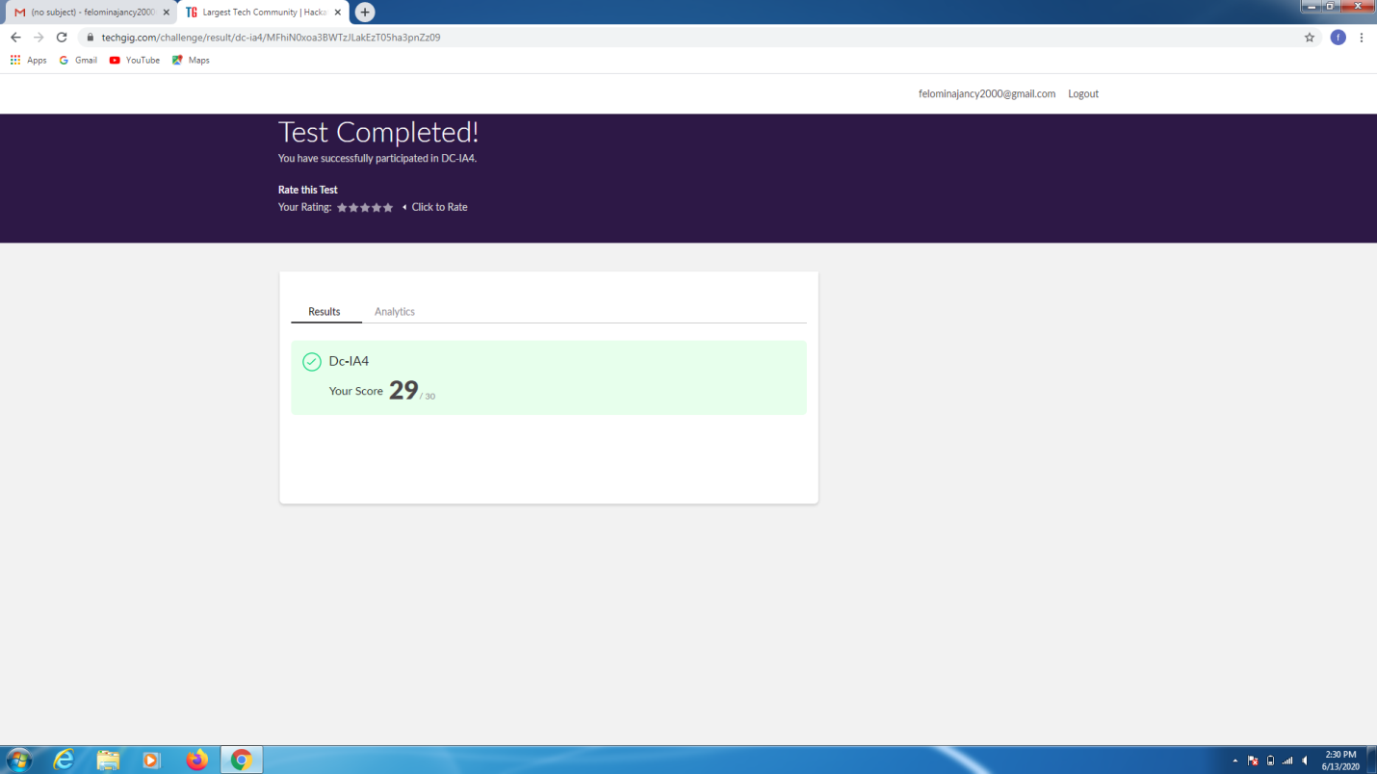

CERTIFICATION COURSE DETAILS:

* As continuation of the online course, I was able to do the week 5 of  **"IoT Wireless and Cloud Computing Emerging Technologies " course.**
* **The concepts covered in week 5 were related IBM , Google ,Clouds and SaaS,IaaS,PaaS.**

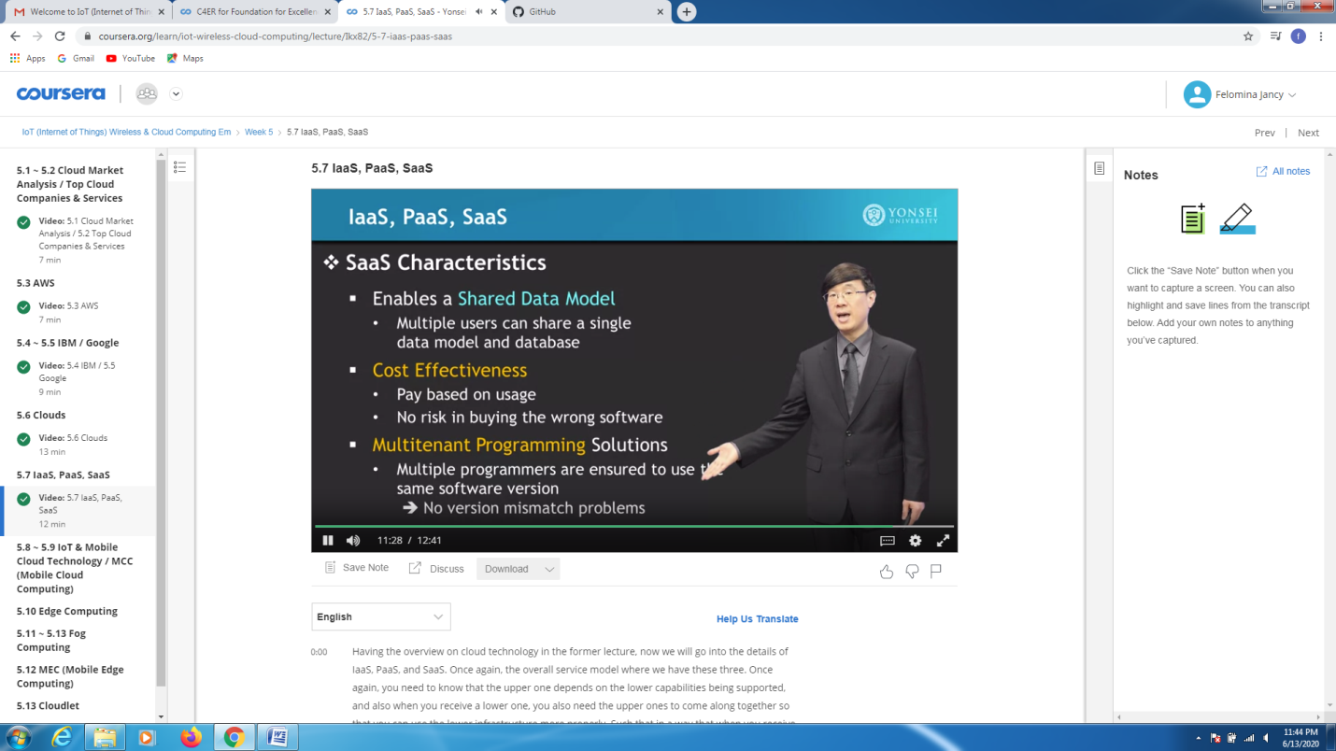

* Then I was able to attend a webinar on **Unchain ethereum and its potential in Zoom app from 4pm to 5:30pm.**

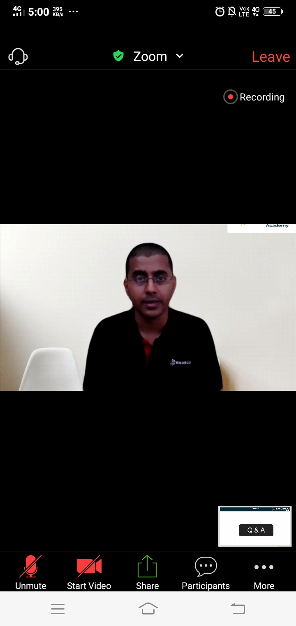 CODING CHALLENGES DETAILS:

Problem statement 1:

Write a C Program to calculate Electricity Bill.

Given an integer U denoting the amount of KWh units of electricity consumed, the task is to calculate the electricity bill with the help of the below charges:  
• 1 to 100 units – Rs 10/- Per Unit  
• 100 to 200 units – Rs. 15/- Per Unit  
• 200 to 300 units – Rs. 20/- Per Unit  
• above 300 units – Rs. 25/- Per Unit

**Examples:**

Input: U = 250

Output: 3500

**Explanation:**

Charge for the first 100 units – 10100 = 1000Charge for the 100 to 200 units – 15100 = 1500  
Charge for the 200 to 250 units – 20*50 = 1000  
Total Electricity Bill = 1000 + 1500 + 1000 = 3500

Solution : Uploaded it in github

