**DAILY ONLINE ACTIVITIES SUMMARY**

|  |  |  |  |  |  |  |  |  |
| --- | --- | --- | --- | --- | --- | --- | --- | --- |
| **Date:** | **14/06/2020** | | | | | **Name:** | **Felomina Jancy** | |
| **Sem & Sec** | **4th SEM 'A' Section** | | | | | **USN:** | **4AL18CS022** | |
| **Online Test Summary** | | | | | | | | |
| **Subject** | | - | | | | | | |
| **Max. Marks** | | **-** | | **Score** | | | **-** | |
| **Certification Course Summary** | | | | | | | | |
| **Course** | **Cloud computing 101** | | | | | | | |
| **Certificate Provider** | | | **Amazon Web Services under ICT Academy** | | **Duration** | | | **3 hours** |
| **Coding Challenges** | | | | | | | | |
| **Problem Statement:** Write a C program to remove specific characters in the String . | | | | | | | | |
| **Status: completed** | | | | | | | | |
| **Uploaded the report in Github** | | | | | **yes** | | | |
| **If yes Repository name** | | | | | **https://github.com/Felomina75/lockdown-coding.git** | | | |
| **Uploaded the report in slack** | | | | | **yes** | | | |

Online Test Details: (Attach the snapshot and briefly write the report for the same)

Certification Course Details: (Attach the snapshot and briefly write the report for the same)

Coding Challenges Details: (Attach the snapshot and briefly write the report for the same)

ONLINE TEST DETAILS:

No test.

CERTIFICATION COURSE DETAILS:

* I started with a new course "Cloud computing 101" organized by Amazon web services under ICT Academy.
* I was able to do module 1 which was about AWS cloud computing fundamentals and also complete module 1 quiz.

 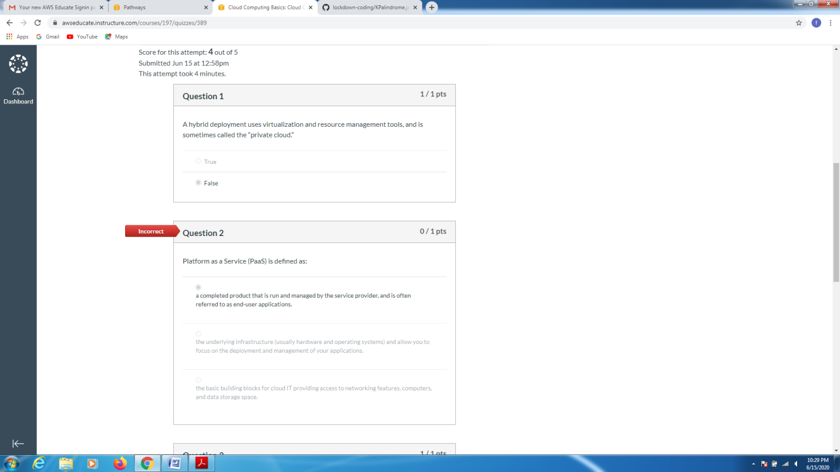CODING CHALLENGES DETAILS:

Problem statement 1:

Write a C program to remove specific characters in the String .

Example  
If the original string is "Welcome to AIET" and the user inputs string to remove "co" then the it should print "Welme to AIET" as output .

**Input**  
First line read a string  
Second line read key character to be removed.

**Output**  
String which doesn't contain key character

Solution : Uploaded it in github

