**DAILY ONLINE ACTIVITIES SUMMARY**

|  |  |  |  |  |  |  |  |  |
| --- | --- | --- | --- | --- | --- | --- | --- | --- |
| **Date:** | **14/07/2020** | | | | | **Name:** | **Felomina Jancy** | |
| **Sem & Sec** | **4th SEM 'A' Section** | | | | | **USN:** | **4AL18CS022** | |
| **Online Test Summary** | | | | | | | | |
| **Subject** | | **-** | | | | | | |
| **Max. Marks** | | **-** | | **Score** | | | **-** | |
| **Certification Course Summary** | | | | | | | | |
| **Course** | **Web development engineer** | | | | | | | |
| **Certificate Provider** | | | **Amazon Web Services** | | **Duration** | | | **3 hours** |
| **Coding Challenges** | | | | | | | | |
| **Problem Statement:** Write a java program to check for balanced parenthesis. | | | | | | | | |
| **Status: completed** | | | | | | | | |
| **Uploaded the report in Github** | | | | | **yes** | | | |
| **If yes Repository name** | | | | | **https://github.com/Felomina75/lockdown-coding.git** | | | |
| **Uploaded the report in slack** | | | | | **yes** | | | |

Online Test Details: (Attach the snapshot and briefly write the report for the same)

Certification Course Details: (Attach the snapshot and briefly write the report for the same)

Coding Challenges Details: (Attach the snapshot and briefly write the report for the same)

ONLINE TEST DETAILS:

No test.

CERTIFICATION COURSE DETAILS:

* I started with a new course "Web development engineer" organized by "Amazon web services".
* It is a 50 hours course.
* The topics covered are:
* [**Software Development: Introduction**](https://awseducate.instructure.com/courses/193/modules/items/4613)
* [Software Development: General](https://awseducate.instructure.com/courses/193/modules/items/4614)
* [Software Development: DevOps](https://awseducate.instructure.com/courses/193/modules/items/4615)
* [Software Development: DevOps Blue/Green](https://awseducate.instructure.com/courses/193/modules/items/4616)

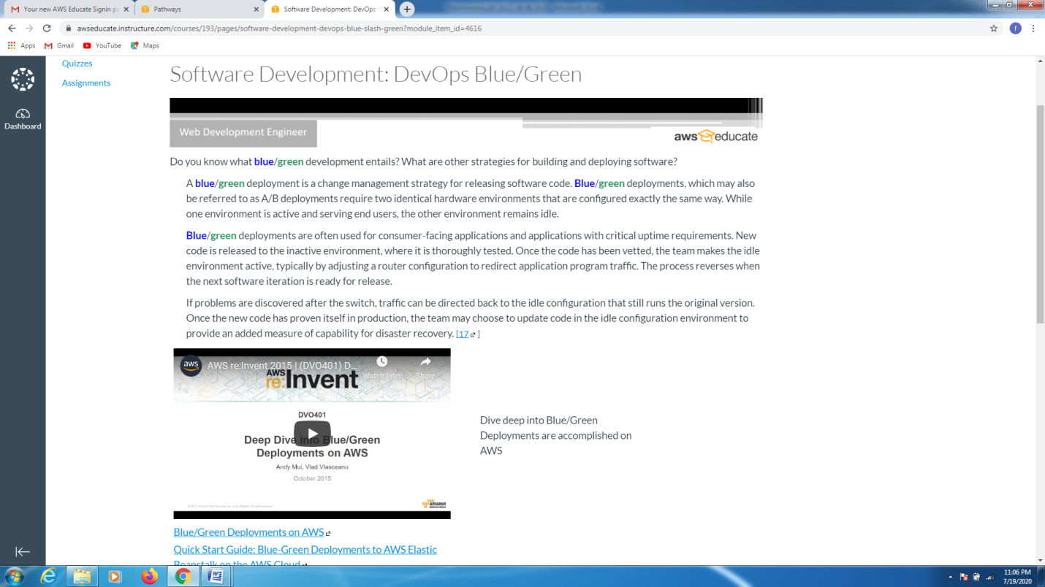

CODING CHALLENGES DETAILS:

Problem statement 1:

Write a java program to check for balanced parenthesis.

Solution : Uploaded it in github

