**DAILY ONLINE ACTIVITIES SUMMARY**

|  |  |  |  |  |  |  |  |  |
| --- | --- | --- | --- | --- | --- | --- | --- | --- |
| **Date:** | **16/06/2020** | | | | | **Name:** | **Felomina Jancy** | |
| **Sem & Sec** | **4th SEM 'A' Section** | | | | | **USN:** | **4AL18CS022** | |
| **Online Test Summary** | | | | | | | | |
| **Subject** | | **Complex analysis, probability and statistical methods** | | | | | | |
| **Max. Marks** | | **30** | | **Score** | | | **28** | |
| **Certification Course Summary** | | | | | | | | |
| **Course** | **Cloud computing 101** | | | | | | | |
| **Certificate Provider** | | | **Amazon Web Services under ICT Academy** | | **Duration** | | | **3 hours** |
| **Coding Challenges** | | | | | | | | |
| **Problem Statement:** Write a Java Program to check whether a given a binary tree is a valid binary search tree (BST) or not? | | | | | | | | |
| **Status: completed** | | | | | | | | |
| **Uploaded the report in Github** | | | | | **yes** | | | |
| **If yes Repository name** | | | | | **https://github.com/Felomina75/lockdown-coding.git** | | | |
| **Uploaded the report in slack** | | | | | **yes** | | | |

Online Test Details: (Attach the snapshot and briefly write the report for the same)

Certification Course Details: (Attach the snapshot and briefly write the report for the same)

Coding Challenges Details: (Attach the snapshot and briefly write the report for the same)

ONLINE TEST DETAILS:

**Complex analysis, probability and statistical methods:** The portion for the online test was from module 1 which was about Calculus of complex function and construction of analytic function . There were 15 questions which was for 2 mark each . Total duration was 40 minutes. The questions were optimal and were easy. The score that I got in the test is 22/30.

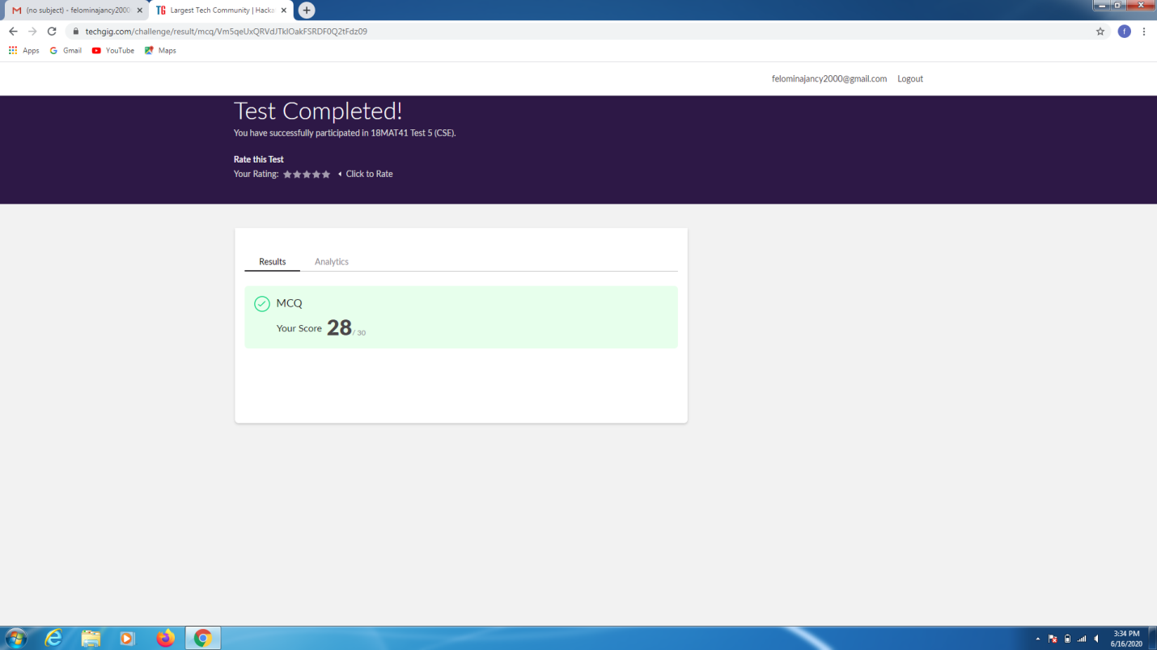

CERTIFICATION COURSE DETAILS:

* I was able to do module 2 of Cloud computing course.
* The topics covered are:
* AWS developer tools
* AWS management tools
* AWS networking and content delivery services
* AWS storage services
* Also, I was able to complete module 2 quiz .

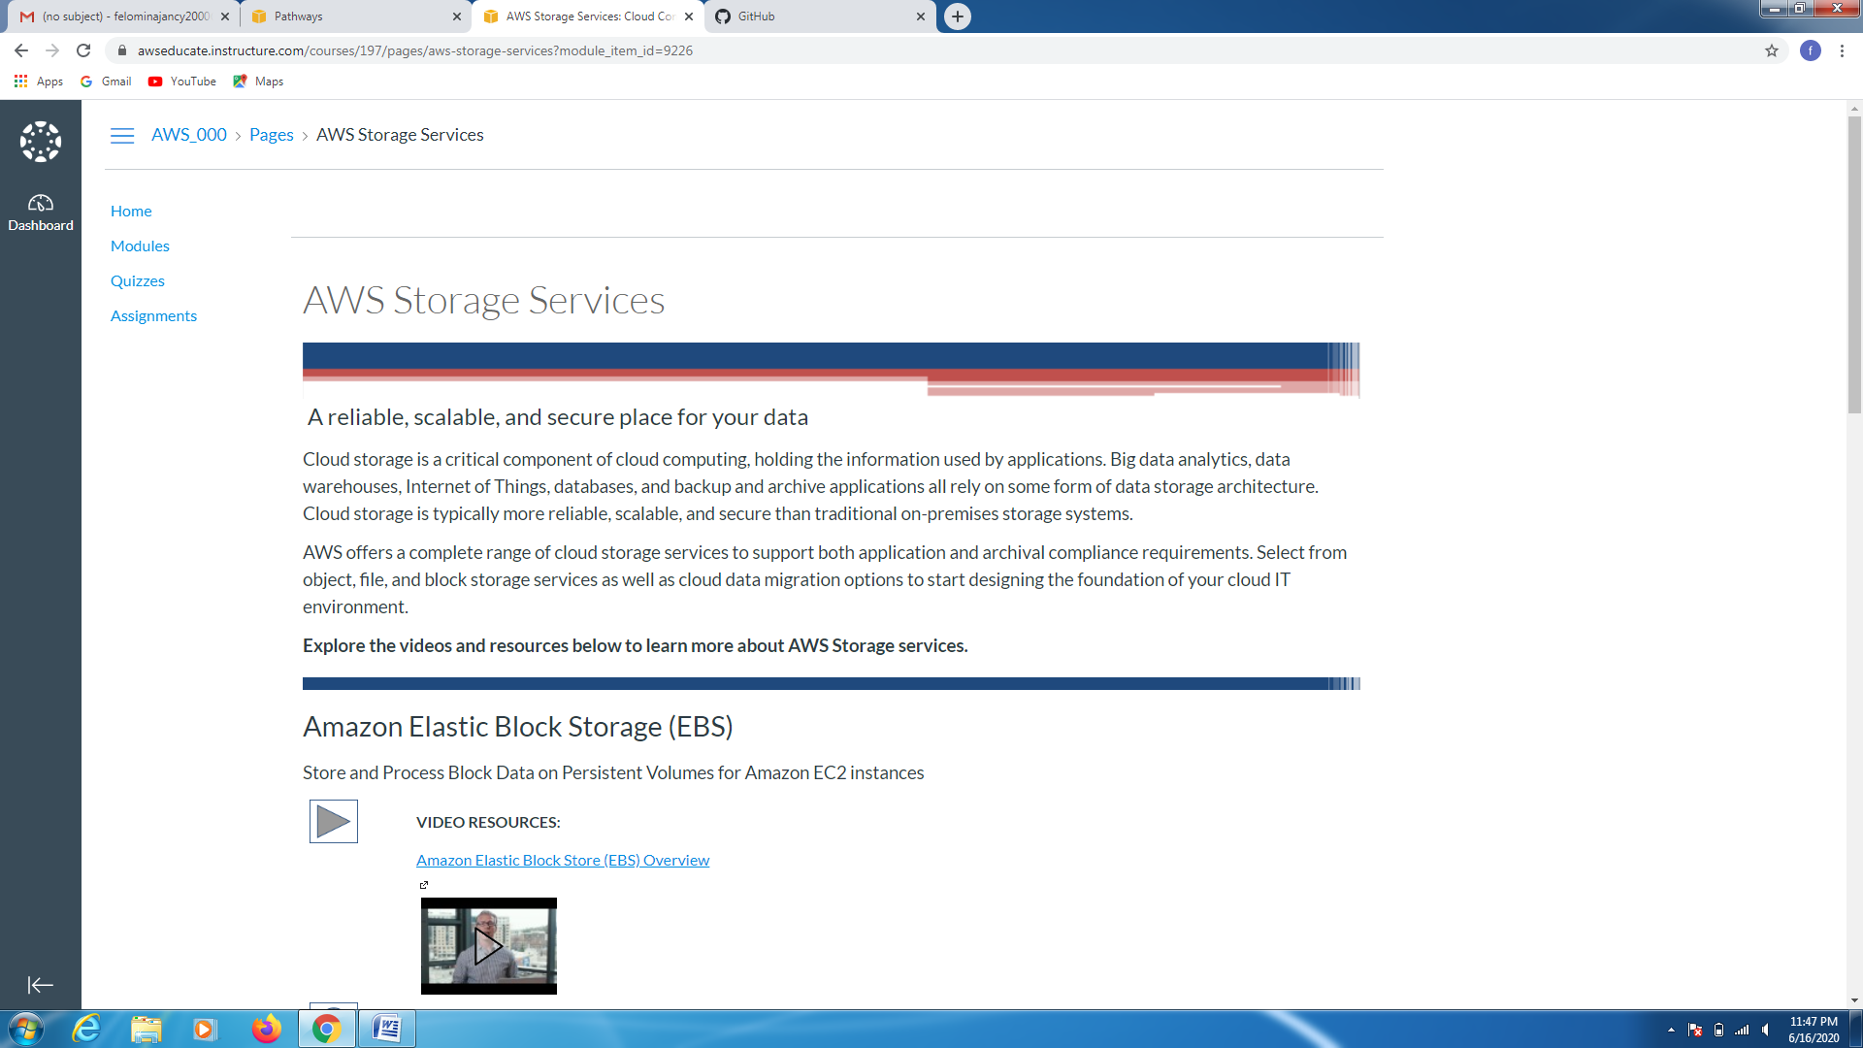 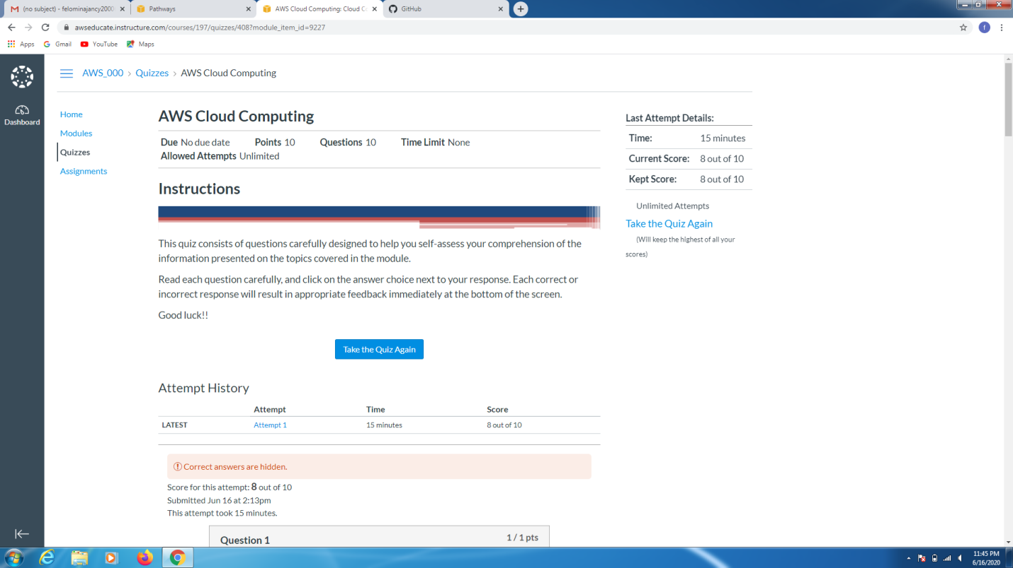CODING CHALLENGES DETAILS:

Problem statement 1:

Write a Java Program to check whether a given a binary tree is a valid binary search tree (BST) or not?

Solution : Uploaded it in github

