**DAILY ONLINE ACTIVITIES SUMMARY**

|  |  |  |  |  |  |  |  |  |
| --- | --- | --- | --- | --- | --- | --- | --- | --- |
| **Date:** | **17/07/2020** | | | | | **Name:** | **Felomina Jancy** | |
| **Sem & Sec** | **4th SEM 'A' Section** | | | | | **USN:** | **4AL18CS022** | |
| **Descriptive Test Summary** | | | | | | | | |
| **Subject** | | **Data communication** | | | | | | |
| **Max. Marks** | | **-** | | **Score** | | | **-** | |
| **Certification Course Summary** | | | | | | | | |
| **Course** | **Web development engineer** | | | | | | | |
| **Certificate Provider** | | | **Amazon Web Services** | | **Duration** | | | **3 hours** |
| **Coding Challenges** | | | | | | | | |
| **Problem Statement:** Write a java program to print alternate prime numbers . | | | | | | | | |
| **Status: completed** | | | | | | | | |
| **Uploaded the report in Github** | | | | | **yes** | | | |
| **If yes Repository name** | | | | | **https://github.com/Felomina75/lockdown-coding.git** | | | |
| **Uploaded the report in slack** | | | | | **yes** | | | |

Online Test Details: (Attach the snapshot and briefly write the report for the same)

Certification Course Details: (Attach the snapshot and briefly write the report for the same)

Coding Challenges Details: (Attach the snapshot and briefly write the report for the same)

DESCRIPTIVE TEST DETAILS:

The descriptive test was of module 1 of data communication. There were four questions to be answered within 45 minutes . The questions were easy .

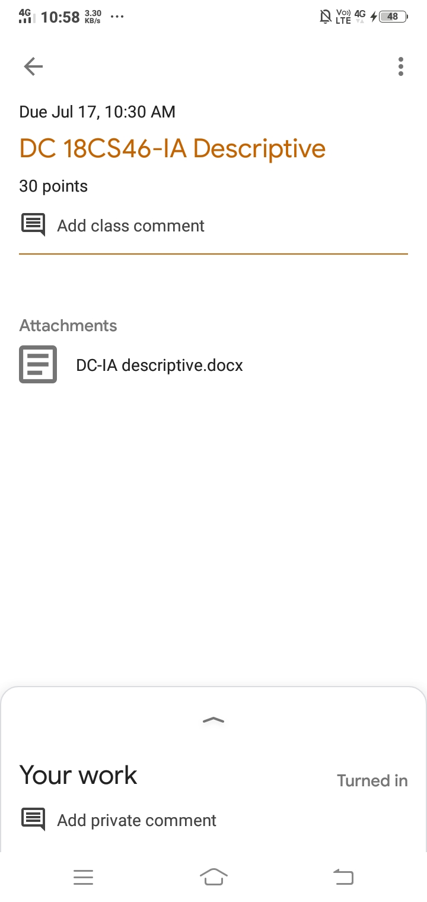

CERTIFICATION COURSE DETAILS:

* As a continuation of the course "Web development engineer" organized by "Amazon web services".
* The topics covered are:
* [**Software Development: Scripting - JavaScript**](https://awseducate.instructure.com/courses/193/modules/items/4623)
* [Software Development: Scripting - PHP](https://awseducate.instructure.com/courses/193/modules/items/4624)
* [Software Development: Scripting - Powershell](https://awseducate.instructure.com/courses/193/modules/items/4625)

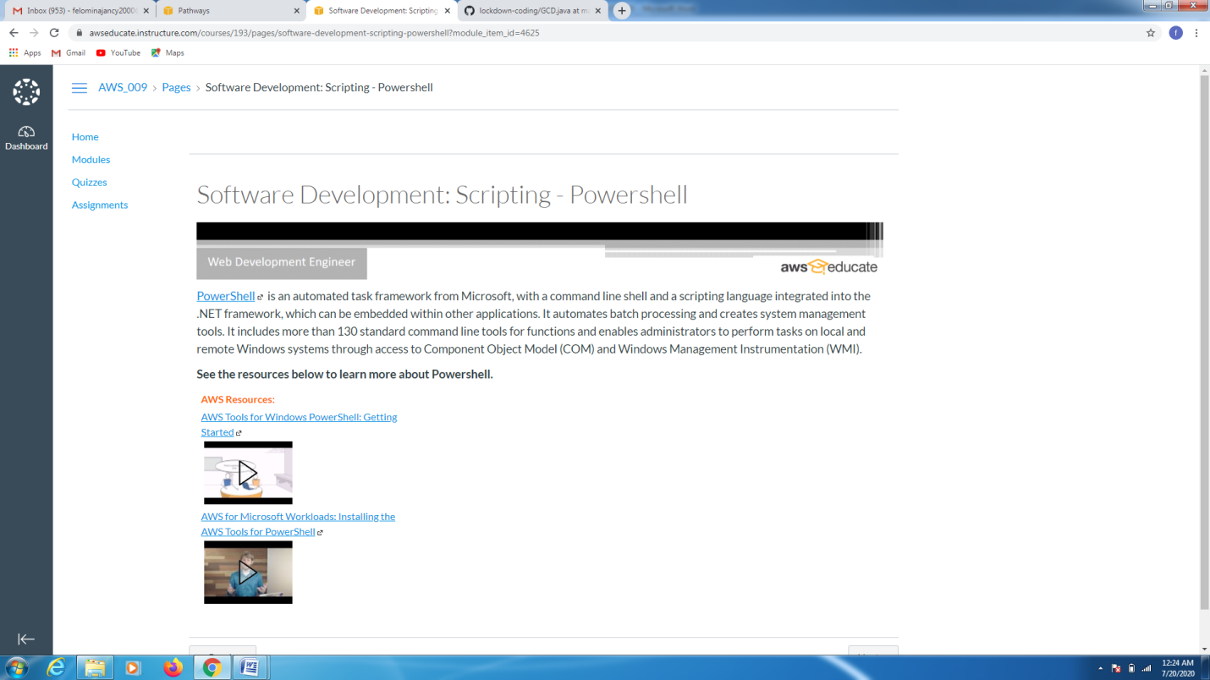

CODING CHALLENGES DETAILS:

Problem statement 1:

Write a java program to print alternate prime numbers .

Solution : Uploaded it in github

