**DAILY ONLINE ACTIVITIES SUMMARY**

|  |  |  |  |  |  |  |  |  |
| --- | --- | --- | --- | --- | --- | --- | --- | --- |
| **Date:** | **18/06/2020** | | | | | **Name:** | **Felomina Jancy** | |
| **Sem & Sec** | **4th SEM 'A' Section** | | | | | **USN:** | **4AL18CS022** | |
| **Online Test Summary** | | | | | | | | |
| **Subject** | | **-** | | | | | | |
| **Max. Marks** | | **-** | | **Score** | | | **-** | |
| **Certification Course Summary** | | | | | | | | |
| **Course** | **Cloud literacy- Inventor** | | | | | | | |
| **Certificate Provider** | | | **Amazon Web Services under ICT Academy** | | **Duration** | | | **3 hours** |
| **Coding Challenges** | | | | | | | | |
| **Problem Statement:** Write a C Program to Count numbers that don’t contain 3. | | | | | | | | |
| **Status: completed** | | | | | | | | |
| **Uploaded the report in Github** | | | | | **yes** | | | |
| **If yes Repository name** | | | | | **https://github.com/Felomina75/lockdown-coding.git** | | | |
| **Uploaded the report in slack** | | | | | **yes** | | | |

Online Test Details: (Attach the snapshot and briefly write the report for the same)

Certification Course Details: (Attach the snapshot and briefly write the report for the same)

Coding Challenges Details: (Attach the snapshot and briefly write the report for the same)

ONLINE TEST DETAILS:

No test.

CERTIFICATION COURSE DETAILS:

* I was able to complete next two missions- 3rd and 4th mission.
* They are:
* Data analysis
* Variables and programming

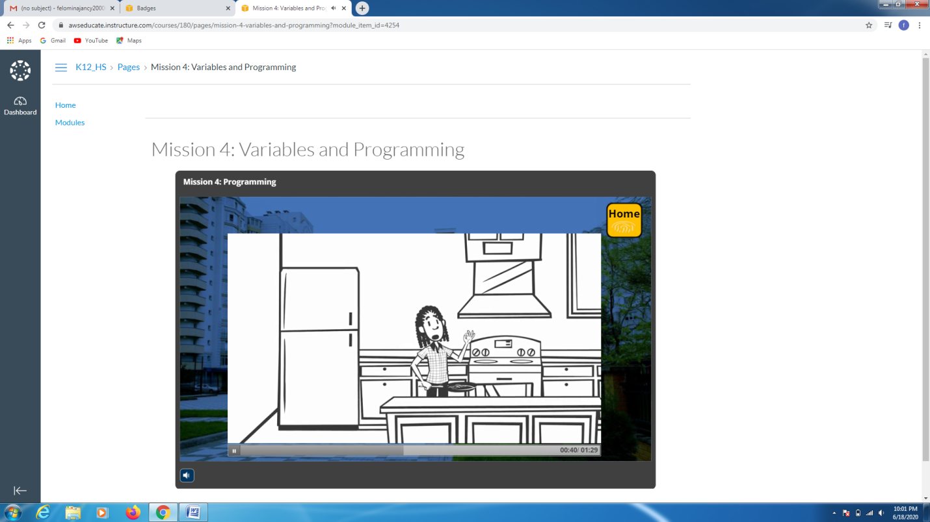

CODING CHALLENGES DETAILS:

Problem statement :

Write a C Program to Count numbers that don’t contain 3.

Given a number n, write a function that returns count of numbers from 1 to n that don’t contain digit 3 in their decimal representation.  
**Examples:**  
**Input:** n = 10  
**Output:** 9  
Here input is 10 means the numbers within 10 are 1,2,3,4,5,6,7,8,9,10 in this series 3 occurs only 1 times so answer is 9

**More examples**  
Input: n = 45  
Output: 31  
// Numbers 3, 13, 23, 30, 31, 32, 33, 34,  
// 35, 36, 37, 38, 39, 43 contain digit 3.

Input: n = 578   
Output: 385

Solution : Uploaded it in github

