**DAILY ONLINE ACTIVITIES SUMMARY**

|  |  |  |  |  |  |  |  |  |
| --- | --- | --- | --- | --- | --- | --- | --- | --- |
| **Date:** | **19/06/2020** | | | | | **Name:** | **Felomina Jancy** | |
| **Sem & Sec** | **4th SEM 'A' Section** | | | | | **USN:** | **4AL18CS022** | |
| **Online Test Summary** | | | | | | | | |
| **Subject** | | Microcontroller and embedded system | | | | | | |
| **Max. Marks** | | **20** | | **Score** | | | **20** | |
| **Certification Course Summary** | | | | | | | | |
| **Course** | **Cloud literacy- Inventor** | | | | | | | |
| **Certificate Provider** | | | **Amazon Web Services under ICT Academy** | | **Duration** | | | **3 hours** |
| **Coding Challenges** | | | | | | | | |
| **Problem Statement:** Write a C Program to Count total set bits in all numbers from 1 to n. | | | | | | | | |
| **Status: completed** | | | | | | | | |
| **Uploaded the report in Github** | | | | | **yes** | | | |
| **If yes Repository name** | | | | | **https://github.com/Felomina75/lockdown-coding.git** | | | |
| **Uploaded the report in slack** | | | | | **yes** | | | |

Online Test Details: (Attach the snapshot and briefly write the report for the same)

Certification Course Details: (Attach the snapshot and briefly write the report for the same)

Coding Challenges Details: (Attach the snapshot and briefly write the report for the same)

ONLINE TEST DETAILS:

The portion for the online test was 3rd module which includes introduction to the embedded system design concepts. The test was conducted in the afternoon from 3pm to 3:30pm. There were 20 questions and the time limit was 30 minutes . The questions were easy . The marks which I scored was 20/20.

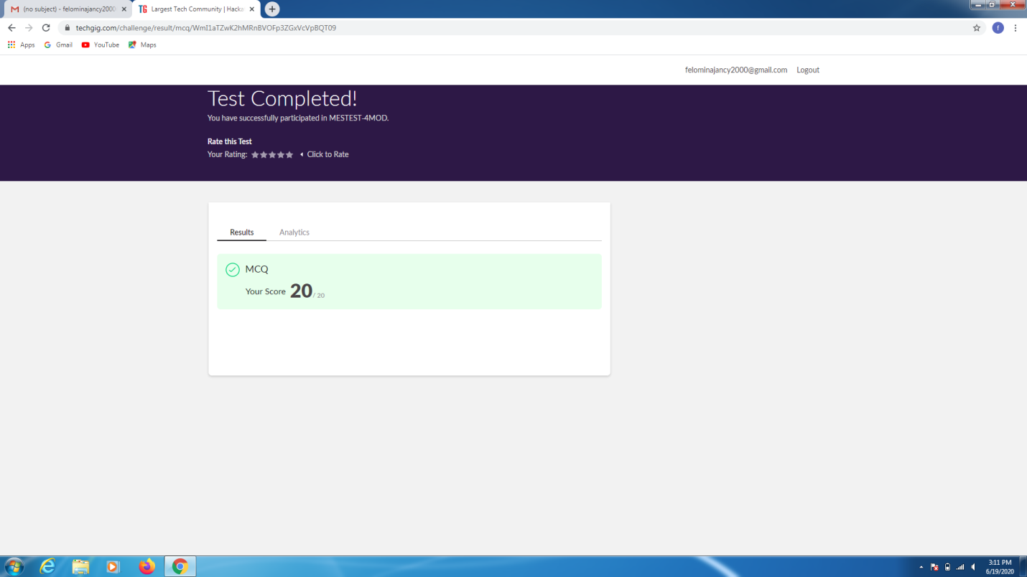

CERTIFICATION COURSE DETAILS:

* I was able to complete the last mission.
* It was about impacts of computing.
* I completed this course.

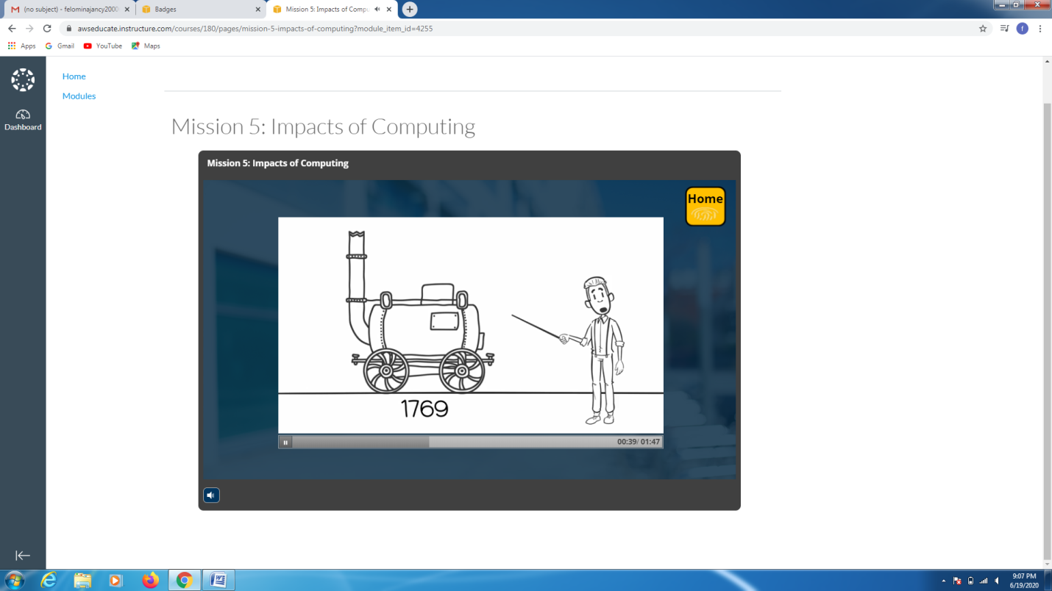

CODING CHALLENGES DETAILS:

Problem statement :

Write a C Program to Count total set bits in all numbers from 1 to n.

Given a positive integer n, count the total number of set bits in binary representation of all numbers from 1 to n.

**Examples:**  
Input: n = 3  
Output: 4  
Input: n = 6  
Output: 9

**Hint:** Read a positive integer (example: 3 indicates range), so u have to consider 1, 2, 3 as the input convert these numbers into binary and count the number of 1 in that (1- 0001, 2- 0010, 3- 0011) number of 1s from all 3 digit is 4 so the answer is 4

Solution : Uploaded it in github

