**DAILY ONLINE ACTIVITIES SUMMARY**

|  |  |  |  |  |  |  |  |  |
| --- | --- | --- | --- | --- | --- | --- | --- | --- |
| **Date:** | **02/06/2020** | | | | | **Name:** | **Felomina Jancy** | |
| **Sem & Sec** | **4th SEM 'A' Section** | | | | | **USN:** | **4AL18CS022** | |
| **Online Test Summary** | | | | | | | | |
| **Subject** | | **-** | | | | | | |
| **Max. Marks** | | **-** | | **Score** | | | **-** | |
| **Certification Course Summary** | | | | | | | | |
| **Course** | **Robotic Process Automation(RPA)** | | | | | | | |
| **Certificate Provider** | | | **UiPath** | | **Duration** | | | **3 hours** |
| **Coding Challenges** | | | | | | | | |
| **Problem Statement:** 1.Write a java program to represent input mismatch exception.  2.Write a java program to find perfect sum problem | | | | | | | | |
| **Status: Completed** | | | | | | | | |
| **Uploaded the report in Github** | | | | | **yes** | | | |
| **If yes Repository name** | | | | | **https://github.com/Felomina75/lockdown-coding.git** | | | |
| **Uploaded the report in slack** | | | | | **yes** | | | |

Online Test Details: (Attach the snapshot and briefly write the report for the same)

Certification Course Details: (Attach the snapshot and briefly write the report for the same)

Coding Challenges Details: (Attach the snapshot and briefly write the report for the same)

ONLINE TEST DETAILS:

Test was not conducted.

CERTIFICATION COURSE DETAILS:

* Online certification course that I opted was Robotic Process Automation(RPA).
* The course is of 3 hours and it consisted two modules.
* Modules:
* Beginner module
* Introduction
* UiPath Components and Extensions
* Scraping, Conditions and loops in UiPath
* Intermediate module
* Basic Automation Workflows

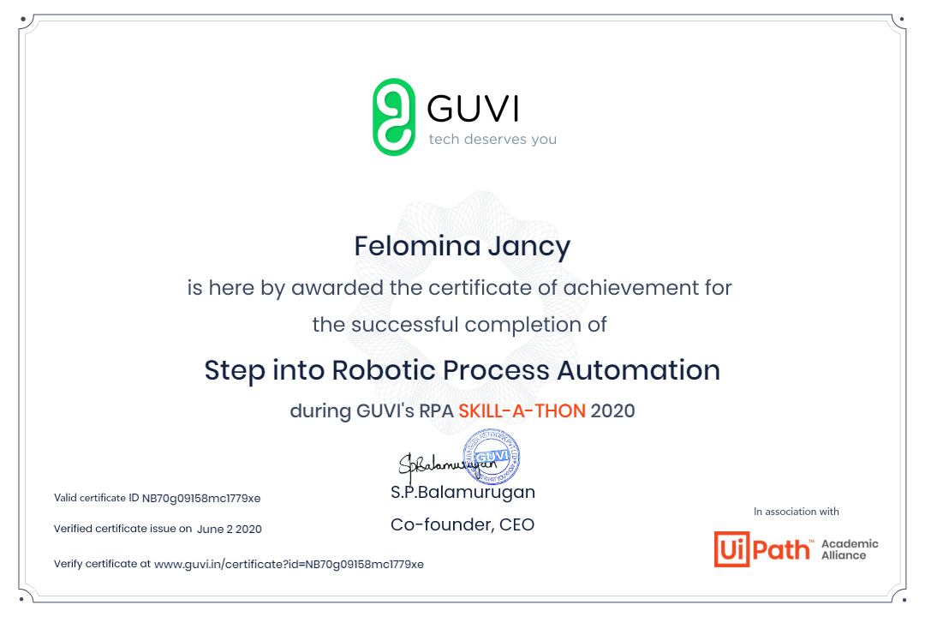 CODING CHALLENGES DETAILS:

Problem statement 1:

Write a program in java, an array of integer data to be initialized. During the initialization, if a user enters a value other than integer value, then it will throw InputMismatchException exception. On the occurrence of such an exception, your program should print “You entered bad data.” If there is no such exception it will print the total sum of the array.

**Solution: Uploaded in github.**

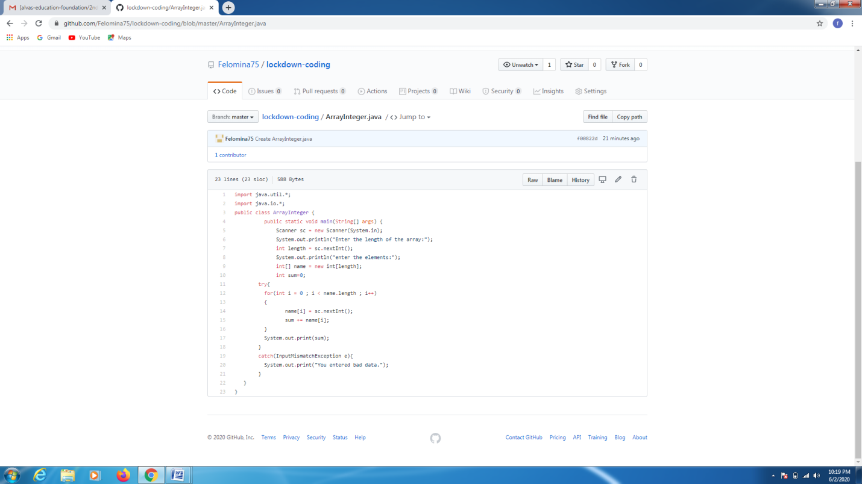

**Problem statement 2:**

Write a java program to find perfect sum problem.

Given an array arr[] of integers and an integer K, the task is to print all subsets of the given array with the sum equal to the given target K.

Solution : Uploaded in github.

