**DAILY ONLINE ACTIVITIES SUMMARY**

|  |  |  |  |  |  |  |  |  |
| --- | --- | --- | --- | --- | --- | --- | --- | --- |
| **Date:** | **20/06/2020** | | | | | **Name:** | **Felomina Jancy** | |
| **Sem & Sec** | **4th SEM 'A' Section** | | | | | **USN:** | **4AL18CS022** | |
| **Online Test Summary** | | | | | | | | |
| **Subject** | | Data Communication | | | | | | |
| **Max. Marks** | | **30** | | **Score** | | | **29** | |
| **Certification Course Summary** | | | | | | | | |
| **Course** | **IoT Wireless and Cloud Computing Emerging Technologies** | | | | | | | |
| **Certificate Provider** | | | **Coursera** | | **Duration** | | | **3 hours** |
| **Coding Challenges** | | | | | | | | |
| **Problem Statement:** Write a Java program to count number of bits to be flipped to convert A to B. | | | | | | | | |
| **Status: completed** | | | | | | | | |
| **Uploaded the report in Github** | | | | | **yes** | | | |
| **If yes Repository name** | | | | | **https://github.com/Felomina75/lockdown-coding.git** | | | |
| **Uploaded the report in slack** | | | | | **yes** | | | |

Online Test Details: (Attach the snapshot and briefly write the report for the same)

Certification Course Details: (Attach the snapshot and briefly write the report for the same)

Coding Challenges Details: (Attach the snapshot and briefly write the report for the same)

ONLINE TEST DETAILS:

The portion for the online test was from module 3 and 4 which was about bandwidth utilization, switching, error detection and correction, data link control, media access control. Introduction to data link layer and IPv4 & addressing sub netting. There were 30 questions and the duration was 30 minutes. The questions were optimal and were easy. The score that I got in the test is 29/30.

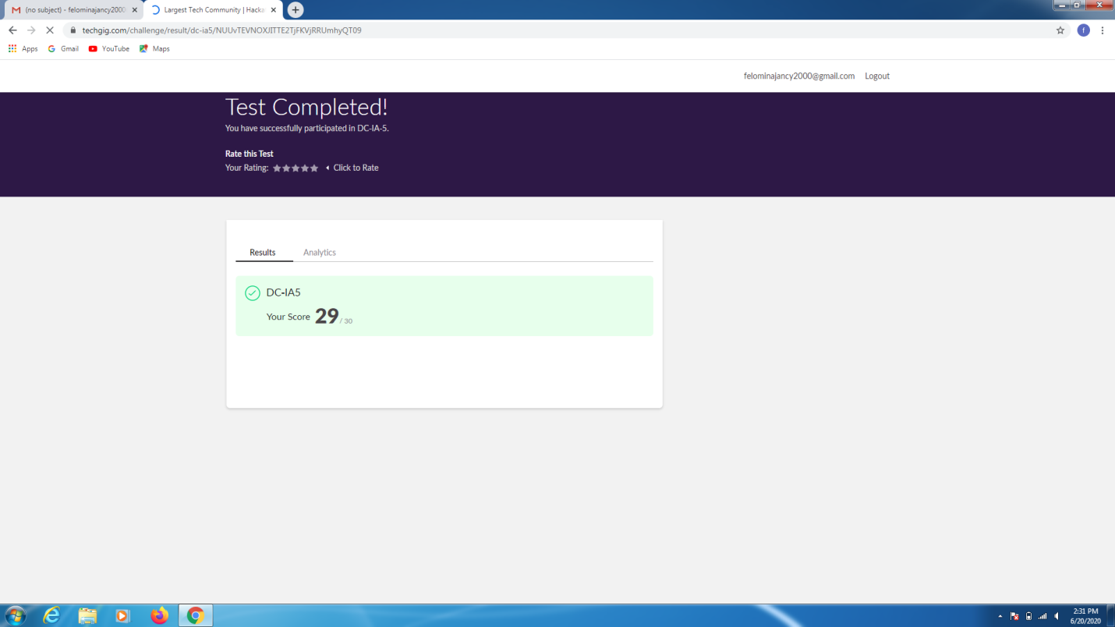CERTIFICATION COURSE DETAILS:

* As continuation of the online course, as I did not complete the week 4 quiz and the due time was over . So the rescheduled the course and completed the week 4 quiz of **"IoT Wireless and Cloud Computing Emerging Technologies " course.**
* **There were two quiz where one was ungraded and another graded quiz.**
* **I was able to do achieve the passing mark in the quiz.**
* **Then started with the week 5 videos.**

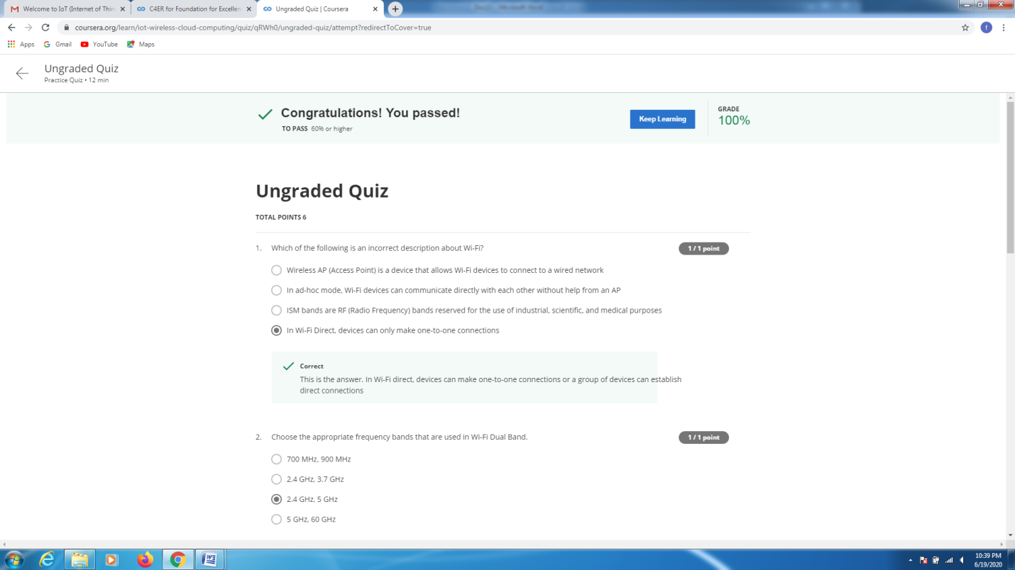 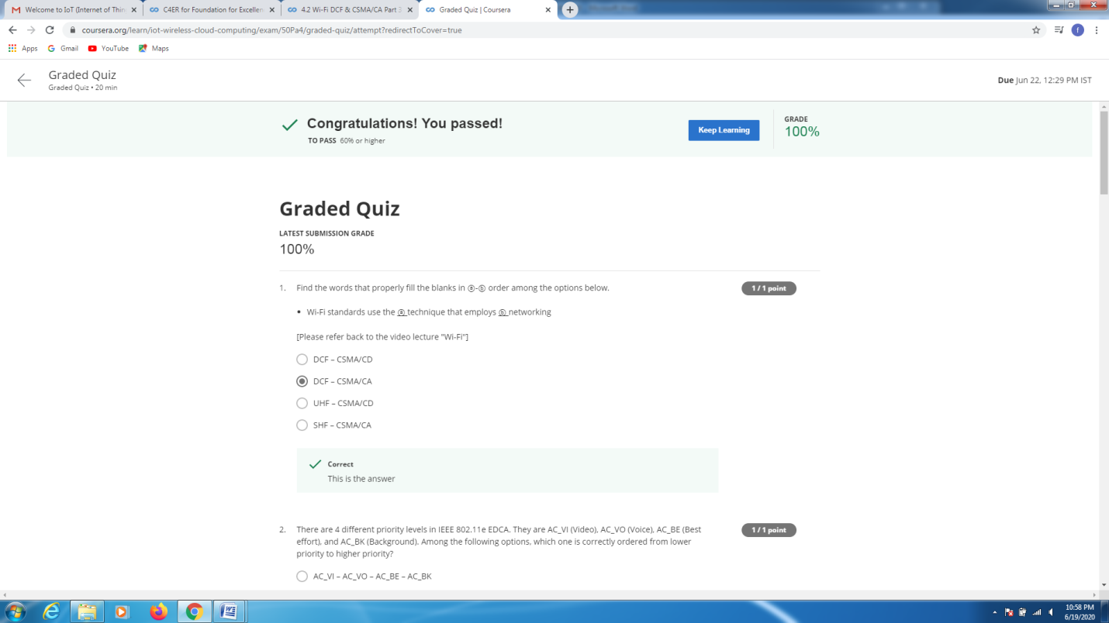

CODING CHALLENGES DETAILS:

Problem statement:

Write a Java program to count number of bits to be flipped to convert A to B.

Solution : Uploaded it in github

