**DAILY ONLINE ACTIVITIES SUMMARY**

|  |  |  |  |  |  |  |  |  |
| --- | --- | --- | --- | --- | --- | --- | --- | --- |
| **Date:** | **20/05/2020** | | | | | **Name:** | **Felomina Jancy** | |
| **Sem & Sec** | **4th SEM 'A' Section** | | | | | **USN:** | **4AL18CS022** | |
| **Online Test Summary** | | | | | | | | |
| **Subject** | | **Object oriented concepts(18CS45)** | | | | | | |
| **Max. Marks** | | **30** | | **Score** | | | **22** | |
| **Certification Course Summary** | | | | | | | | |
| **Course** | **1. IoT Wireless and Cloud Computing Emerging Technologies**  **2. STEPATHON** | | | | | | | |
| **Certificate Provider** | | | **1. Coursera**  **2. ICT Academy** | | **Duration** | | | **1. 1.5 hours**  **2.1 hour** |
| **Coding Challenges** | | | | | | | | |
| **Problem Statement:** 1. To reverse a singly linked list  2. To print duplicate elements of an array | | | | | | | | |
| **Status: completed** | | | | | | | | |
| **Uploaded the report in Github** | | | | | **yes** | | | |
| **If yes Repository name** | | | | | **https://github.com/Felomina75/lockdown-coding.git** | | | |
| **Uploaded the report in slack** | | | | | **yes** | | | |

Online Test Details: (Attach the snapshot and briefly write the report for the same)

Certification Course Details: (Attach the snapshot and briefly write the report for the same)

Coding Challenges Details: (Attach the snapshot and briefly write the report for the same)

ONLINE TEST DETAILS:

The online test was from module 1 which was about overview of object oriented programming. There were 20 MCQ+10(programming)questions and the duration was 40 minutes. The questions were optimal and easy. The score that I got was 22/30.

Snapshot: 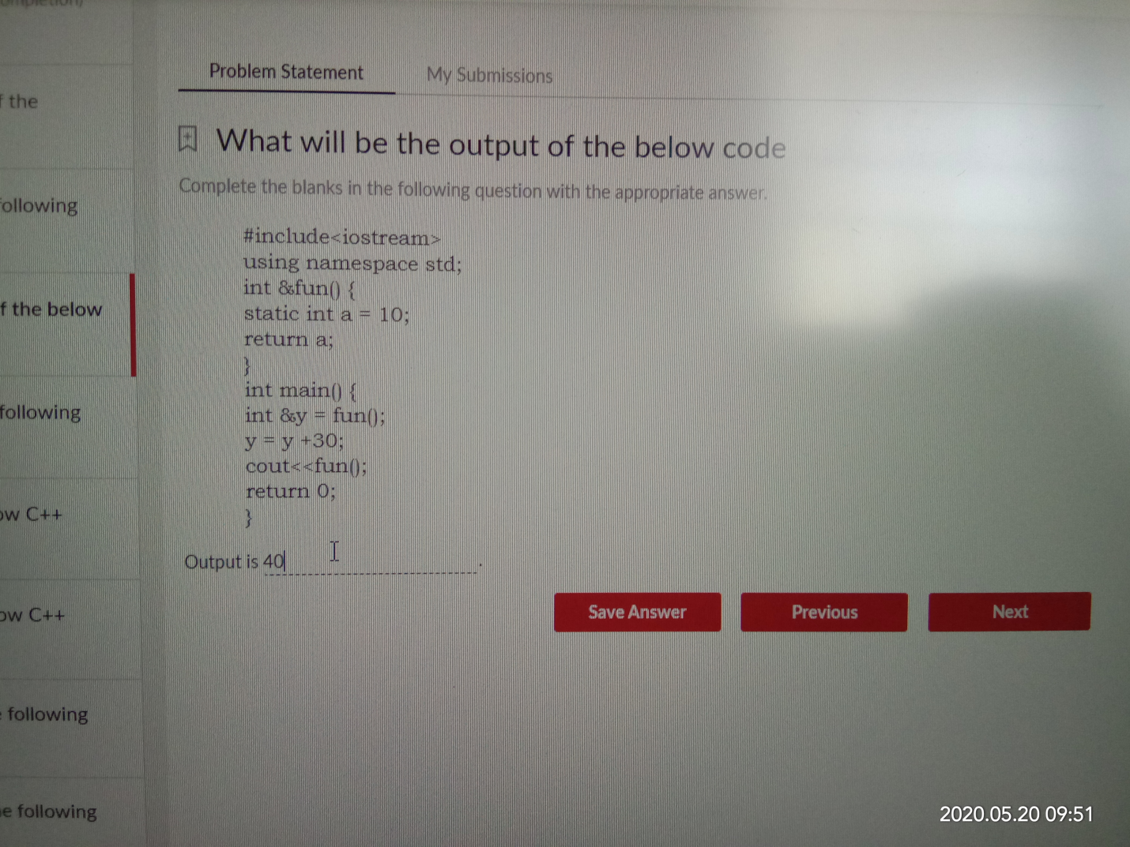

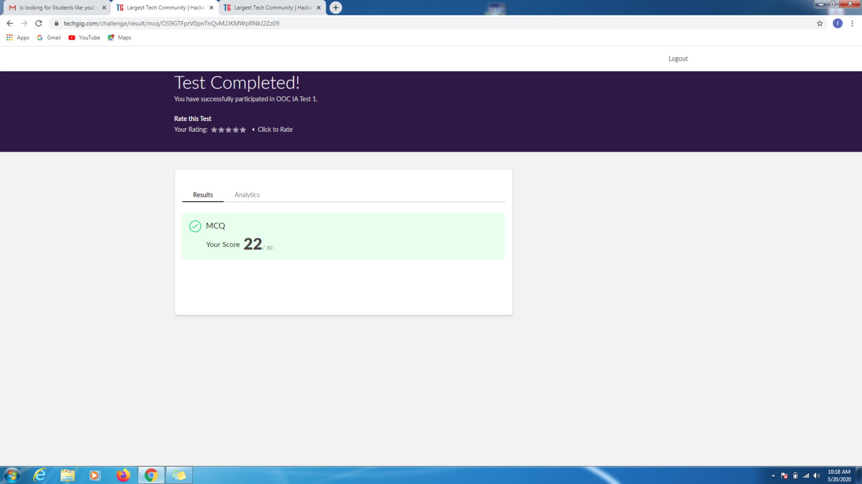

CERTIFICATION COURSE DETAILS:

* As continuation of the online course, I was able to do the week 2 part 2.2 of the "**IoT Wireless and Cloud Computing Emerging Technologies".**
* **The concepts covered in 2.2 under IoT technologies are:**
* WSN(wireless sensor networks)
* Cloud computing
* IoT Research and Development
* Sensors ,Actuators and RFID
* Processors and Microcontrollers
* Arduino, Atmel

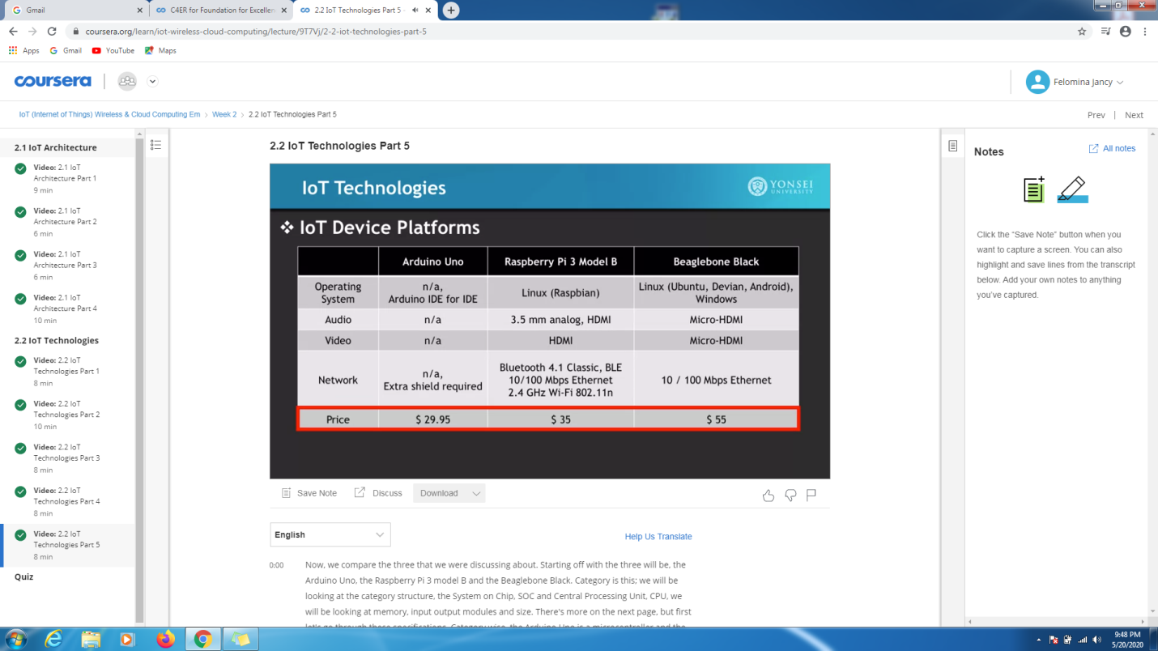

* Another course is "STEPATHON" of ICT Academy . I was able to complete a part of the week 1 activities and complete the questions which were asked.

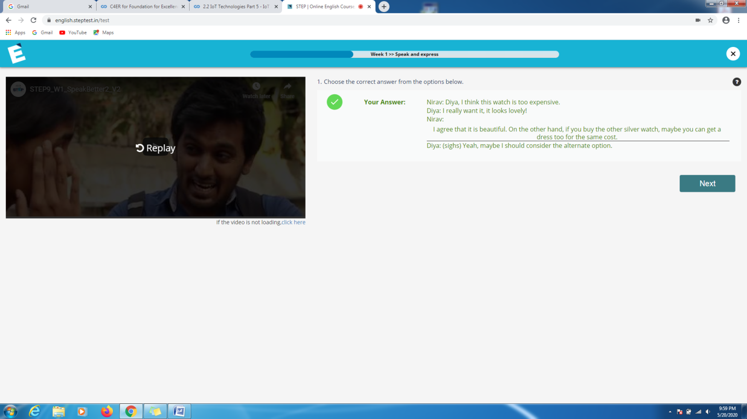

CODING CHALLENGES DETAILS:

Problem statement 1:

[Write a C Program to Reverse a Linked List (SLL) in groups of given size.](https://github.com/orgs/alvas-education-foundation/teams/2nd-year/discussions/67)

Test Case 1:  
If a linked list is: 1 → 2 → 3 → 4 → 5 → 6 → 7 → 8  
The value of size k is 2  
Then the linked list looks like: 2 → 1 → 4 → 3 → 6 → 5 → 8 → 7

Test Case 2:  
If a linked list is: 1 → 2 → 3 → 4 → 5 → 6 → 7 → 8  
The value of size k is 3  
Then the linked list looks like: 3 → 2 → 1 → 6 → 5 → 4 → 8 → 7

Solution : Uploaded it in github

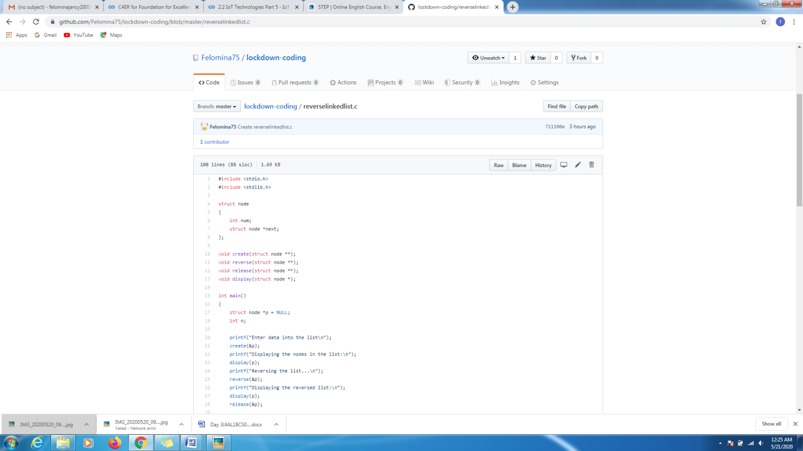

Problem statement 2:

Given an array a[] of size n which contains elements from 0 to n-1, write a program printDuplicates which prints the duplicate elements of the given array. If no duplicate element is found print -1.

Solution: Uploaded in github.

