**DAILY ONLINE ACTIVITIES SUMMARY**

|  |  |  |  |  |  |  |  |  |
| --- | --- | --- | --- | --- | --- | --- | --- | --- |
| **Date:** | **21/05/2020** | | | | | **Name:** | **Felomina Jancy** | |
| **Sem & Sec** | **4th SEM 'A' Section** | | | | | **USN:** | **4AL18CS022** | |
| **Online Test Summary** | | | | | | | | |
| **Subject** | | Microcontroller and Embedded Systems | | | | | | |
| **Max. Marks** | | **30** | | **Score** | | | **24** | |
| **Certification Course Summary** | | | | | | | | |
| **Course** | **STEPATHON** | | | | | | | |
| **Certificate Provider** | | | **ICT Academy** | | **Duration** | | | **2 hour** |
| **Coding Challenges** | | | | | | | | |
| **Problem Statement:** 1. To demonstrate the process of SRTF scheduling  2. To remove duplicate elements from a SLL | | | | | | | | |
| **Status: completed** | | | | | | | | |
| **Uploaded the report in Github** | | | | | **yes** | | | |
| **If yes Repository name** | | | | | **https://github.com/Felomina75/lockdown-coding.git** | | | |
| **Uploaded the report in slack** | | | | | **yes** | | | |

Online Test Details: (Attach the snapshot and briefly write the report for the same)

Certification Course Details: (Attach the snapshot and briefly write the report for the same)

Coding Challenges Details: (Attach the snapshot and briefly write the report for the same)

ONLINE TEST DETAILS:

The online test was from module 1 which was about Introduction to the subject and the fundamentals of ARM processor. There were 30 questions and the duration was 30 minutes. The questions were optimal and were easy. The score that I got was 24/30.

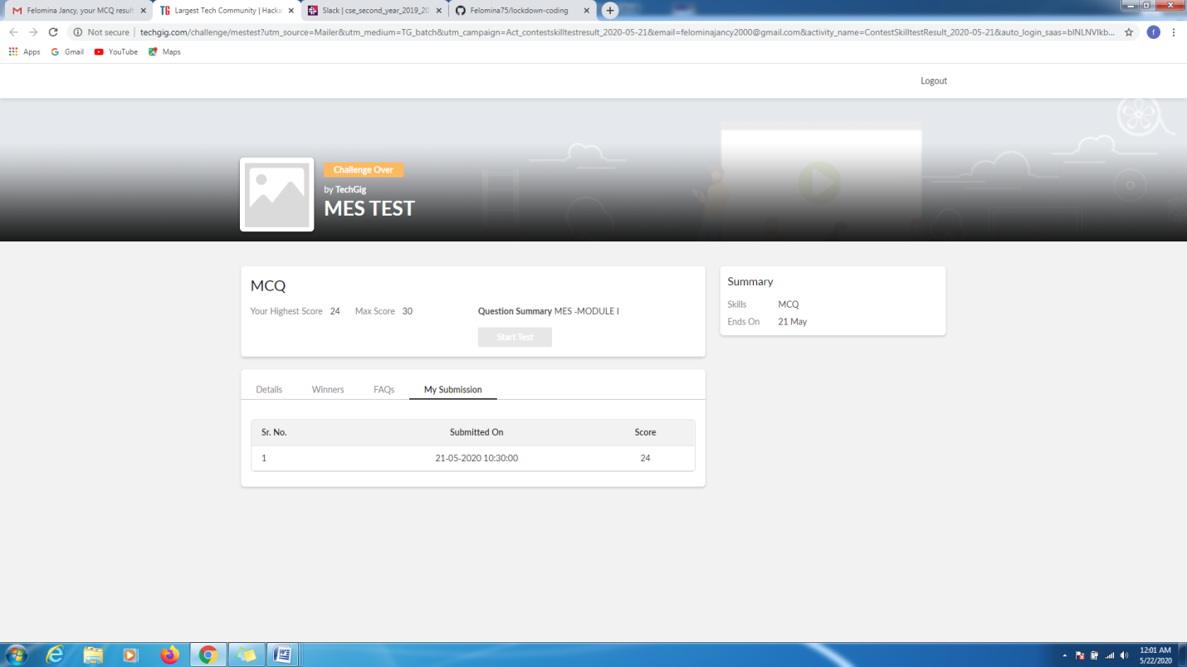

CERTIFICATION COURSE DETAILS:

The course is "STEPATHON" of ICT Academy . I was able to complete a part of the week 2 activities and complete the questions which were asked.

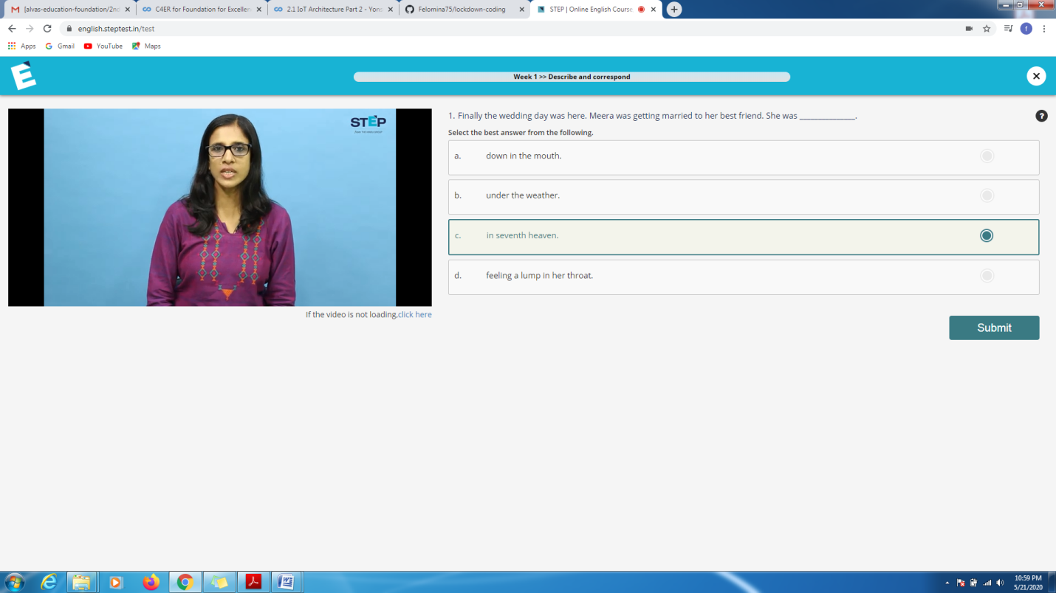

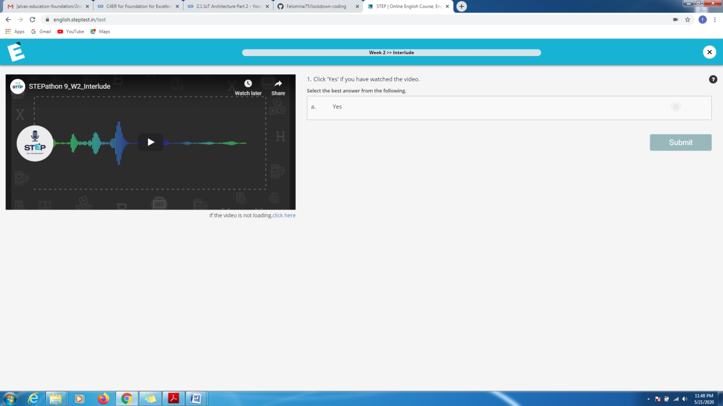

CODING CHALLENGES DETAILS:

Problem statement 1:

Write a program to remove duplicate elements from a singly linked list

Solution : Uploaded it in github

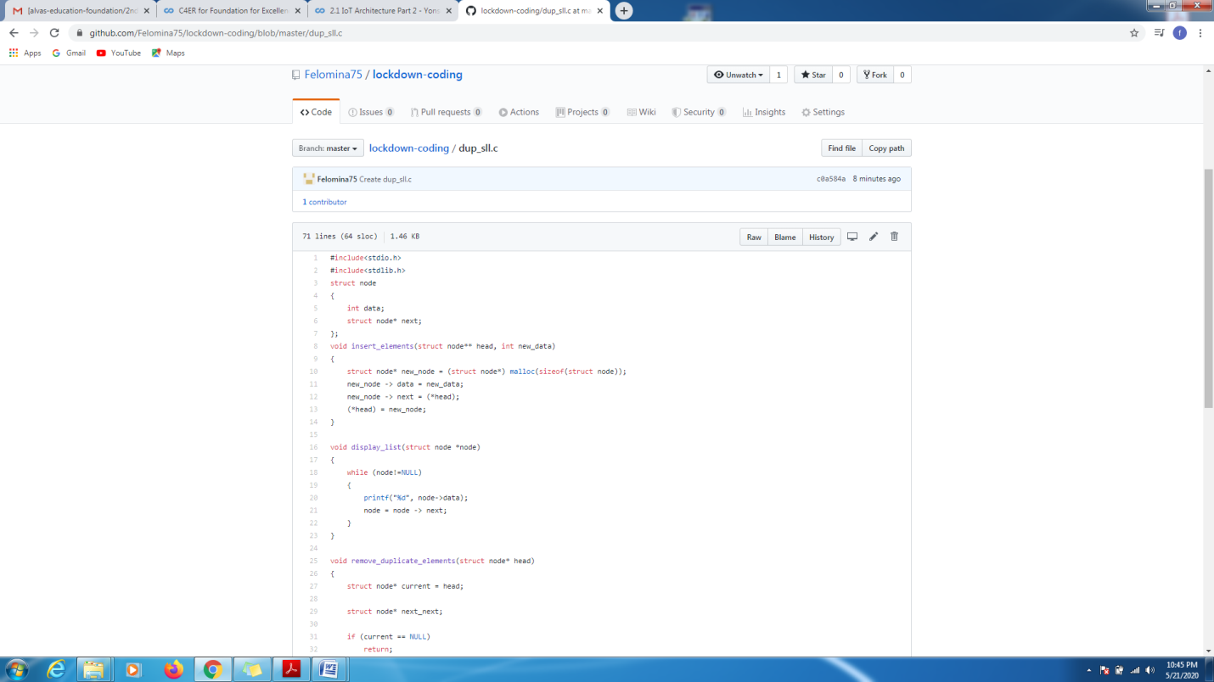

Problem statement 2:

Write a program to demonstrate SRTF(Shortest Remaining Time First) scheduling process.

Solution: Uploaded in github.

