**DAILY ONLINE ACTIVITIES SUMMARY**

|  |  |  |  |  |  |  |  |  |
| --- | --- | --- | --- | --- | --- | --- | --- | --- |
| **Date:** | **22/05/2020** | | | | | **Name:** | **Felomina Jancy** | |
| **Sem & Sec** | **4th SEM 'A' Section** | | | | | **USN:** | **4AL18CS022** | |
| **Online Test Summary** | | | | | | | | |
| **Subject** | | OPERATING SYSTEMS(18CS43) | | | | | | |
| **Max. Marks** | | **30** | | **Score** | | | **23** | |
| **Certification Course Summary** | | | | | | | | |
| **Course** | **Automation Anywhere** | | | | | | | |
| **Certificate Provider** | | | **ICT Academy** | | **Duration** | | | **3 hours** |
| **Coding Challenges** | | | | | | | | |
| **Problem Statement:**1. Stack operation using SLL  2. Round robin type of process scheduling | | | | | | | | |
| **Status: completed** | | | | | | | | |
| **Uploaded the report in Github** | | | | | **yes** | | | |
| **If yes Repository name** | | | | | **https://github.com/Felomina75/lockdown-coding.git** | | | |
| **Uploaded the report in slack** | | | | | **yes** | | | |

Online Test Details: (Attach the snapshot and briefly write the report for the same)

Certification Course Details: (Attach the snapshot and briefly write the report for the same)

Coding Challenges Details: (Attach the snapshot and briefly write the report for the same)

ONLINE TEST DETAILS:

The online test was from module 1 which was about the introduction to operating systems, system structures, different operating system services and process management. There were 30 questions and the duration was 30 minutes. The questions were optimal and were easy. The score that I got was 23/30.

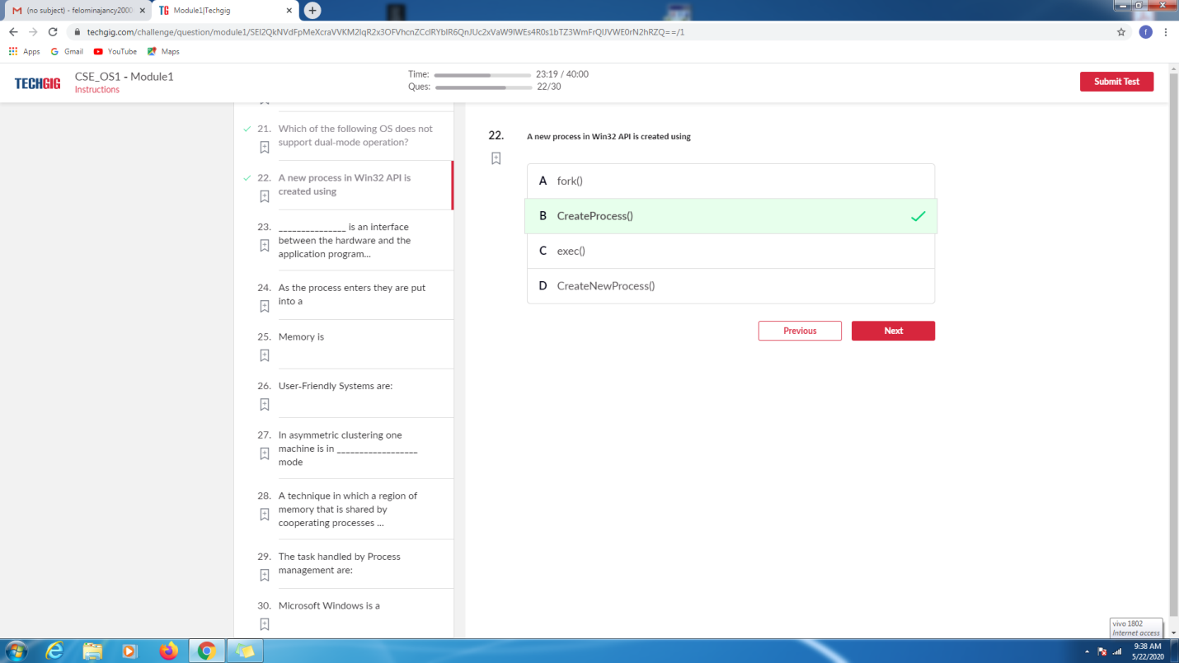

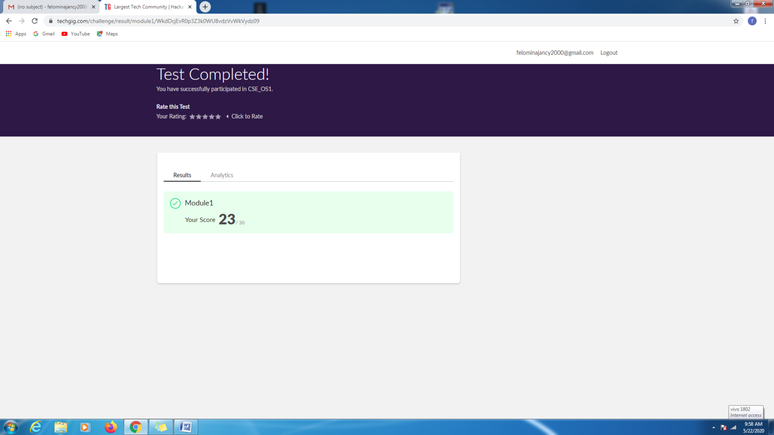

CERTIFICATION COURSE DETAILS:

* Today I started with a new course of "Automation Anywhere" organized by ICT Academy .
* It consists of 11 modules. I just started with 1st module which comprises of 7 sub-modules .It took 3hours to complete a single module.
* It was just the introduction to Robotic Process Automation (RPA) and its applications.

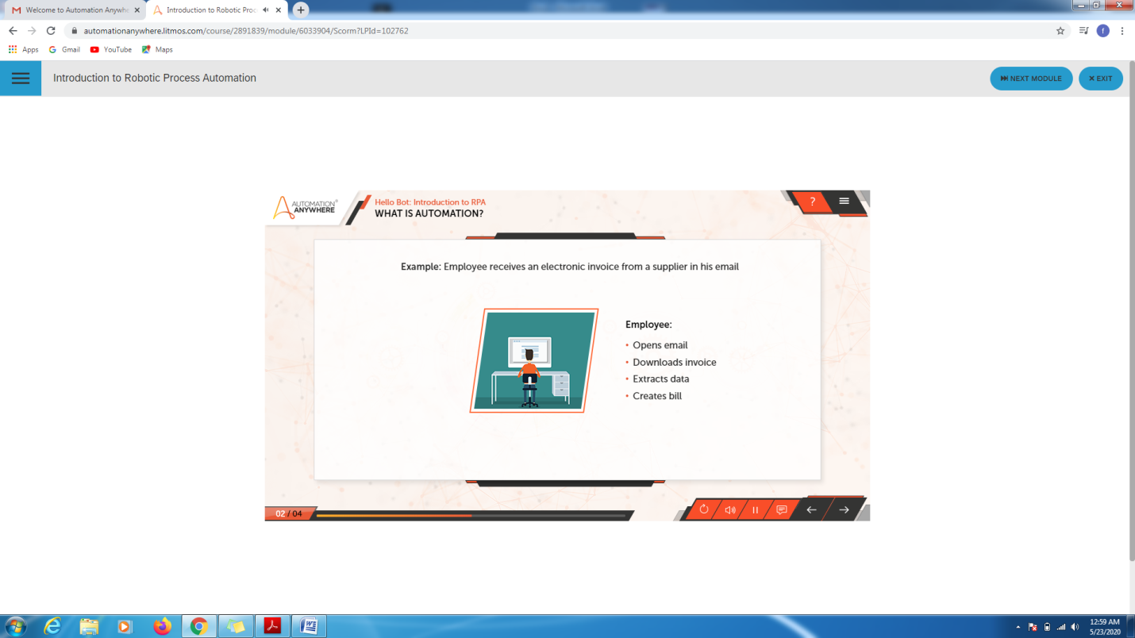

CODING CHALLENGES DETAILS:

Problem statement 1:

Write a C program to perform round robin type of process scheduling.

Solution : Uploaded it in github

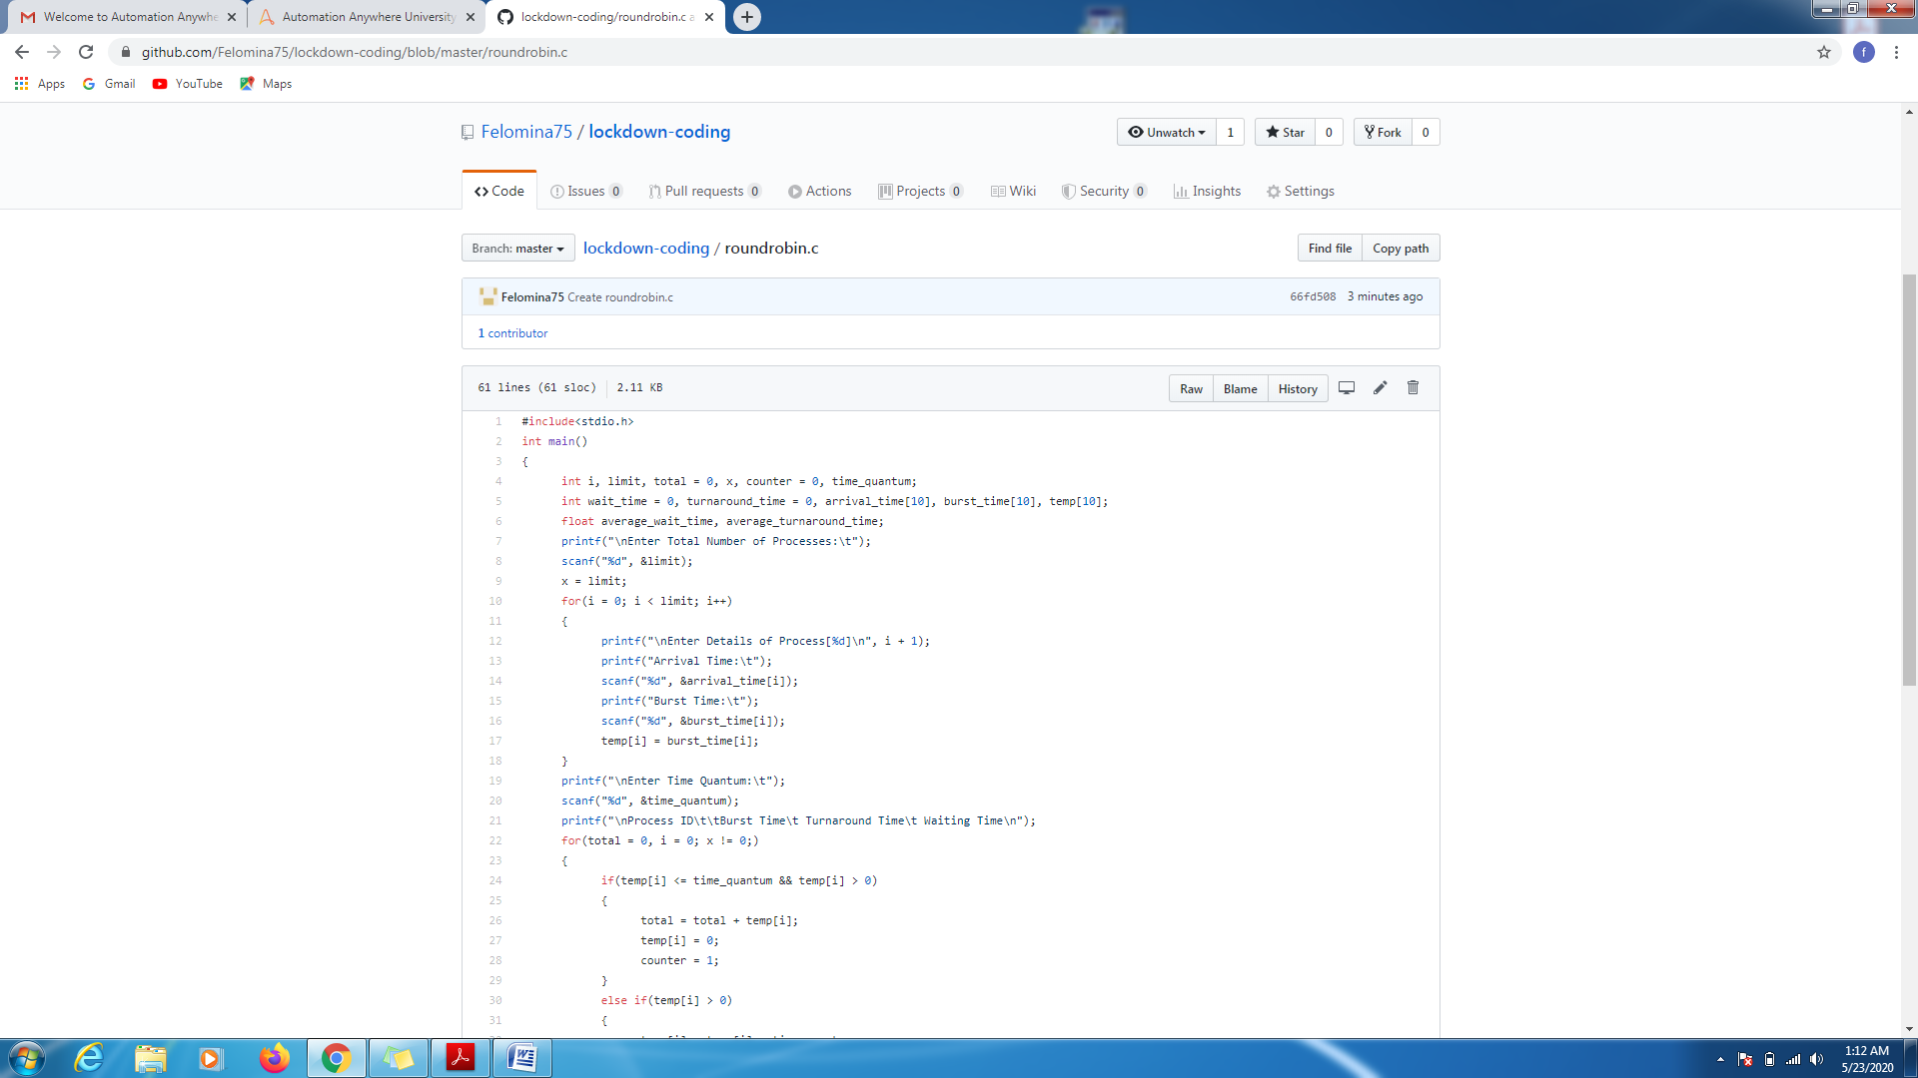

Problem statement 2:

Write a C Program to implement various operations on Singly Linked List Stack.

Solution: Uploaded in github.

