**DAILY ONLINE ACTIVITIES SUMMARY**

|  |  |  |  |  |  |  |  |  |
| --- | --- | --- | --- | --- | --- | --- | --- | --- |
| **Date:** | **23/05/2020** | | | | | **Name:** | **Felomina Jancy** | |
| **Sem & Sec** | **4th SEM 'A' Section** | | | | | **USN:** | **4AL18CS022** | |
| **Online Test Summary** | | | | | | | | |
| **Subject** | | DATA COMMUNICATION(18CS46) | | | | | | |
| **Max. Marks** | | **30** | | **Score** | | | **30** | |
| **Certification Course Summary** | | | | | | | | |
| **Course** | **Automation Anywhere** | | | | | | | |
| **Certificate Provider** | | | **ICT Academy** | | **Duration** | | | **3 hours** |
| **Coding Challenges** | | | | | | | | |
| **Problem Statement:**1. Write a C Program to generate first N Triangular Numbers (Where N is Read from the Key board). | | | | | | | | |
| **Status: completed** | | | | | | | | |
| **Uploaded the report in Github** | | | | | **yes** | | | |
| **If yes Repository name** | | | | | **https://github.com/Felomina75/lockdown-coding.git** | | | |
| **Uploaded the report in slack** | | | | | **yes** | | | |

Online Test Details: (Attach the snapshot and briefly write the report for the same)

Certification Course Details: (Attach the snapshot and briefly write the report for the same)

Coding Challenges Details: (Attach the snapshot and briefly write the report for the same)

ONLINE TEST DETAILS:

The online test was from module 1 and module 2 which was about the introduction to data communication, about network models, digital transmission, analog transmission and introduction to physical layer. There were 30 questions and the duration was 30 minutes. The questions were optimal and were easy. The score that I got was 30/30.

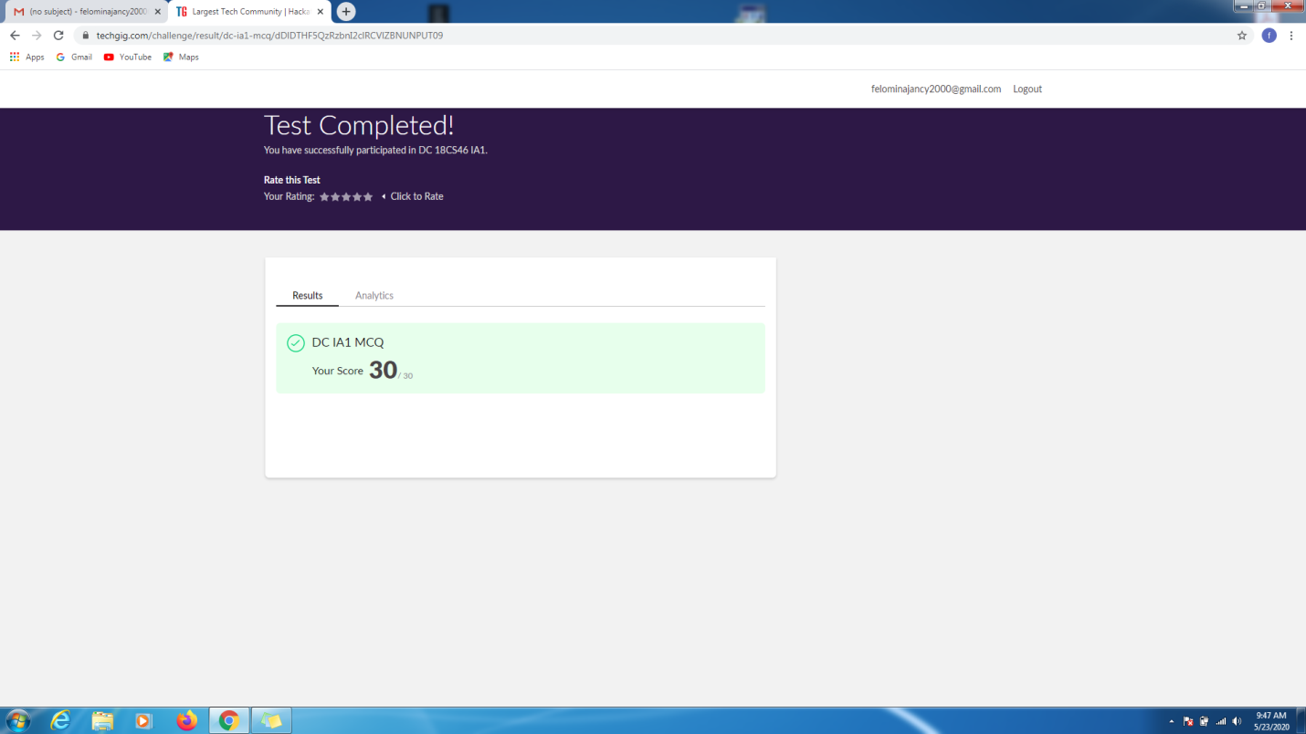

CERTIFICATION COURSE DETAILS:

* Today I did a part of "Automation Anywhere" course organized by ICT Academy .
* I started with the second module which consists of several concepts in which I was able to complete 10 concepts with a assessment and it took 3hours.
* It was just the introduction to :
* Automation Anywhere
* Web control room
* Client
* Recorders and it's types
* Workbench

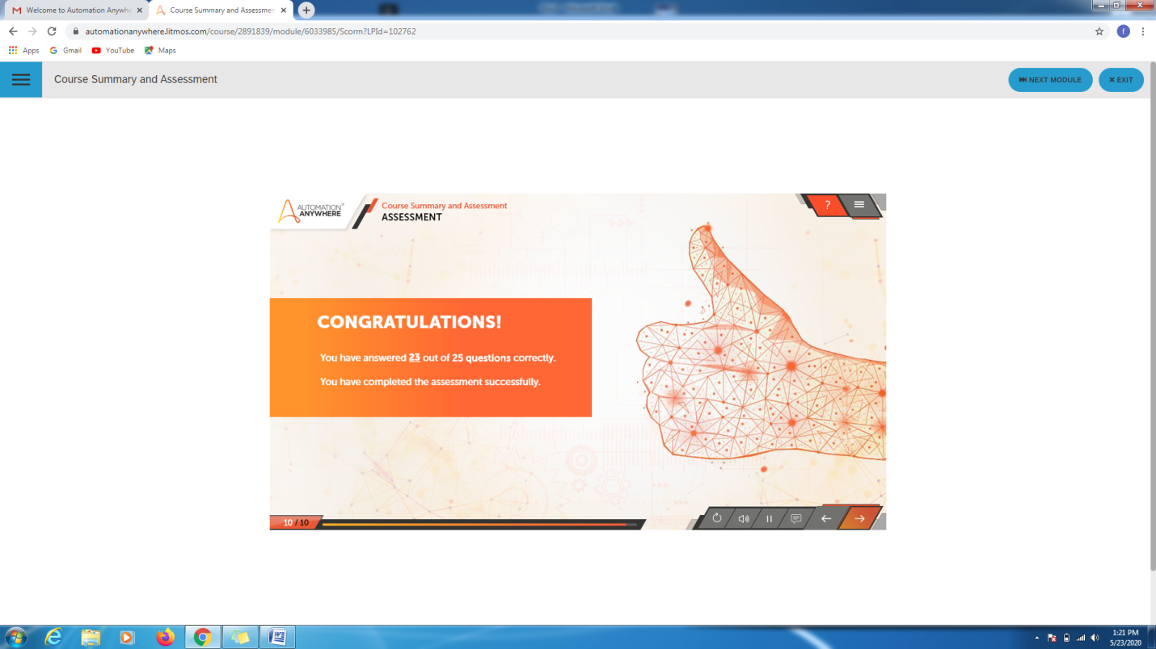

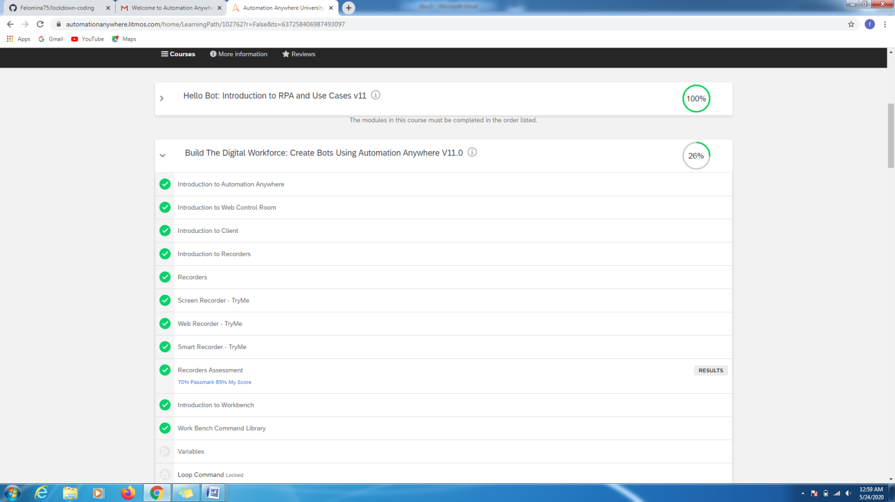

CODING CHALLENGES DETAILS:

Problem statement 1:

Write a C Program to generate first N Triangular Numbers (Where N is Read from the Key board).

Solution : Uploaded it in github

