**DAILY ONLINE ACTIVITIES SUMMARY**

|  |  |  |  |  |  |  |  |  |
| --- | --- | --- | --- | --- | --- | --- | --- | --- |
| **Date:** | **24/06/2020** | | | | | **Name:** | **Felomina Jancy** | |
| **Sem & Sec** | **4th SEM 'A' Section** | | | | | **USN:** | **4AL18CS022** | |
| **Online Test Summary** | | | | | | | | |
| **Subject** | | - | | | | | | |
| **Max. Marks** | | **-** | | **Score** | | | **-** | |
| **Certification Course Summary** | | | | | | | | |
| **Course** | **Network visualization concepts** | | | | | | | |
| **Certificate Provider** | | | **ICT Academy** | | **Duration** | | | **3 hours** |
| **Coding Challenges** | | | | | | | | |
| **Problem Statement:** Write a python Program to Split the array and add the first part to the end There is a given an array and split it from a specified position, and move the first part of array add to the end. | | | | | | | | |
| **Status: completed** | | | | | | | | |
| **Uploaded the report in Github** | | | | | **yes** | | | |
| **If yes Repository name** | | | | | **https://github.com/Felomina75/lockdown-coding.git** | | | |
| **Uploaded the report in slack** | | | | | **yes** | | | |

Online Test Details: (Attach the snapshot and briefly write the report for the same)

Certification Course Details: (Attach the snapshot and briefly write the report for the same)

Coding Challenges Details: (Attach the snapshot and briefly write the report for the same)

ONLINE TEST DETAILS:

No test.

CERTIFICATION COURSE DETAILS:

* I took a new course of "Network Visualization concepts" organized by ICT Academy.
* It consists 6 modules and I was able to complete first module and a half of second module.
* The concepts covered are:
* Introduction to Network visualization
* What is network visualization
* What is software-defined networking
* Virtual networks in physical networks

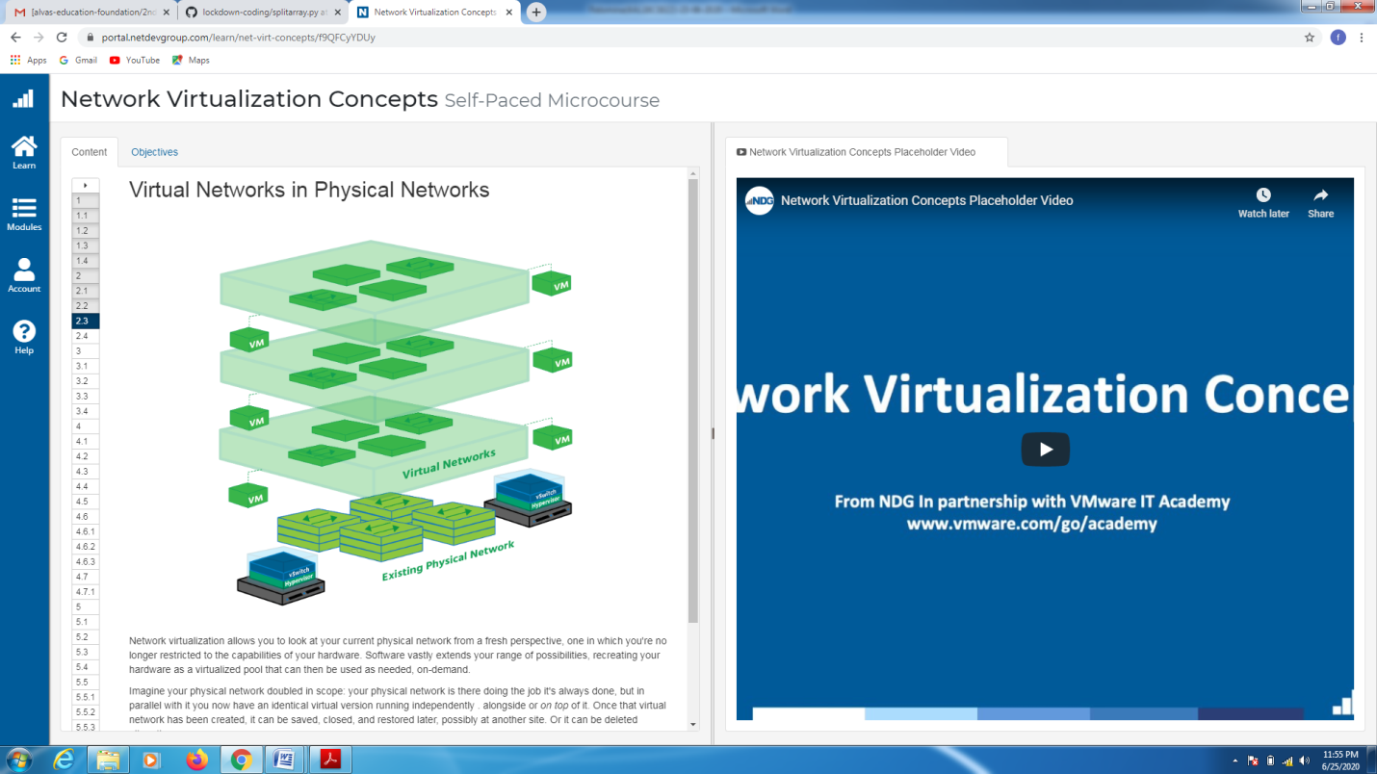CODING CHALLENGES DETAILS:

Problem statement:

Write a python Program to Split the array and add the first part to the end There is a given an array and split it from a specified position, and move the first part of array add to the end.

Solution : Uploaded it in github

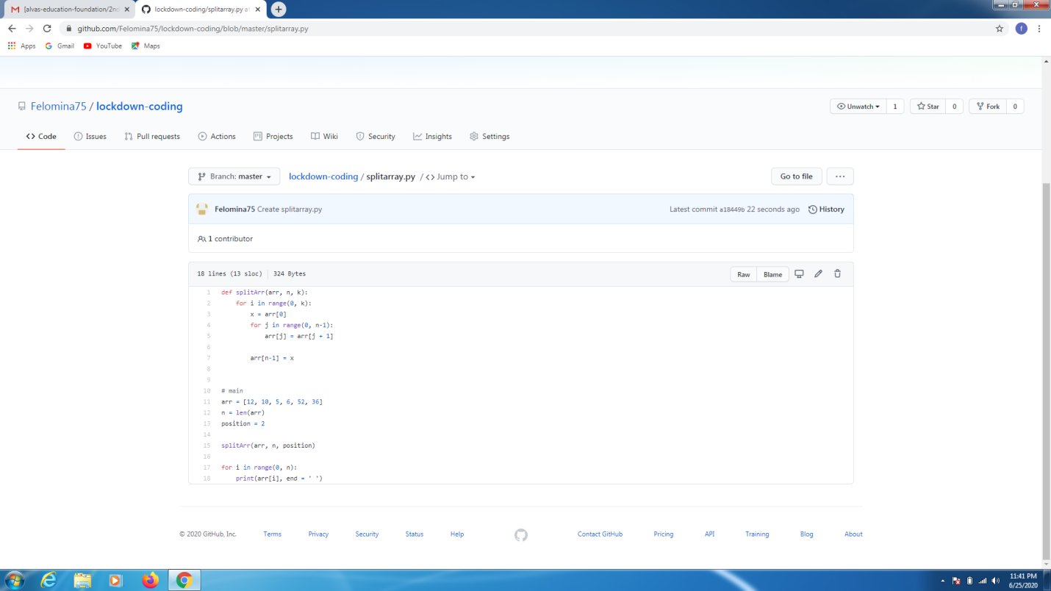

EXTRA ACTIVITIES:

We had a webinar on General talk Introduction, data types, input and output, operators and a quiz by Ms.Megha D.Hegde. I scored 12/15 in the quiz.

