**DAILY ONLINE ACTIVITIES SUMMARY**

|  |  |  |  |  |  |  |  |  |
| --- | --- | --- | --- | --- | --- | --- | --- | --- |
| **Date:** | **26/05/2020** | | | | | **Name:** | **Felomina Jancy** | |
| **Sem & Sec** | **4th SEM 'A' Section** | | | | | **USN:** | **4AL18CS022** | |
| **Online Test Summary** | | | | | | | | |
| **Subject** | | Design and Analysis of Algorithms | | | | | | |
| **Max. Marks** | | **30** | | **Score** | | | **26** | |
| **Certification Course Summary** | | | | | | | | |
| **Course** | **Automation Anywhere** | | | | | | | |
| **Certificate Provider** | | | **ICT Academy** | | **Duration** | | | **2 hours** |
| **Coding Challenges** | | | | | | | | |
| **Problem Statement:** 1. Number of permutations of a given string  2. Number of sub-arrays of the given type | | | | | | | | |
| **Status: completed** | | | | | | | | |
| **Uploaded the report in Github** | | | | | **yes** | | | |
| **If yes Repository name** | | | | | **https://github.com/Felomina75/lockdown-coding.git** | | | |
| **Uploaded the report in slack** | | | | | **yes** | | | |

Online Test Details: (Attach the snapshot and briefly write the report for the same)

Certification Course Details: (Attach the snapshot and briefly write the report for the same)

Coding Challenges Details: (Attach the snapshot and briefly write the report for the same)

ONLINE TEST DETAILS:

The online test was from module 2 which was about divide and conquer algorithms and decrease and conquer algorithms. There were 30 questions and the duration was 45 minutes. The questions were optimal and were easy. The score that I got in the test is 26/30.

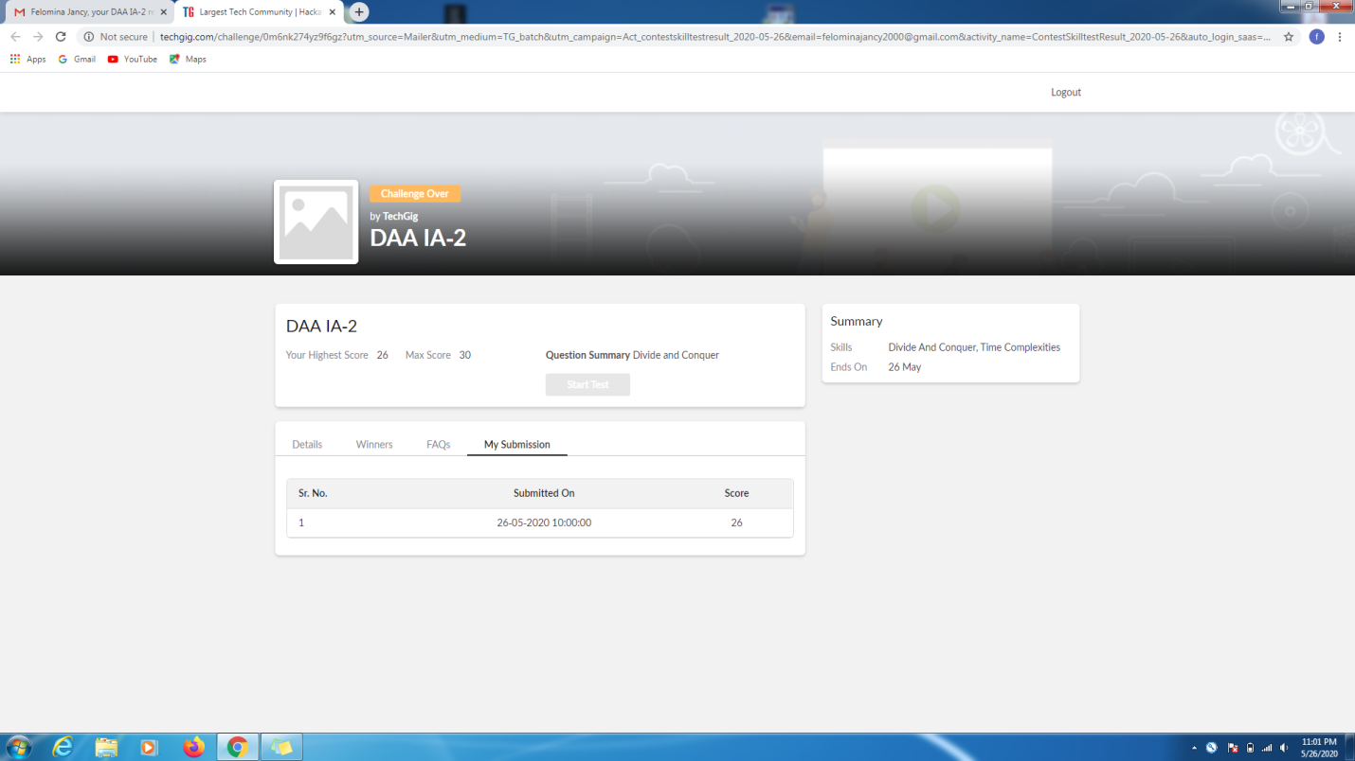.

CERTIFICATION COURSE DETAILS:

* I was able to do second module, only some sub-modules of the course of "Automation Anywhere" organized by ICT Academy .
* The topics included were :
* Variables
* Types of variables
* Variable manager
* Variable operation command

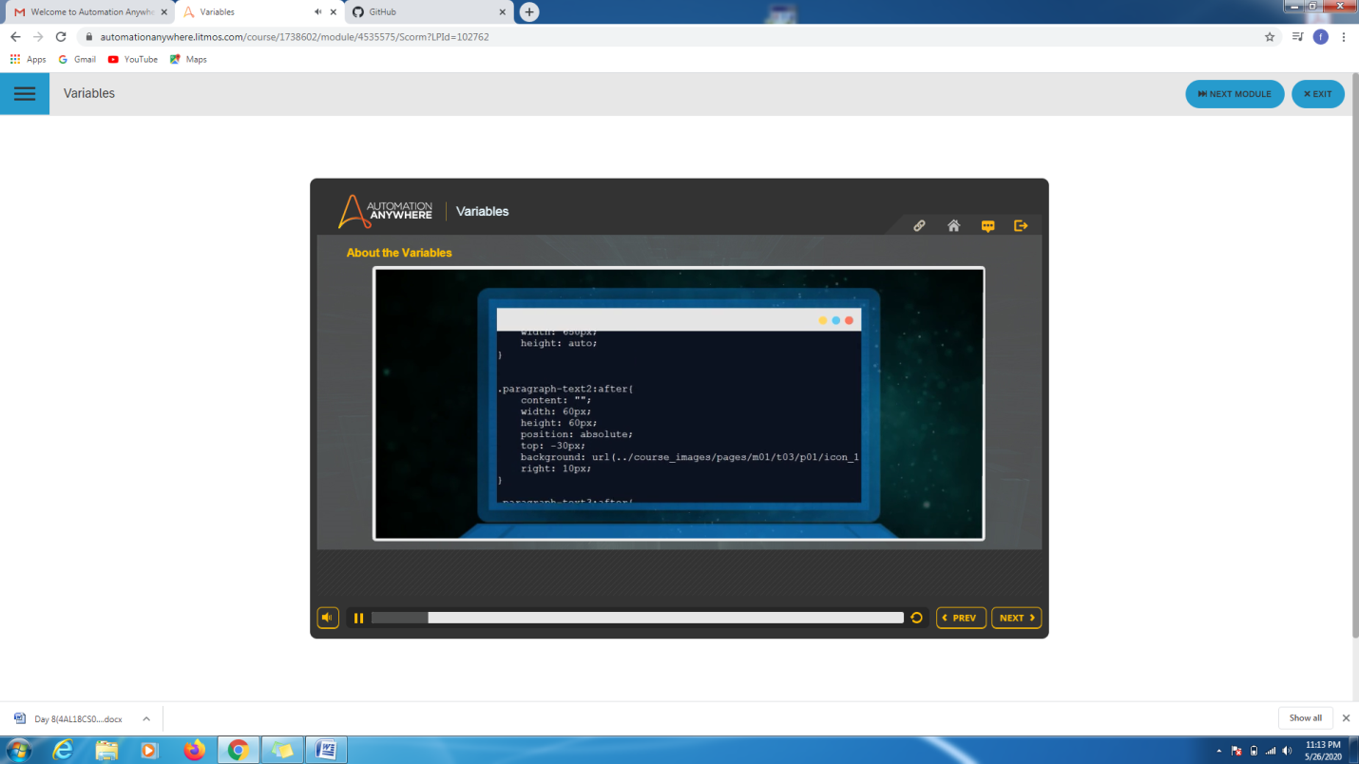

CODING CHALLENGES DETAILS:

Problem statement 1:

Write a C program to print all permutations of a given string using pointers

Solution : Uploaded it in github

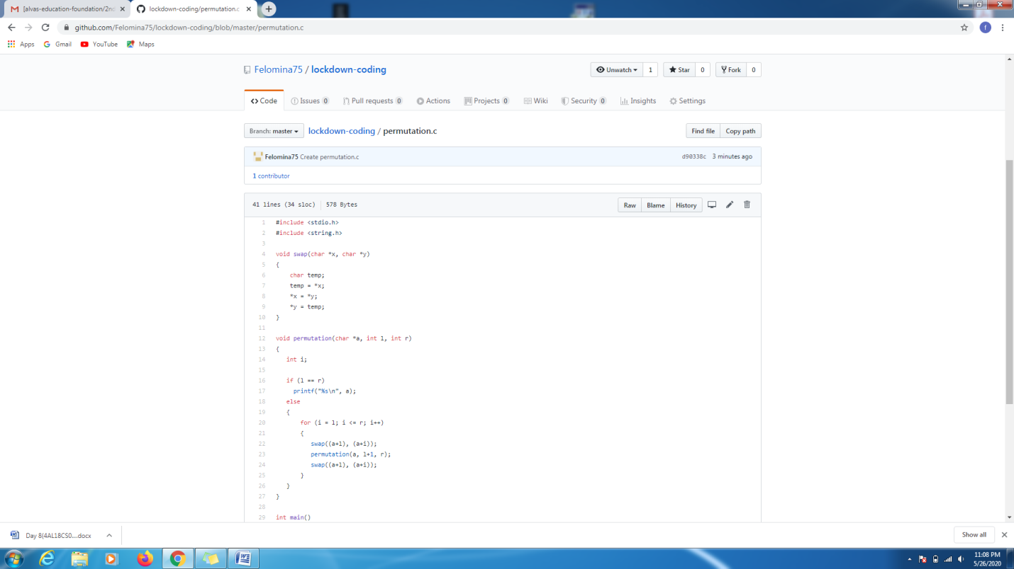

Problem statement 2:

Write a java program [Given an array A of size N where the array elements contain values from 1 to N with duplicates, the task is to find total number of sub-arrays which start and end with the same element.](https://github.com/orgs/alvas-education-foundation/teams/2nd-year/discussions/80)

Solution: Uploaded in github.

