**DAILY ONLINE ACTIVITIES SUMMARY**

|  |  |  |  |  |  |  |  |  |
| --- | --- | --- | --- | --- | --- | --- | --- | --- |
| **Date:** | **27/06/2020** | | | | | **Name:** | **Felomina Jancy** | |
| **Sem & Sec** | **4th SEM 'A' Section** | | | | | **USN:** | **4AL18CS022** | |
| **Online Test Summary** | | | | | | | | |
| **Subject** | | Data communication | | | | | | |
| **Max. Marks** | | **30** | | **Score** | | | **28** | |
| **Certification Course Summary** | | | | | | | | |
| **Course** | **Network visualization concepts** | | | | | | | |
| **Certificate Provider** | | | **ICT Academy** | | **Duration** | | | **3 hours** |
| **Coding Challenges** | | | | | | | | |
| **Problem Statement: Write a C Program to generate nth Magic Numbers.** | | | | | | | | |
| **Status: completed** | | | | | | | | |
| **Uploaded the report in Github** | | | | | **yes** | | | |
| **If yes Repository name** | | | | | **https://github.com/Felomina75/lockdown-coding.git** | | | |
| **Uploaded the report in slack** | | | | | **yes** | | | |

Online Test Details: (Attach the snapshot and briefly write the report for the same)

Certification Course Details: (Attach the snapshot and briefly write the report for the same)

Coding Challenges Details: (Attach the snapshot and briefly write the report for the same)

ONLINE TEST DETAILS:

The portion for the online test was 5th module which was about wired LAN Ethernet, wireless LAN and other wireless networks. There were 30 questions and the time limit was 30 minutes . The questions were easy . The marks which I scored was 28/30.

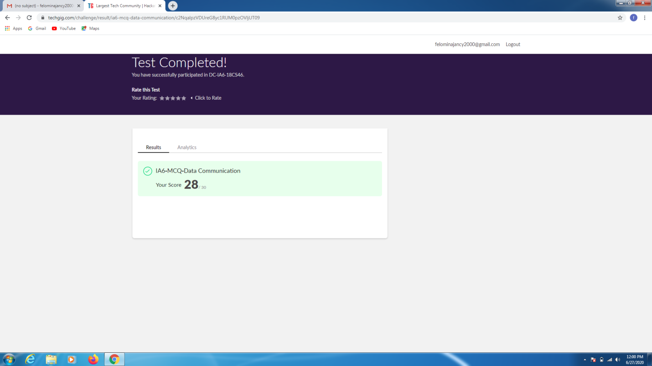CERTIFICATION COURSE DETAILS:

* As a continuation of the course ,I was able to complete fourth and a part of fifth module .
* The concepts covered are:
* Edge routing and NAT
* Load balancing
* L2/L3 VPN
* NSX logical firewall
* key components

CODING CHALLENGES DETAILS:

Problem statement:

**Write a C Program to generate nth Magic Numbers.**

Solution : Uploaded it in github

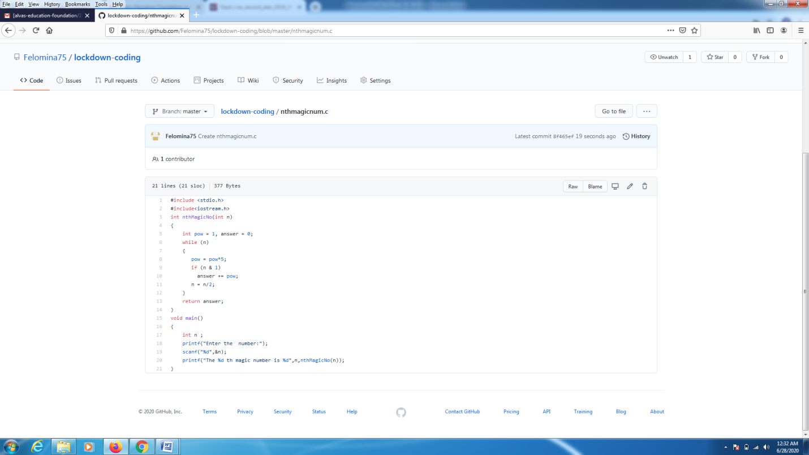

EXTRA ACTIVITIES:

We had a webinar on Loops, conditional statements and array and also a quiz by Ms.Megha D Hegde. I scored 13/15 in the quiz

