**DAILY ONLINE ACTIVITIES SUMMARY**

|  |  |  |  |  |  |  |  |  |
| --- | --- | --- | --- | --- | --- | --- | --- | --- |
| **Date:** | **27/05/2020** | | | | | **Name:** | **Felomina Jancy** | |
| **Sem & Sec** | **4th SEM 'A' Section** | | | | | **USN:** | **4AL18CS022** | |
| **Online Test Summary** | | | | | | | | |
| **Subject** | | **Object Oriented Concepts(18CS45)** | | | | | | |
| **Max. Marks** | | **30** | | **Score** | | | **29** | |
| **Certification Course Summary** | | | | | | | | |
| **Course** | **1. IoT Wireless and Cloud Computing Emerging Technologies**  **2.Cybersecurity Webinar** | | | | | | | |
| **Certificate Provider** | | | **1. Coursera**  **2. IEE RITB** | | **Duration** | | | **1. 2 hours**  **2. 1.5 hour** |
| **Coding Challenges** | | | | | | | | |
| **Problem Statement:1.**Python Program to Check if a Number is a Palindrome  2.Write a C program to perform bubble sort | | | | | | | | |
| **Status: Completed** | | | | | | | | |
| **Uploaded the report in Github** | | | | | **yes** | | | |
| **If yes Repository name** | | | | | **https://github.com/Felomina75/lockdown-coding.git** | | | |
| **Uploaded the report in slack** | | | | | **yes** | | | |

Online Test Details: (Attach the snapshot and briefly write the report for the same)

Certification Course Details: (Attach the snapshot and briefly write the report for the same)

Coding Challenges Details: (Attach the snapshot and briefly write the report for the same)

ONLINE TEST DETAILS:

The online test was from module 5 . The module comprises of the introduction to applets, swings and about different event handling topics in JAVA. There were 30 questions and the duration was 30 minutes. The questions were optimal and were easy. The score that I got in the test is 29/30.

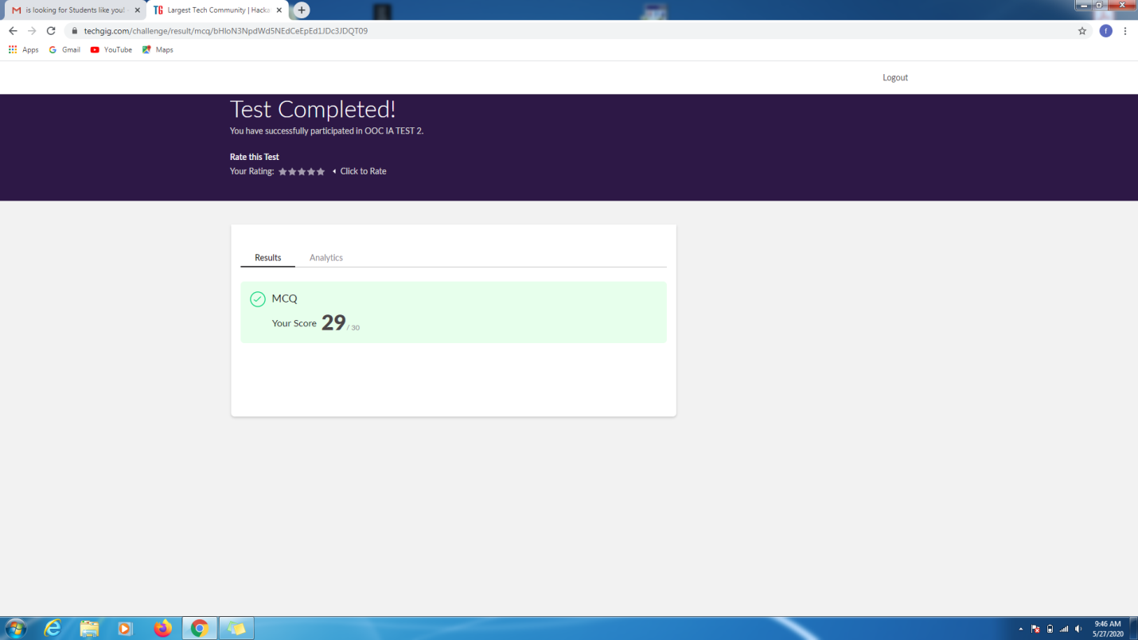

CERTIFICATION COURSE DETAILS:

* I was able to start week 3 course and complete 7 videos.
* Concepts covered were:
* 3.1. IoT wireless networks
* 3.2. ISM Band
* 3.3. IoT WPAN's
* 3.4. IoT LPWAN's

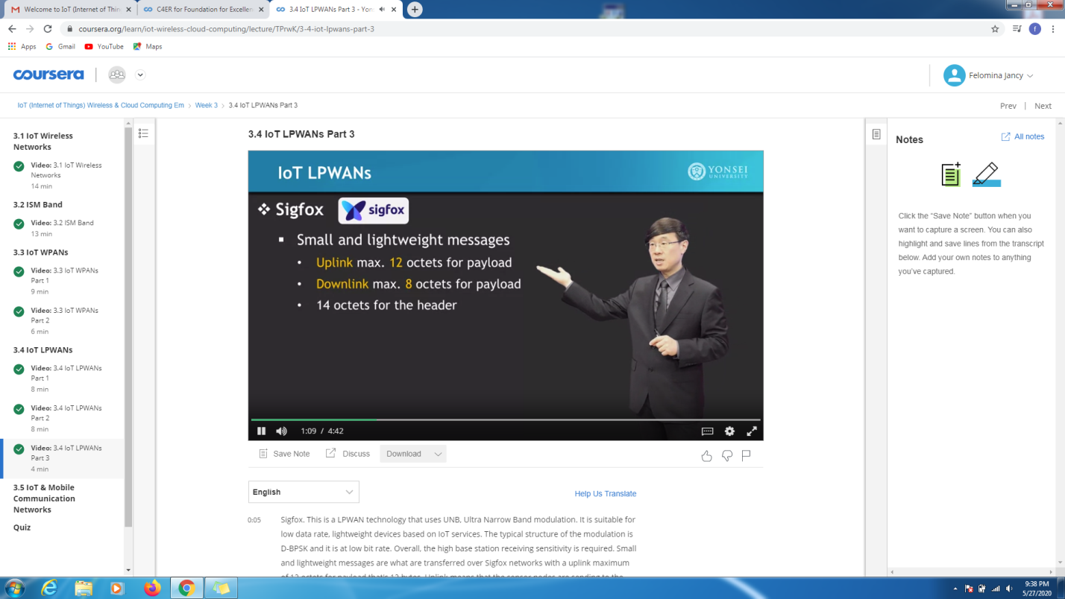

* Also gained a certificate of cybersecurity webinar organized by IEEE RITB in association with Internet Society Cybersecurity SIG and Internet Society Development SIG.

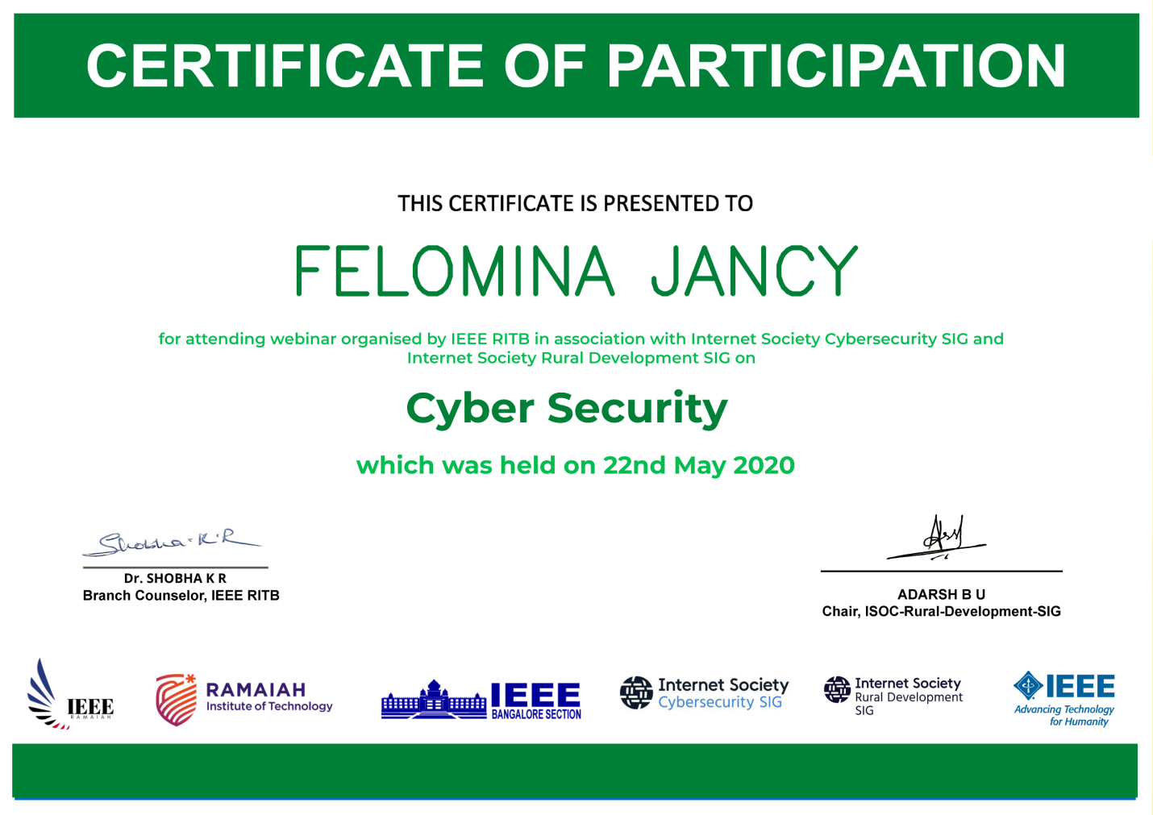

CODING CHALLENGES DETAILS:

Problem statement 1: Python Program to Check if a Number is a Palindrome

**Solution: Uploaded in github.**

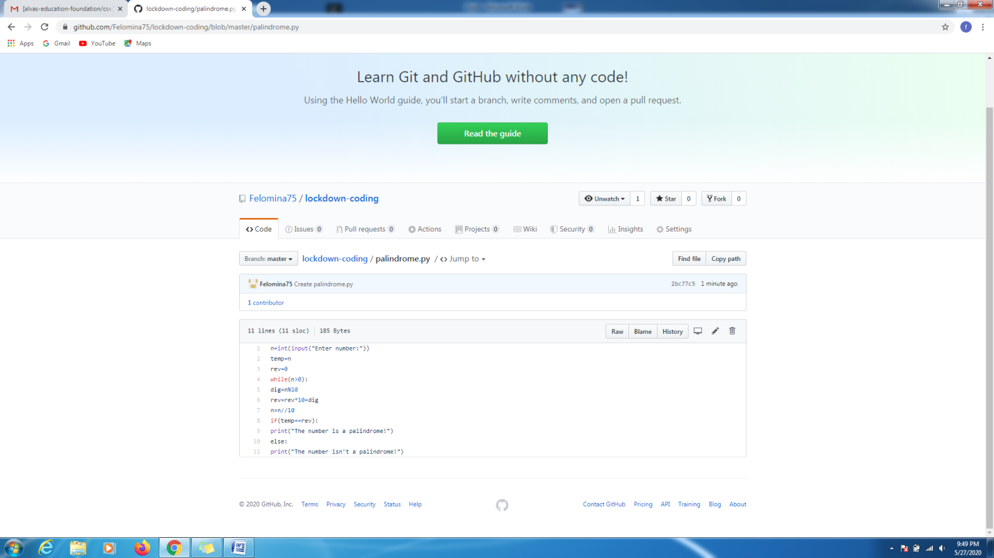

**Problem statement 2:**

Write a C program to perform bubble sort

Solution : Uploaded in github.

