**DAILY ONLINE ACTIVITIES SUMMARY**

|  |  |  |  |  |  |  |  |  |
| --- | --- | --- | --- | --- | --- | --- | --- | --- |
| **Date:** | **28/06/2020** | | | | | **Name:** | **Felomina Jancy** | |
| **Sem & Sec** | **4th SEM 'A' Section** | | | | | **USN:** | **4AL18CS022** | |
| **Online Test Summary** | | | | | | | | |
| **Subject** | | - | | | | | | |
| **Max. Marks** | | **-** | | **Score** | | | **-** | |
| **Certification Course Summary** | | | | | | | | |
| **Course** | **Network visualization concepts** | | | | | | | |
| **Certificate Provider** | | | **ICT Academy** | | **Duration** | | | **3 hours** |
| **Coding Challenges** | | | | | | | | |
| **Problem Statement: Write a Python program to count the number of odd and even numbers in a given list.** | | | | | | | | |
| **Status: completed** | | | | | | | | |
| **Uploaded the report in Github** | | | | | **yes** | | | |
| **If yes Repository name** | | | | | **https://github.com/Felomina75/lockdown-coding.git** | | | |
| **Uploaded the report in slack** | | | | | **yes** | | | |

Online Test Details: (Attach the snapshot and briefly write the report for the same)

Certification Course Details: (Attach the snapshot and briefly write the report for the same)

Coding Challenges Details: (Attach the snapshot and briefly write the report for the same)

ONLINE TEST DETAILS:

No test.

CERTIFICATION COURSE DETAILS:

* As a continuation of the course ,I was able to complete fifth and sixth module . Hence completed the course and earned a badge.
* The concepts covered are:
* Key benefits
* Integrating with existing infrastructure
* NSX architecture
* Management plane
* Control plane
* Data plane
* Security features
* Micro-segmentation
* Secure end-user

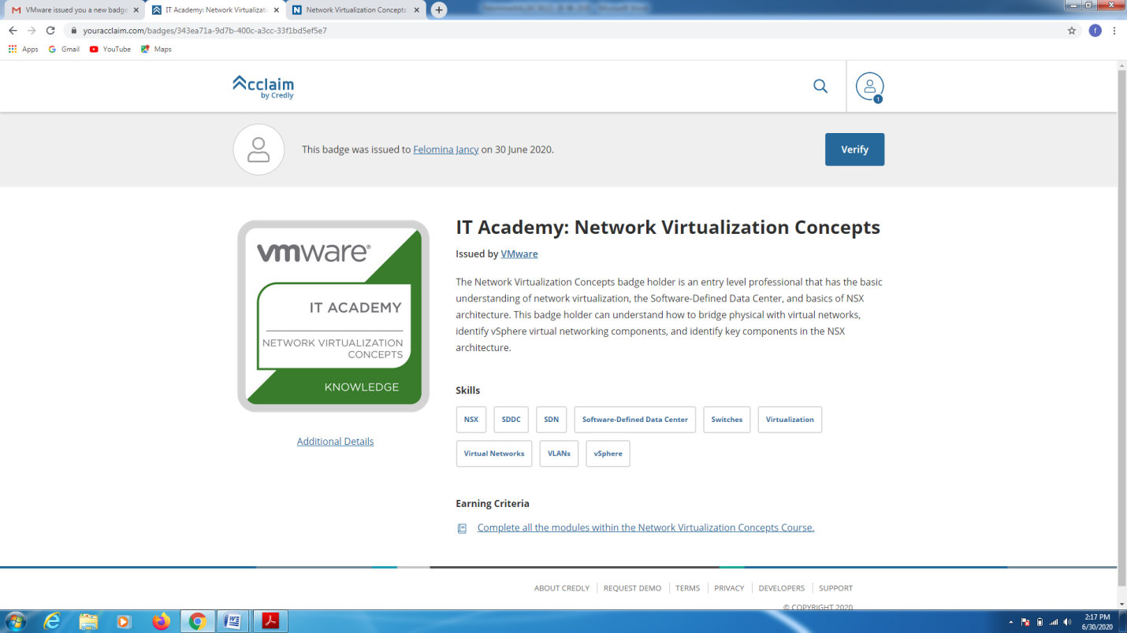CODING CHALLENGES DETAILS:

Problem statement:

**Write a Python program to count the number of odd and even numbers in a given list.**

Solution : Uploaded it in github

