**DAILY ONLINE ACTIVITIES SUMMARY**

|  |  |  |  |  |  |  |  |  |
| --- | --- | --- | --- | --- | --- | --- | --- | --- |
| **Date:** | **28/05/2020** | | | | | **Name:** | **Felomina Jancy** | |
| **Sem & Sec** | **4th SEM 'A' Section** | | | | | **USN:** | **4AL18CS022** | |
| **Online Test Summary** | | | | | | | | |
| **Subject** | | **1.** Microcontroller and Embedded Systems  2. Aadalitha Kannada | | | | | | |
| **Max. Marks** | | **1. 20**  **2. 50** | | **Score** | | | **1. 19**  **2. 40** | |
| **Certification Course Summary** | | | | | | | | |
| **Course** | **Automation Anywhere** | | | | | | | |
| **Certificate Provider** | | | **ICT Academy** | | **Duration** | | | **3 hours** |
| **Coding Challenges** | | | | | | | | |
| **Problem Statement:1.** Pink Floyd happiness  **2.** Digital root of a number | | | | | | | | |
| **Status: completed** | | | | | | | | |
| **Uploaded the report in Github** | | | | | **yes** | | | |
| **If yes Repository name** | | | | | **https://github.com/Felomina75/lockdown-coding.git** | | | |
| **Uploaded the report in slack** | | | | | **yes** | | | |

Online Test Details: (Attach the snapshot and briefly write the report for the same)

Certification Course Details: (Attach the snapshot and briefly write the report for the same)

Coding Challenges Details: (Attach the snapshot and briefly write the report for the same)

ONLINE TEST DETAILS:

1. **MES :**The portion for the test was module 2 which is about the introduction to ARM instruction set and ARM programming using assembly language. There were 20 questions and the duration was 40 minutes. The questions were optimal and were easy. The score that I got in the test is 19/20.
2. **Aadalitha Kannada:** The portion for the test was all 10 chapters. All were objective type questions and were optimal. There were 50 questions and the duration was 50 minutes. The score that I got is 40/50

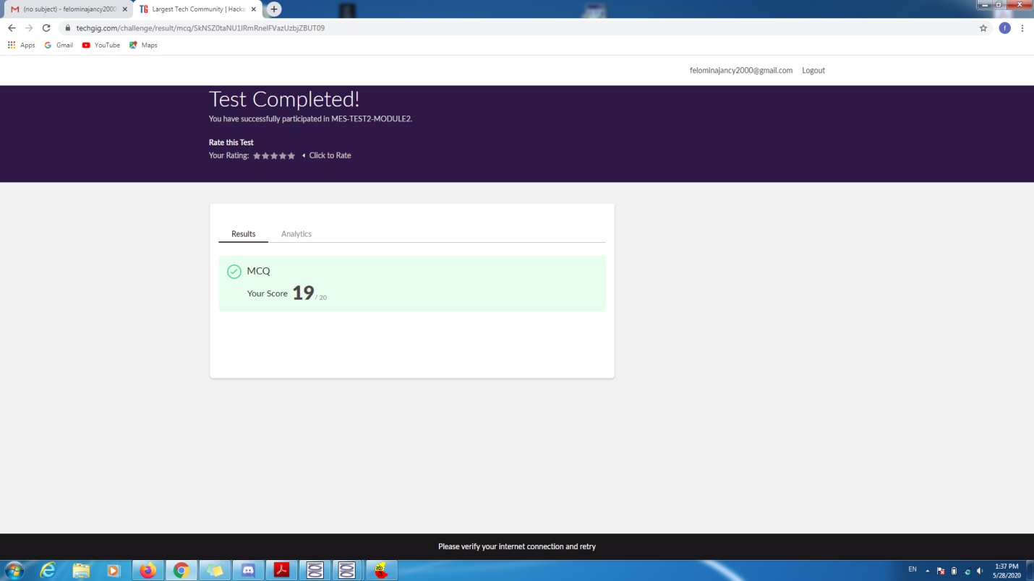

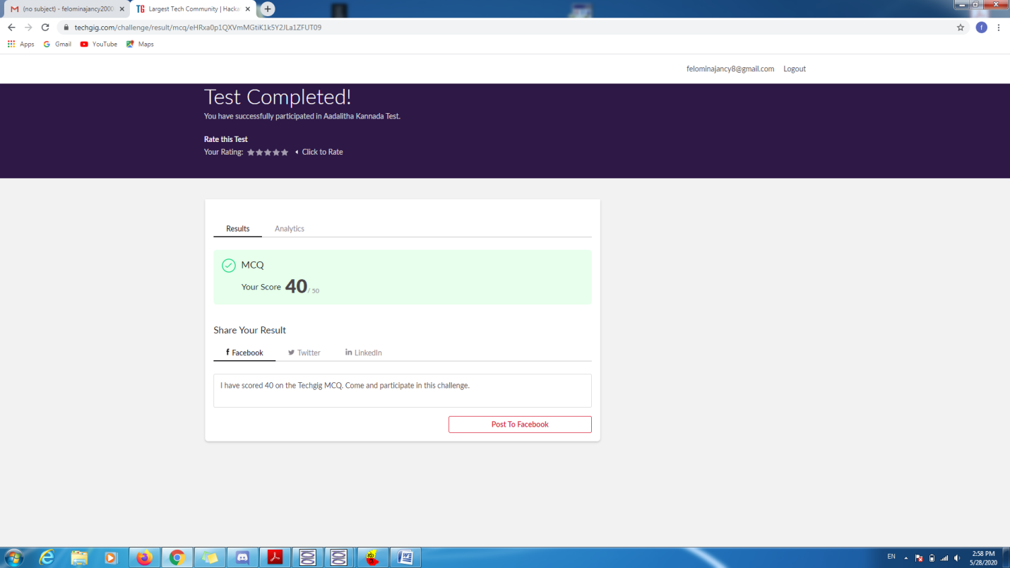

CERTIFICATION COURSE DETAILS:

* Today I started with the "Automation Anywhere " course organized by ICT Academy. In the module 2 there are several modules . Out of those sub-modules , I was able to cover some topics .
* The topics are :
* Loop command
* Image recognition command
* Insert work item command
* Error handling command
* Manage web control command

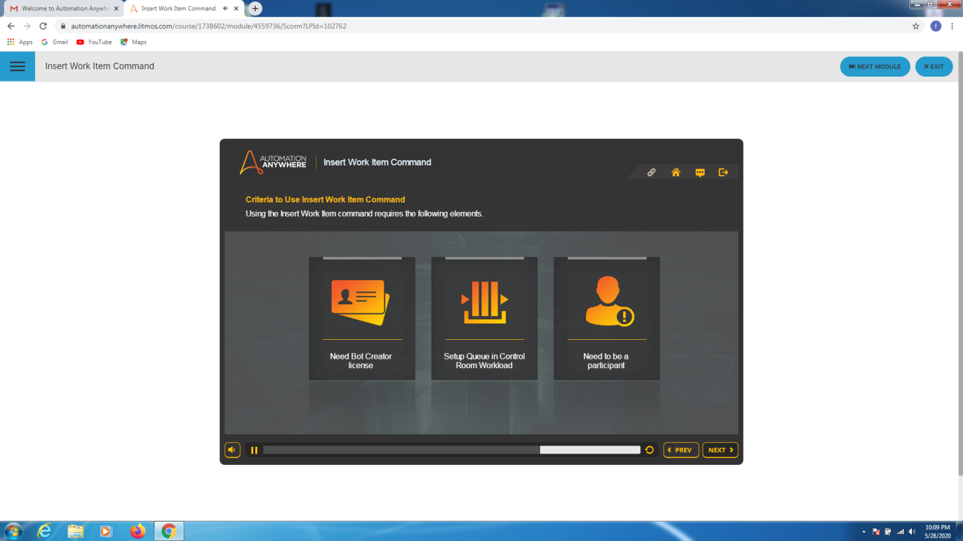

CODING CHALLENGES DETAILS:

Problem statement 1:

Pink is sad because of some reasons, he wants to cheer up by listening to some songs from his favorite band, Pink Floyd.

There are N records and Pink will be happy if he listens to them in the ascending order, i.e, first the song No. 1, then No.2 and so on(He has to listen to all the N songs to become Happy).

Pink is delivered his records in some given order, he can either add the record to the Playlist in the delivered order or put some on an another table. After being put on the table only the topmost record can be added to the playlist at any time.

Print whether Pink will be sad or happy after the delivery of the records.

**INPUT**

N - Number of records followed  by

N numbers- order of records

**OUTPUT**

Print "Happy" if the playlist has songs from 1 to N in order else "Sad".

**CONSTRAINTS**

1<=N<=10^5

The array consists of 1-N distinct numbers.

Solution : Uploaded it in github

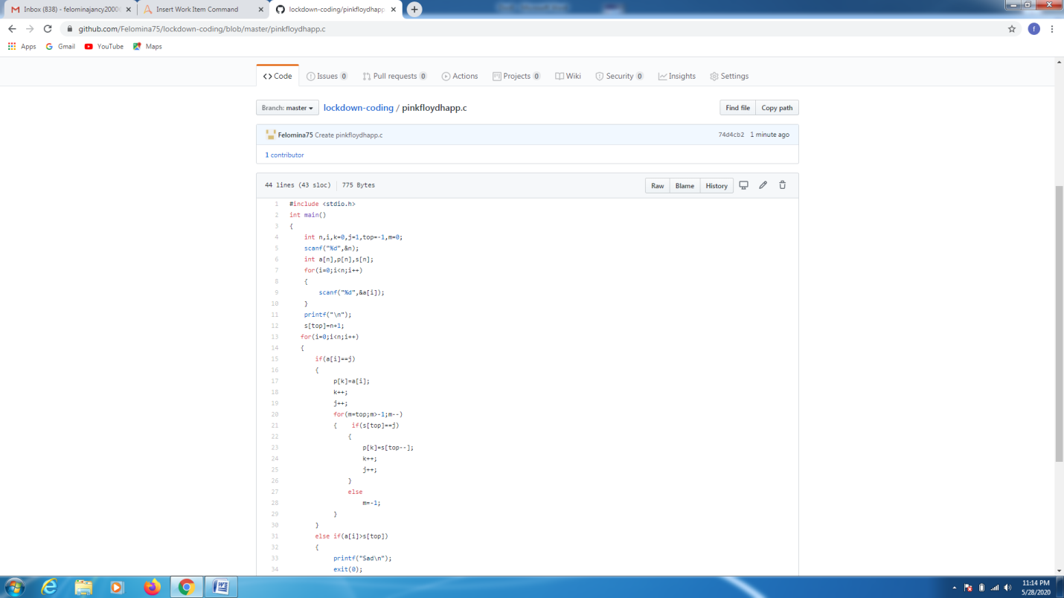

Problem statement 2:

Write a program to print the digital root of a number.

Solution: Uploaded in github.

