**DAILY ONLINE ACTIVITIES SUMMARY**

|  |  |  |  |  |  |  |  |  |
| --- | --- | --- | --- | --- | --- | --- | --- | --- |
| **Date:** | **29/05/2020** | | | | | **Name:** | **Felomina Jancy** | |
| **Sem & Sec** | **4th SEM 'A' Section** | | | | | **USN:** | **4AL18CS022** | |
| **Online Test Summary** | | | | | | | | |
| **Subject** | | Operating System(18CS43) | | | | | | |
| **Max. Marks** | | **30** | | **Score** | | | **28** | |
| **Certification Course Summary** | | | | | | | | |
| **Course** | **Automation Anywhere** | | | | | | | |
| **Certificate Provider** | | | **ICT Academy** | | **Duration** | | | **3 hours** |
| **Coding Challenges** | | | | | | | | |
| **Problem Statement:**1..Write a C Program to generate first N Armstrong Numbers  **2.**Write a Java program to Find size of the largest ‘+’ formed by all ones in a binary matrix | | | | | | | | |
| **Status: completed** | | | | | | | | |
| **Uploaded the report in Github** | | | | | **yes** | | | |
| **If yes Repository name** | | | | | **https://github.com/Felomina75/lockdown-coding.git** | | | |
| **Uploaded the report in slack** | | | | | **yes** | | | |

Online Test Details: (Attach the snapshot and briefly write the report for the same)

Certification Course Details: (Attach the snapshot and briefly write the report for the same)

Coding Challenges Details: (Attach the snapshot and briefly write the report for the same)

ONLINE TEST DETAILS:

The portion for the test was from module 2 which was about Multi-threaded Programming. There were 30 questions and the duration was 45 minutes. The questions were optimal and were easy. The score that I got in the test is 28/30.

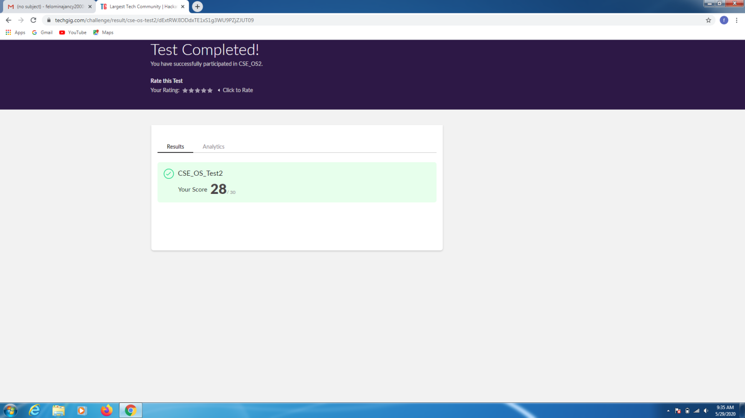

CERTIFICATION COURSE DETAILS:

* Today I started with the "Automation Anywhere " course organized by ICT Academy. In the module 2 there are several modules . Out of those sub-modules , I was able to cover some topics .
* The topics are :
* Log to file command
* If/Else command
* Manage Windows control command
* File / Folder command
* Object cloning command
* Insert keystroke command

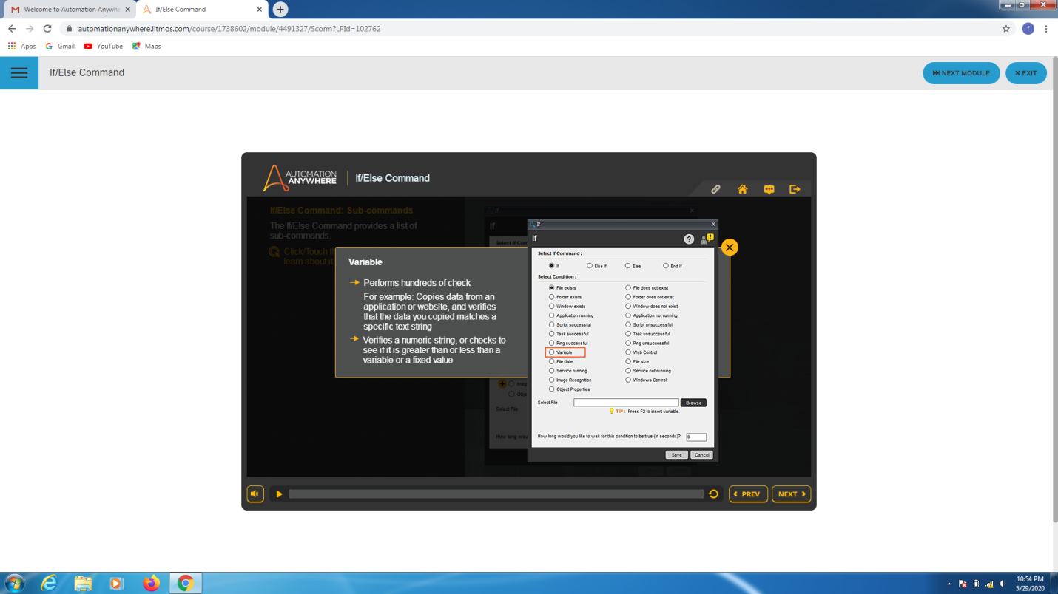

CODING CHALLENGES DETAILS:

Problem statement 1:

Write a C Program to generate first N Armstrong Numbers.

Solution : Uploaded it in github

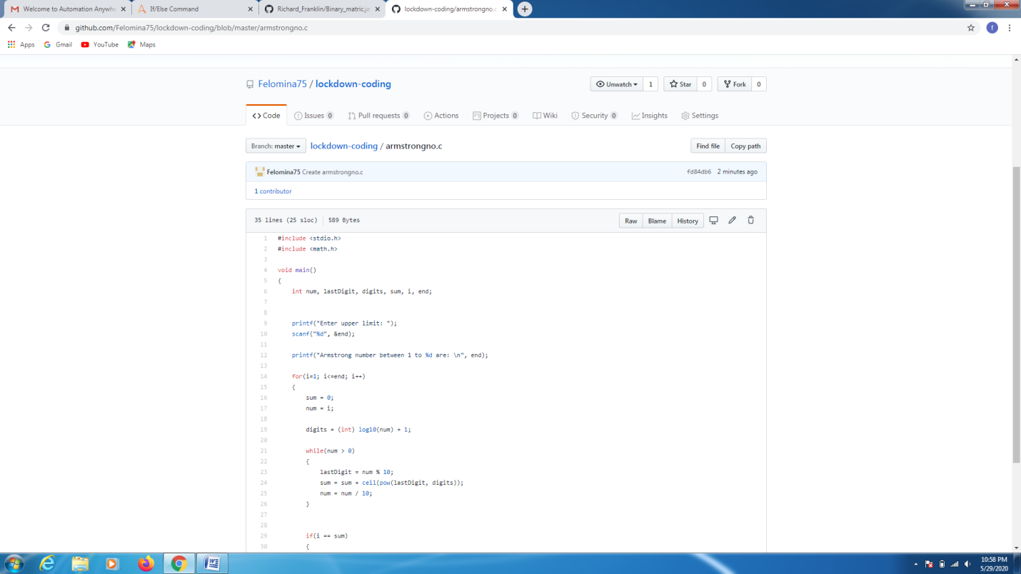

Problem statement 2:

Write a Java program to Find size of the largest ‘+’ formed by all ones in a binary matrix.

Solution: Uploaded in github.

