**DAILY ONLINE ACTIVITIES SUMMARY**

|  |  |  |  |  |  |  |  |  |
| --- | --- | --- | --- | --- | --- | --- | --- | --- |
| **Date:** | **30/06/2020** | | | | | **Name:** | **Felomina Jancy** | |
| **Sem & Sec** | **4th SEM 'A' Section** | | | | | **USN:** | **4AL18CS022** | |
| **Online Test Summary** | | | | | | | | |
| **Subject** | | - | | | | | | |
| **Max. Marks** | | **-** | | **Score** | | | **-** | |
| **Certification Course Summary** | | | | | | | | |
| **Course** | **IoT Wireless and Cloud Computing Emerging Technologies** | | | | | | | |
| **Certificate Provider** | | | **Coursera** | | **Duration** | | | **3 hours** |
| **Coding Challenges** | | | | | | | | |
| **Problem Statement:** Write a C Program to generate first n ugly numbers. | | | | | | | | |
| **Status: completed** | | | | | | | | |
| **Uploaded the report in Github** | | | | | **yes** | | | |
| **If yes Repository name** | | | | | **https://github.com/Felomina75/lockdown-coding.git** | | | |
| **Uploaded the report in slack** | | | | | **yes** | | | |

Online Test Details: (Attach the snapshot and briefly write the report for the same)

Certification Course Details: (Attach the snapshot and briefly write the report for the same)

Coding Challenges Details: (Attach the snapshot and briefly write the report for the same)

ONLINE TEST DETAILS:

No test.

CERTIFICATION COURSE DETAILS:

* As a continuation of the course " **IoT Wireless and Cloud Computing Emerging Technologies" by Coursera , I was able to do week 5.**
* **The concepts covered are:**
* **Cloud market analysis**
* **Top cloud companies and services**
* **AWS**
* **IBM**
* **Google**
* **Clouds**
* **IaaS, PaaS, SaaS**
* **Edge computing, Fog computing, MEC, Cloudnet**

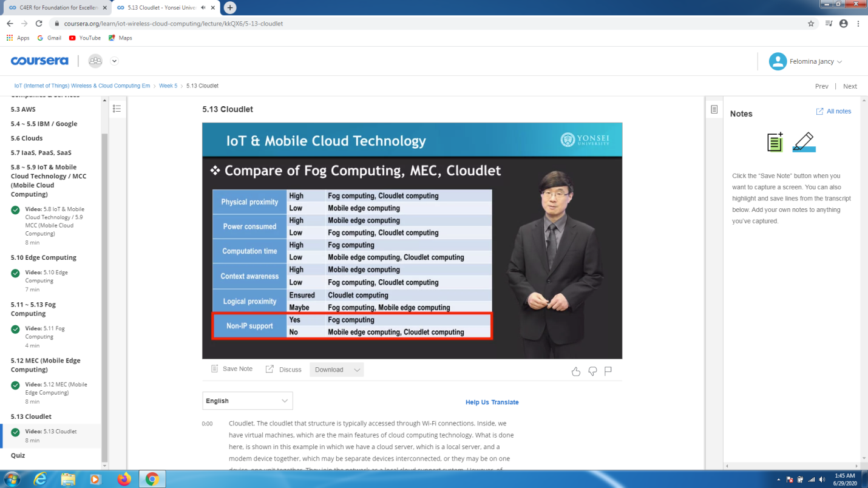

* Also completed the graded and ungraded quiz of week 5.

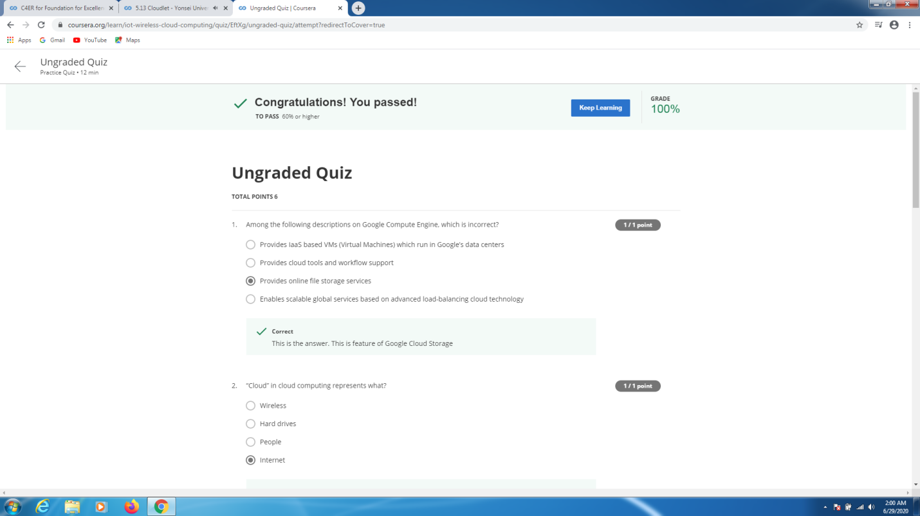 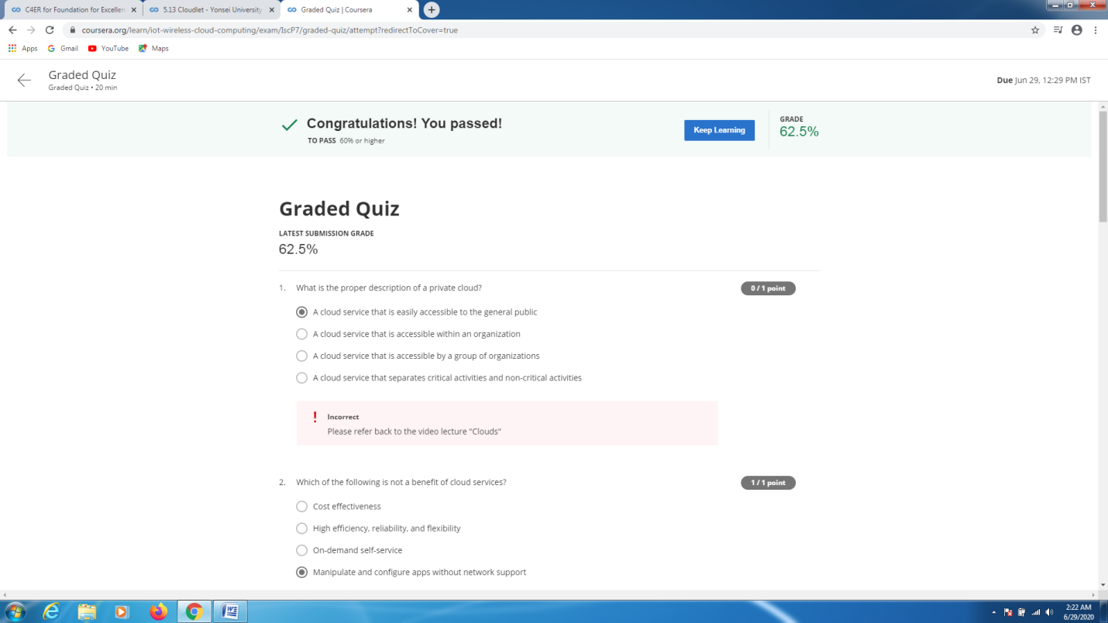CODING CHALLENGES DETAILS:

Problem statement:

Write a C Program to generate first n ugly numbers.

Solution : Uploaded it in github

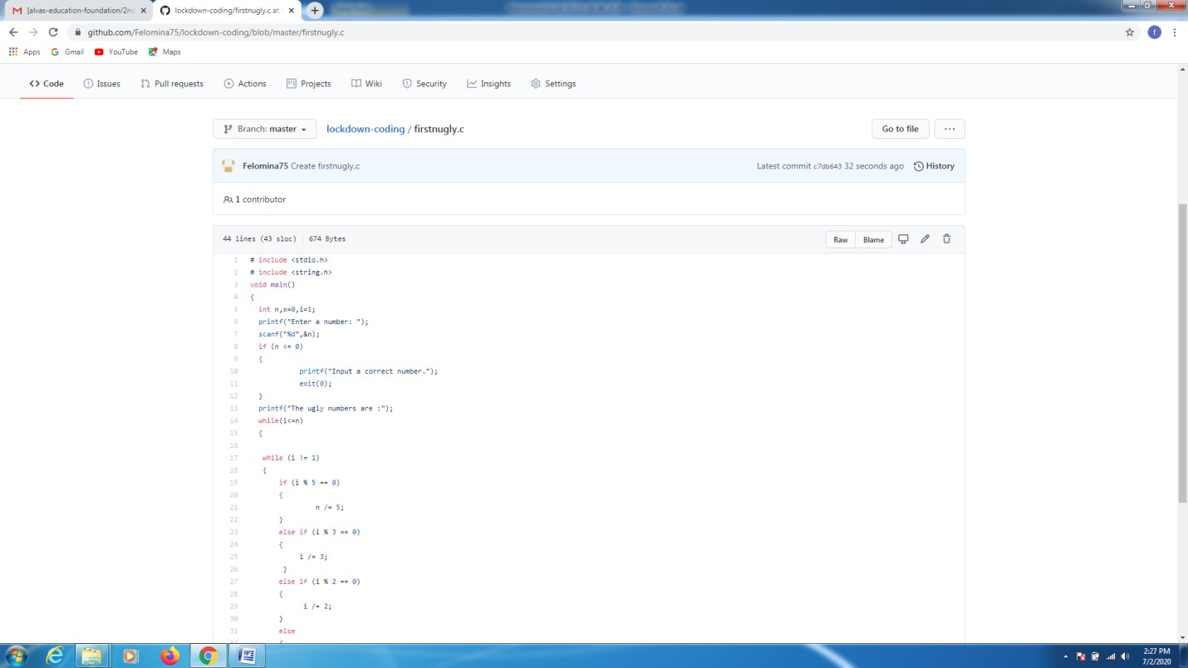

EXTRA ACTIVITIES:

I attended a webinar on "Input, Output in C++, Syntax and structure of C++ program , class and object, static member function and member data " by Ms. Shruthi Shetty J . At the end of the session there was a quiz . I was able to score 30/30 in the quiz.

