**DAILY ONLINE ACTIVITIES SUMMARY**

|  |  |  |  |  |  |  |  |  |
| --- | --- | --- | --- | --- | --- | --- | --- | --- |
| **Date:** | **30/05/2020** | | | | | **Name:** | **Felomina Jancy** | |
| **Sem & Sec** | **4th SEM 'A' Section** | | | | | **USN:** | **4AL18CS022** | |
| **Online Test Summary** | | | | | | | | |
| **Subject** | | **1.Data Communication**  **2.** **Complex analysis, probability and statistical methods(18MAT** | | | | | | |
| **Max. Marks** | | **1.30**  **2.30** | | **Score** | | | **1. 28**  **2. 30** | |
| **Certification Course Summary** | | | | | | | | |
| **Course** | **1. IoT Wireless and Cloud Computing Emerging Technologies**  **2. STEPATHON** | | | | | | | |
| **Certificate Provider** | | | **1. Coursera**  **2. ICT Academy** | | **Duration** | | | **1. 1 hour**  **2.2 hours** |
| **Coding Challenges** | | | | | | | | |
| **Problem Statement:** [Write a C Program to count Uppercase, Lowercase, special character and numeric values for a given String](https://github.com/orgs/alvas-education-foundation/teams/2nd-year/discussions/88) | | | | | | | | |
| **Status: completed** | | | | | | | | |
| **Uploaded the report in Github** | | | | | **yes** | | | |
| **If yes Repository name** | | | | | **https://github.com/Felomina75/lockdown-coding.git** | | | |
| **Uploaded the report in slack** | | | | | **yes** | | | |

Online Test Details: (Attach the snapshot and briefly write the report for the same)

Certification Course Details: (Attach the snapshot and briefly write the report for the same)

Coding Challenges Details: (Attach the snapshot and briefly write the report for the same)

ONLINE TEST DETAILS:

1. **Data communication :**The portion for the online test was from module 3 and 4 which was about bandwidth utilization, switching, error detection and correction, data link control, media access control. Introduction to data link layer and IPv4 & addressing sub netting. There were 30 questions and the duration was 45 minutes. The questions were optimal and were easy. The score that I got in the test is 28/30.
2. **Complex analysis, probability and statistical methods:** The portion for the online test was from module 3 which was about probability distribution. There were two rounds. The first round had 10 questions which was for 1 mark each and the second round had 10 questions for 2 marks each . Total duration was 45 minutes. The questions were optimal and were easy. The score that I got in the test is 28/30.

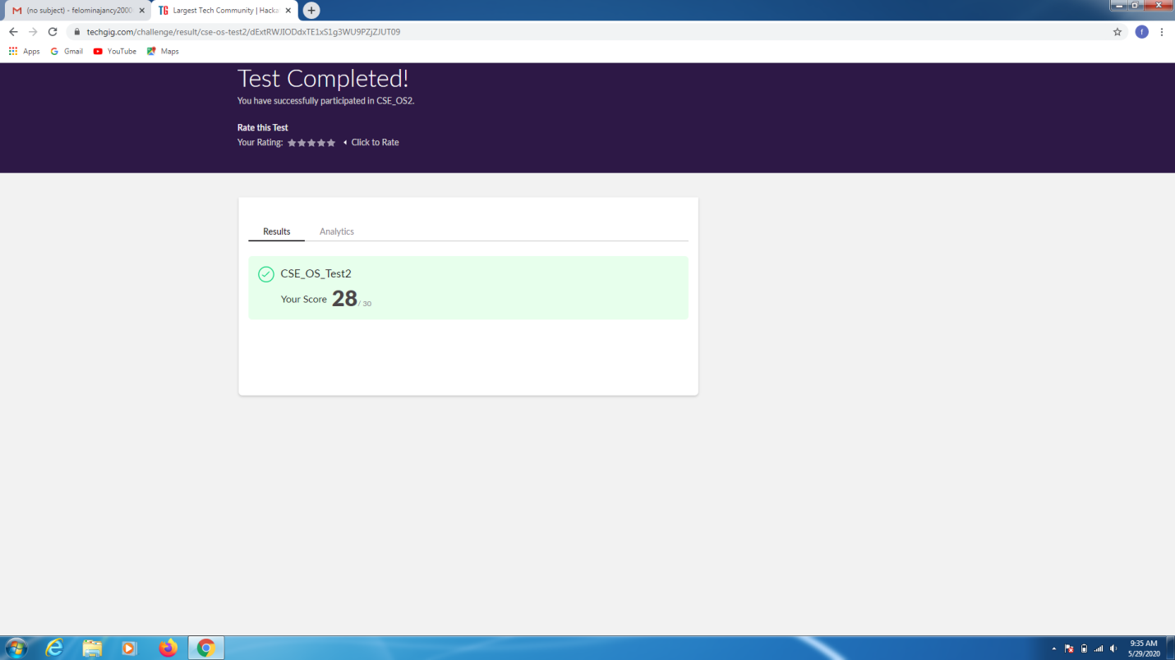

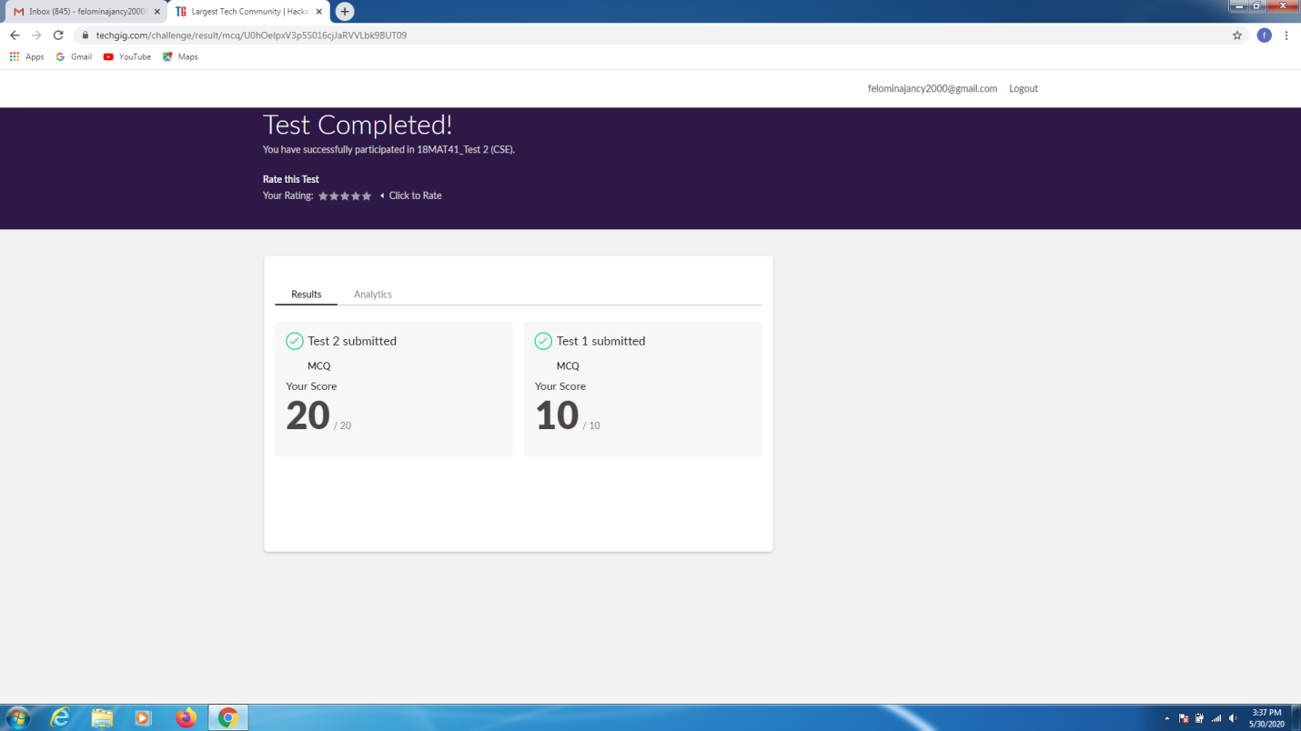

CERTIFICATION COURSE DETAILS:

* As continuation of the online course, I was able to do the week 3 part 3.5 of the "**IoT Wireless and Cloud Computing Emerging Technologies".**
* **The concepts covered in 3.5 was IoT and mobile communication networks.**

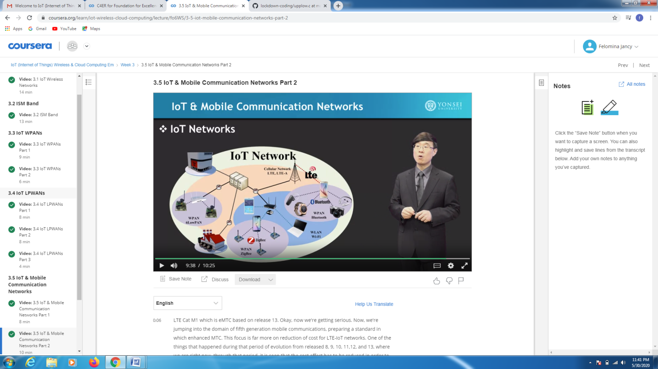

* Another course is "STEPATHON" of ICT Academy . I was able to complete a part of the week 2 activities and complete the questions which were asked.

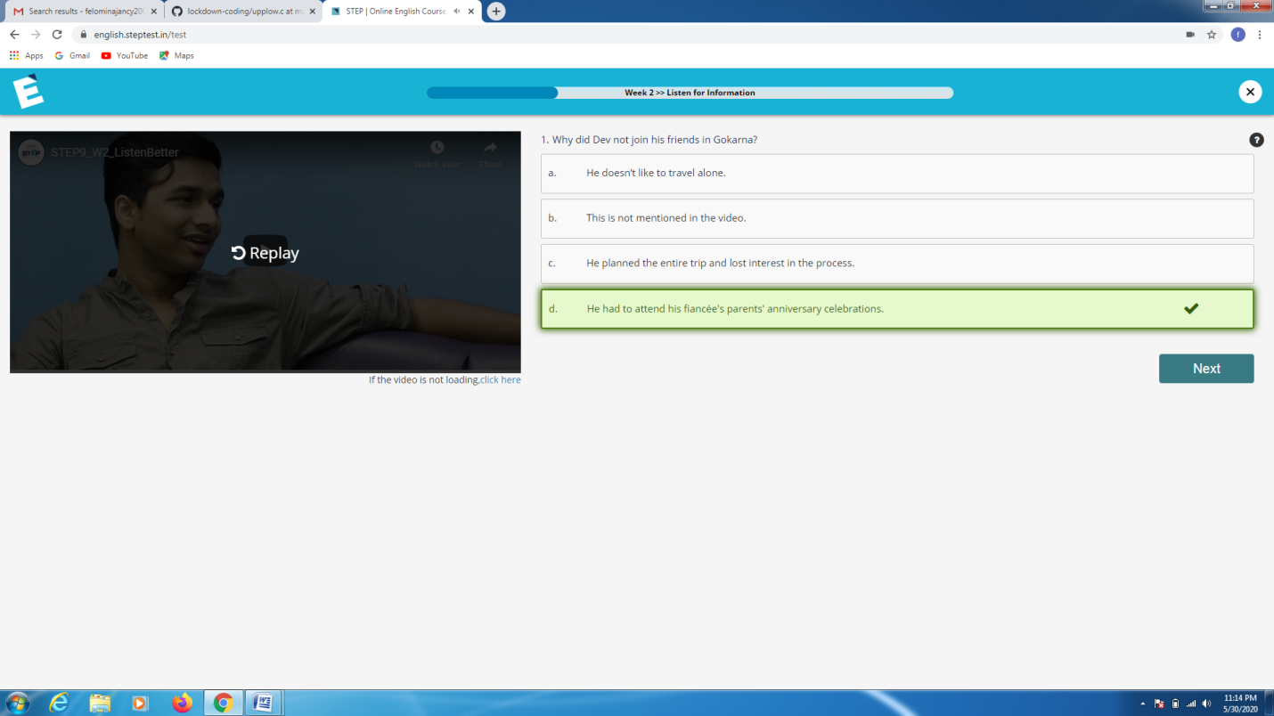

CODING CHALLENGES DETAILS:

Problem statement 1:

[Write a C Program to count Uppercase, Lowercase, special character and numeric values for a given String](https://github.com/orgs/alvas-education-foundation/teams/2nd-year/discussions/88)

Solution : Uploaded it in github

