**DAILY ONLINE ACTIVITIES SUMMARY**

|  |  |  |  |  |  |  |  |  |
| --- | --- | --- | --- | --- | --- | --- | --- | --- |
| **Date:** | **31/05/2020** | | | | | **Name:** | **Felomina Jancy** | |
| **Sem & Sec** | **4th SEM 'A' Section** | | | | | **USN:** | **4AL18CS022** | |
| **Online Test Summary** | | | | | | | | |
| **Subject** | | **No test** | | | | | | |
| **Max. Marks** | | **-** | | **Score** | | | **-** | |
| **Certification Course Summary** | | | | | | | | |
| **Course** | **1. Automation Anywhere**  **2. STEPATHON** | | | | | | | |
| **Certificate Provider** | | | **1. ICT Academy**  **2. ICT Academy** | | **Duration** | | | **1. 2 hours**  **2. 1 hour** |
| **Coding Challenges** | | | | | | | | |
| **Problem Statement: Write a java program to implement permutation(nPr) of numbers.** | | | | | | | | |
| **Status: Completed** | | | | | | | | |
| **Uploaded the report in Github** | | | | | **yes** | | | |
| **If yes Repository name** | | | | | **https://github.com/Felomina75/lockdown-coding.git** | | | |
| **Uploaded the report in slack** | | | | | **yes** | | | |

Online Test Details: (Attach the snapshot and briefly write the report for the same)

Certification Course Details: (Attach the snapshot and briefly write the report for the same)

Coding Challenges Details: (Attach the snapshot and briefly write the report for the same)

ONLINE TEST DETAILS:

No test, as it was Sunday.

CERTIFICATION COURSE DETAILS:

* I was able to do a part of module 2 of "Automation Anywhere" course organized by ICT Academy.
* Concepts covered were:
* Introduction to metabot
* Metabot designer
* Introduction Bot insight
* Business Analytics
* Bot Analytics

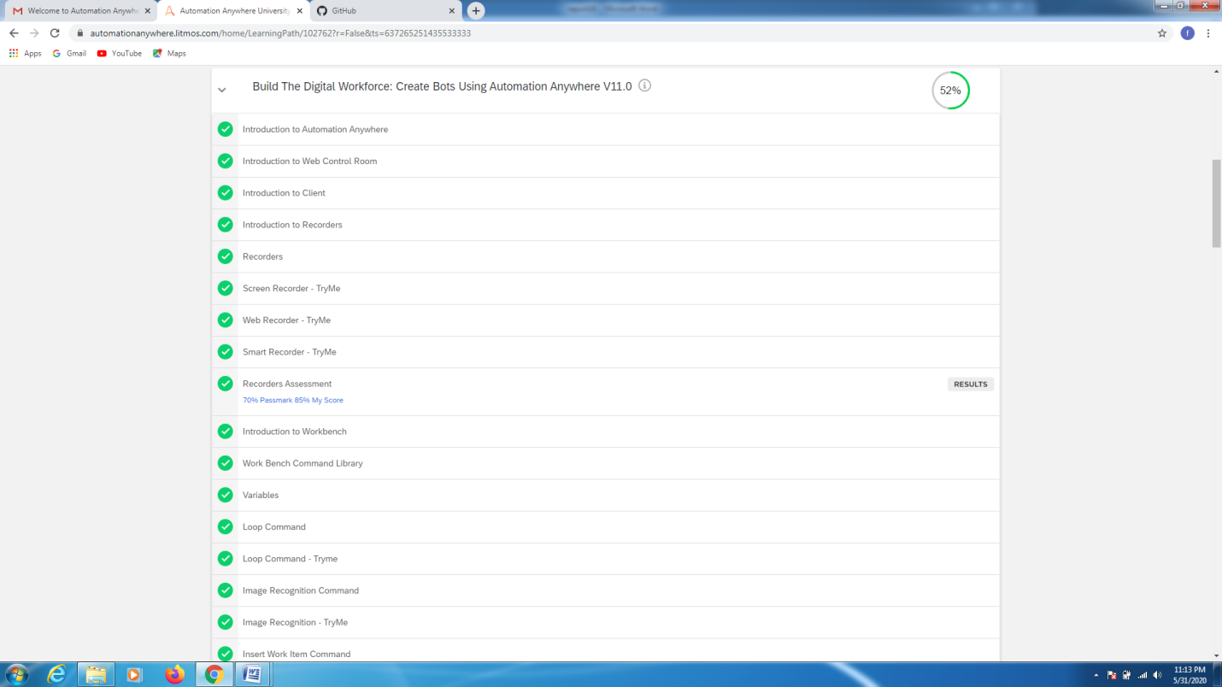

* Another course , I was able to do 6 activities provided in "STEPATHON" organized by ICT Academy.

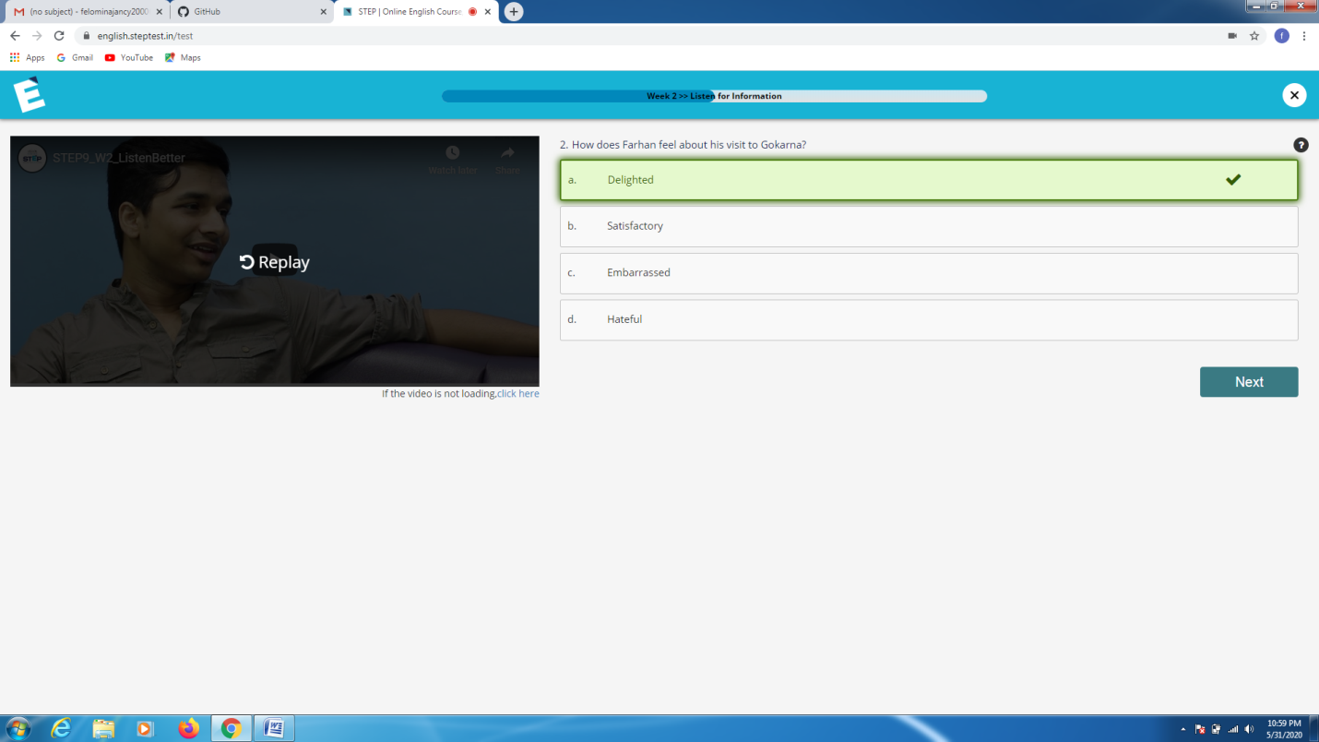

CODING CHALLENGES DETAILS:

Problem statement 1:

**Write a java program to implement permutation(nPr) of numbers.**

**nPr** represents n permutation r and value of nPr is **(n!) / (n-r)!.**

**Input:**  
The first line of the input contains **T** denoting the number of test cases. T test cases follow. First line of the test case will be the value of n and r respectively.

Output:  
For each test case, in a new line, output will be the value of nPr.

Constraints:  
**1 <= T <= 100  
1 <= n, r <= 20  
n >= r**

**Example:**  
Input:  
2  
2 1  
10 4  
Output:  
2  
5040

**Solution: Uploaded in github.**

