REPORT

DATE:18/05/2020

* Online certification course that I opted was "IoT Wireless and Cloud Computing Emerging Technologies " which is organized by coursera .
* The course is of 6 weeks. I was able to complete week 1 videos of almost 1 hour 20 minutes .
* Concepts covered were:

1.1.

* Introduction to IoT
* IoT market and industry
* Influence of IoT

1.2.

* IoT products and service
* IoT companies
* IoT applications

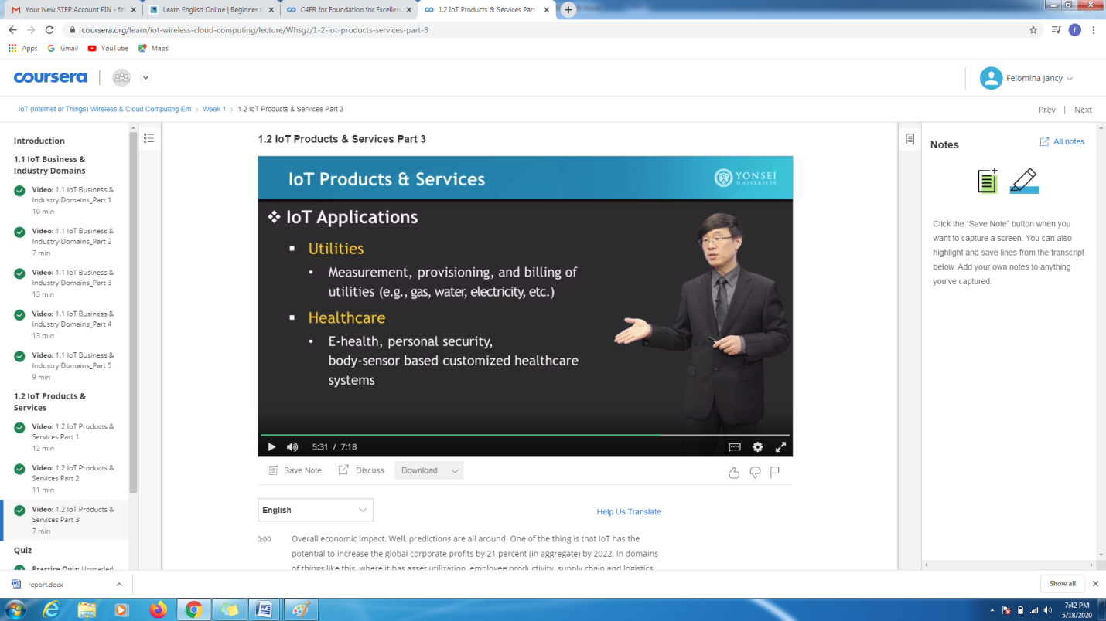

* I was able to complete the week 1 graded quiz in which at least 60% of marks was required to complete the week.

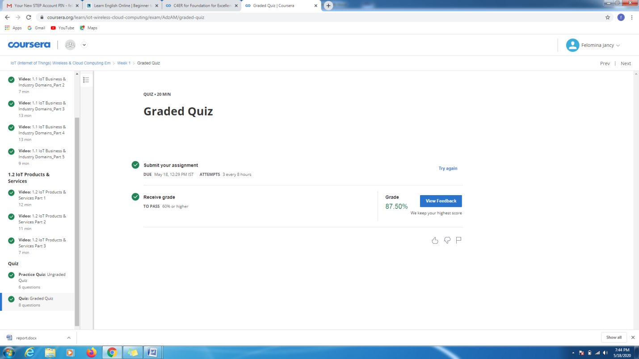

* Another course which I did was "STEPATHON" organized by ICT Academy .
* In this course , it was possible for me to complete the introduction and warm-up session .
* Also I completed a simple test and gained a sample report of my activity. 