**DAILY ONLINE ACTIVITIES SUMMARY**

|  |  |  |  |  |  |  |  |  |
| --- | --- | --- | --- | --- | --- | --- | --- | --- |
| **Date:** | **18/05/2020** | | | | | **Name:** | **Felomina Jancy** | |
| **Sem & Sec** | **4th SEM 'A' Section** | | | | | **USN:** | **4AL18CS022** | |
| **Online Test Summary** | | | | | | | | |
| **Subject** | | **Complex analysis, Probability and Statistical methods(18MAT41)** | | | | | | |
| **Max. Marks** | | **30** | | **Score** | | | **Not yet declared** | |
| **Certification Course Summary** | | | | | | | | |
| **Course** | **1. IoT Wireless and Cloud Computing Emerging Technologies**  **2. STEPATHON** | | | | | | | |
| **Certificate Provider** | | | **1. Coursera**  **2. ICT Academy** | | **Duration** | | | **1. 2 hours**  **2. 1 hour** |
| **Coding Challenges** | | | | | | | | |
| **Problem Statement: Given an array of distinct integers. The task is to count all the triplets such that the sum of two elements equals the third element.** | | | | | | | | |
| **Status: Completed** | | | | | | | | |
| **Uploaded the report in Github** | | | | | **yes** | | | |
| **If yes Repository name** | | | | | **https://github.com/Felomina75/lockdown-coding.git** | | | |
| **Uploaded the report in slack** | | | | | **yes** | | | |

Online Test Details: (Attach the snapshot and briefly write the report for the same)

Certification Course Details: (Attach the snapshot and briefly write the report for the same)

Coding Challenges Details: (Attach the snapshot and briefly write the report for the same)

ONLINE TEST DETAILS:

As there were some issues that the time was not sufficient to answer all the questions , the marks are not yet declared.

CERTIFICATION COURSE DETAILS:

* Online certification course that I opted was "IoT Wireless and Cloud Computing Emerging Technologies " which is organized by coursera .
* The course is of 6 weeks. I was able to complete week 1 videos of almost 1 hour 40 minutes .
* Concepts covered were:

1.1.

* Introduction to IoT
* IoT market and industry
* Influence of IoT

1.2.

* IoT products and service
* IoT companies
* IoT applications

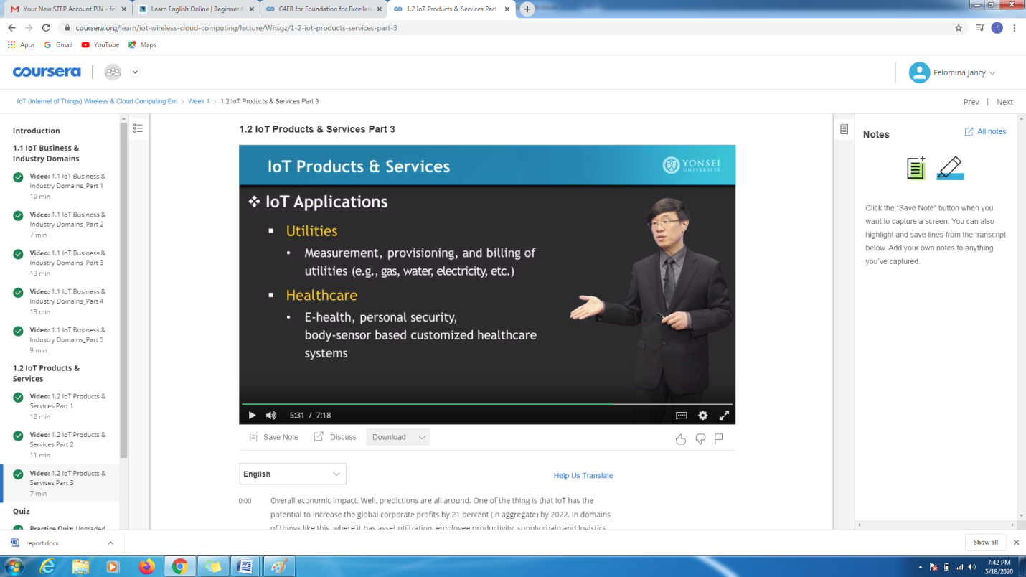

* I was able to complete the week 1 graded quiz OF 20 minutes in which at least 60% of marks was required to complete the week.

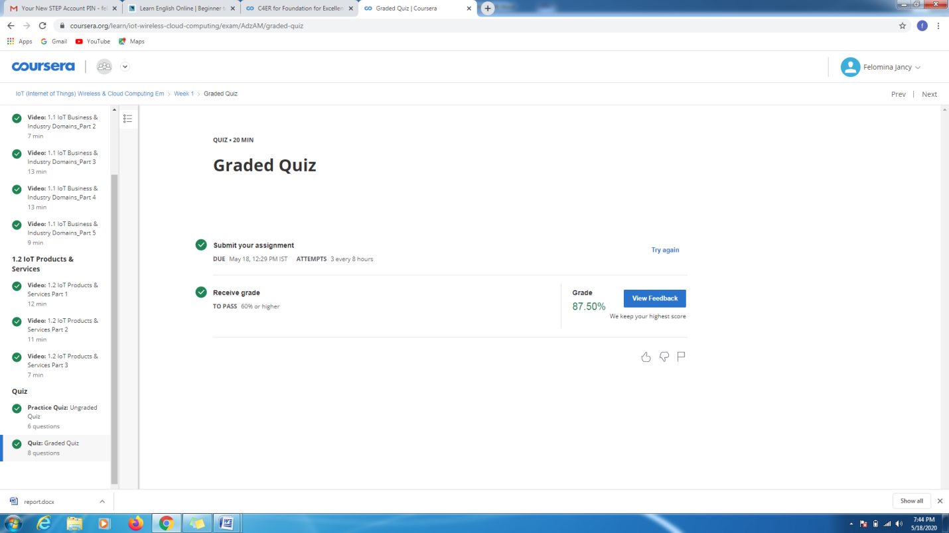

* Another course which I did was "STEPATHON" organized by ICT Academy .
* In this course , it was possible for me to complete the introduction and warm-up session .
* Also I completed a simple test and gained a sample report of my activity. 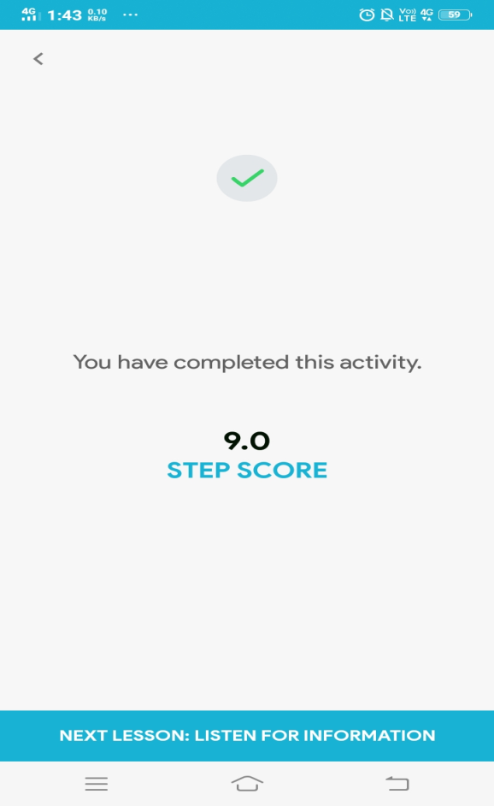

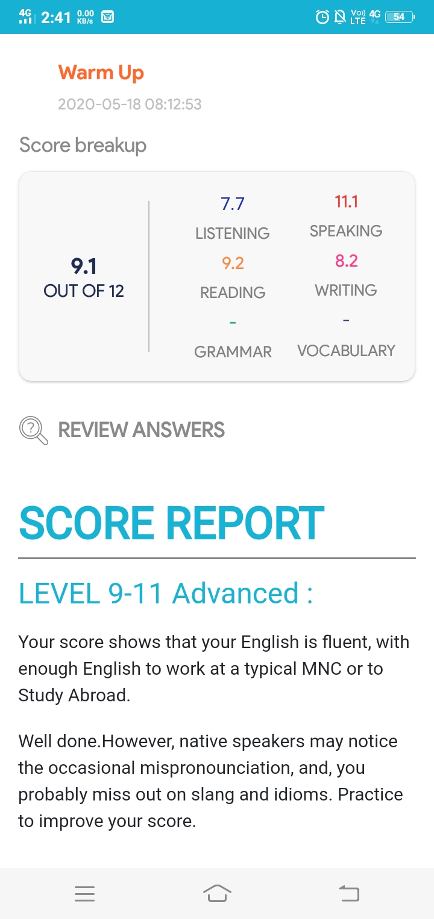

CODING CHALLENGES DETAILS:

Problem statement 1:

**Given an array of distinct integers. The task is to count all the triplets such that the sum of two elements equals the third element.**

**Solution: Uploaded in github.**

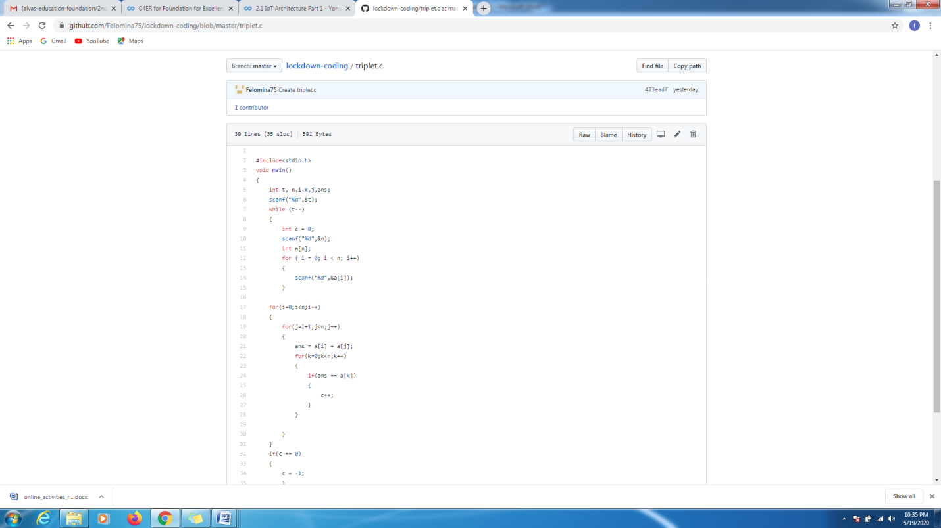

**Problem statement 2:**

Using methods charAt() & length() of String class, write a program to print the  
frequency of each character in a string.  
“Hello friend”

Output should be  
-: 1  
d: 1  
e: 2  
f: 1  
(continued for all character in the string)

Solution : Uploaded in github.

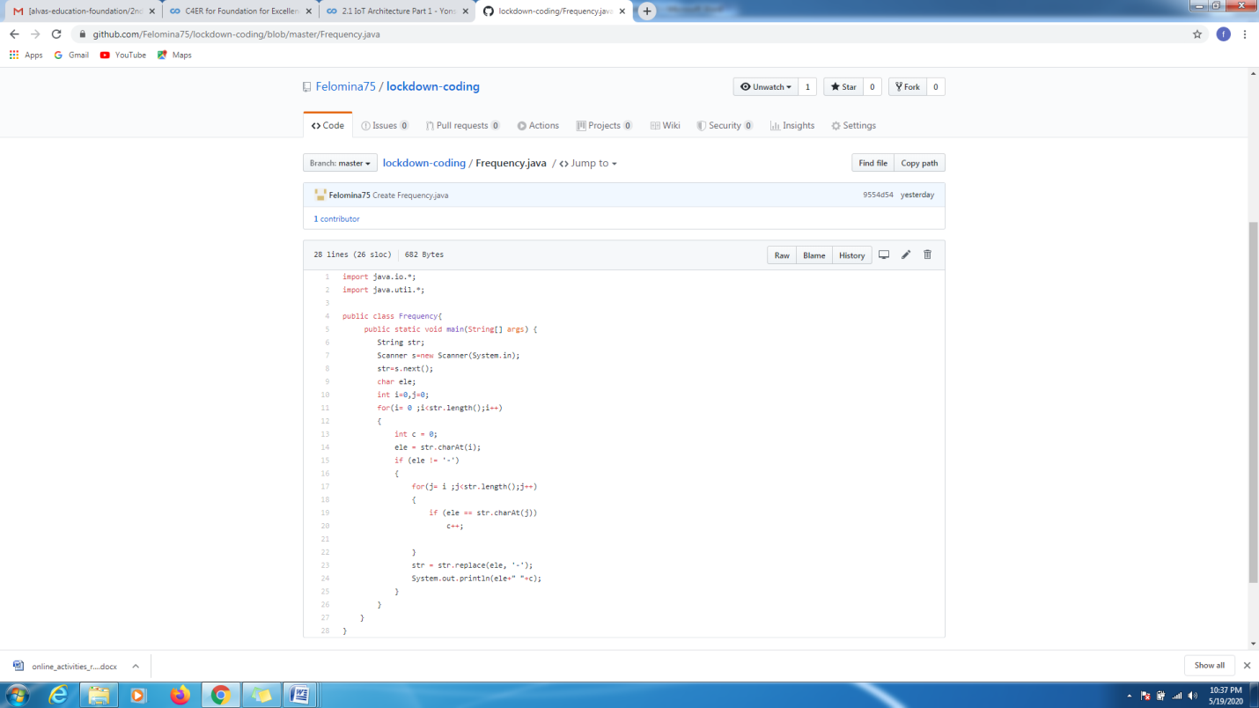

Problem statement 3:

Write a C Program to check whether the two string are Anagram or not.

Hint: An Anagram of a string is another string that contains same characters, only the order of characters can be different.  
For example, "act" and "cat" are anagram of each other.

Solution: Uploaded in github.

