**DAILY ONLINE ACTIVITIES SUMMARY**

|  |  |  |  |  |  |  |  |  |
| --- | --- | --- | --- | --- | --- | --- | --- | --- |
| **Date:** | **19/05/2020** | | | | | **Name:** | **Felomina Jancy** | |
| **Sem & Sec** | **4th SEM 'A' Section** | | | | | **USN:** | **4AL18CS022** | |
| **Online Test Summary** | | | | | | | | |
| **Subject** | | **Design and Analysis of Algorithms-18CS42** | | | | | | |
| **Max. Marks** | | **30** | | **Score** | | | **24** | |
| **Certification Course Summary** | | | | | | | | |
| **Course** | **1. IoT Wireless and Cloud Computing Emerging Technologies**  **2. STEPATHON** | | | | | | | |
| **Certificate Provider** | | | **1. Coursera**  **2. ICT Academy** | | **Duration** | | | **1. 1.5 hours**  **2.1 hour** |
| **Coding Challenges** | | | | | | | | |
| **Problem Statement:** A user will input two strings, and we find if one of the strings is a sub sequence of the other. Program prints “yes” if either the first string is a sub sequence of the second string or the second string is a sub sequence of the first string. Assume that, the length of the first string is smaller than or equal to the length of the second string. | | | | | | | | |
| **Status: completed** | | | | | | | | |
| **Uploaded the report in Github** | | | | | **yes** | | | |
| **If yes Repository name** | | | | | **https://github.com/Felomina75/lockdown-coding.git** | | | |
| **Uploaded the report in slack** | | | | | **yes** | | | |

Online Test Details: (Attach the snapshot and briefly write the report for the same)

Certification Course Details: (Attach the snapshot and briefly write the report for the same)

Coding Challenges Details: (Attach the snapshot and briefly write the report for the same)

ONLINE TEST DETAILS:

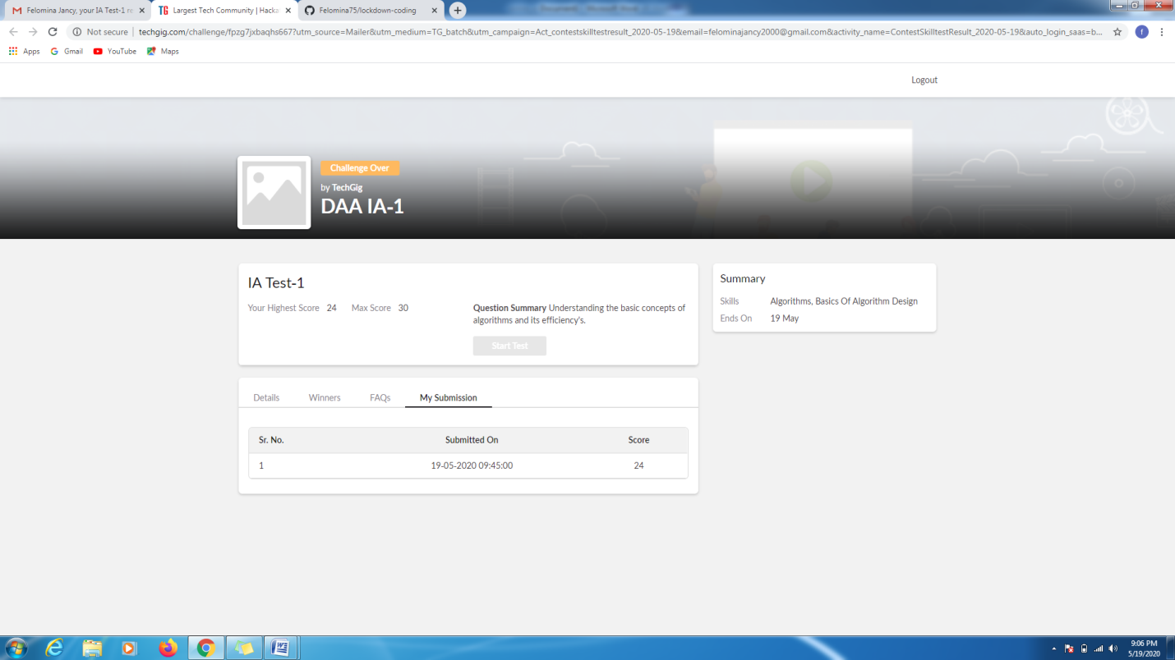

CERTIFICATION COURSE DETAILS:

* As continuation of the online course, I was able to do the week 2 part 2.1 of the "**IoT Wireless and Cloud Computing Emerging Technologies".**
* **The concepts covered in 2.1 under IoT architecture layers are:**
* Sensor layer
* Gateway and network layer
* Management service
* Application layers

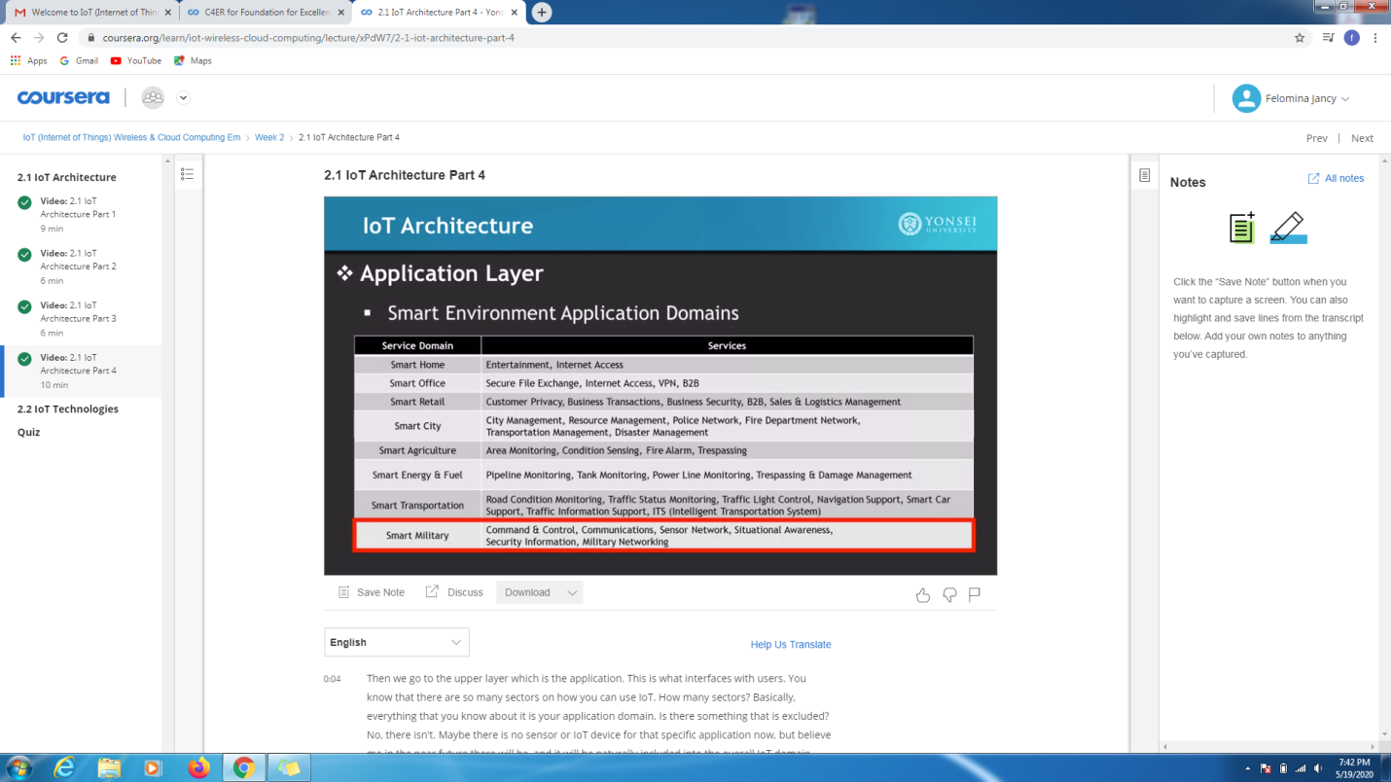

* Another course is "STEPATHON" of ICT Academy . I was able to complete a part of the week 1 activities and complete the questions which were asked.



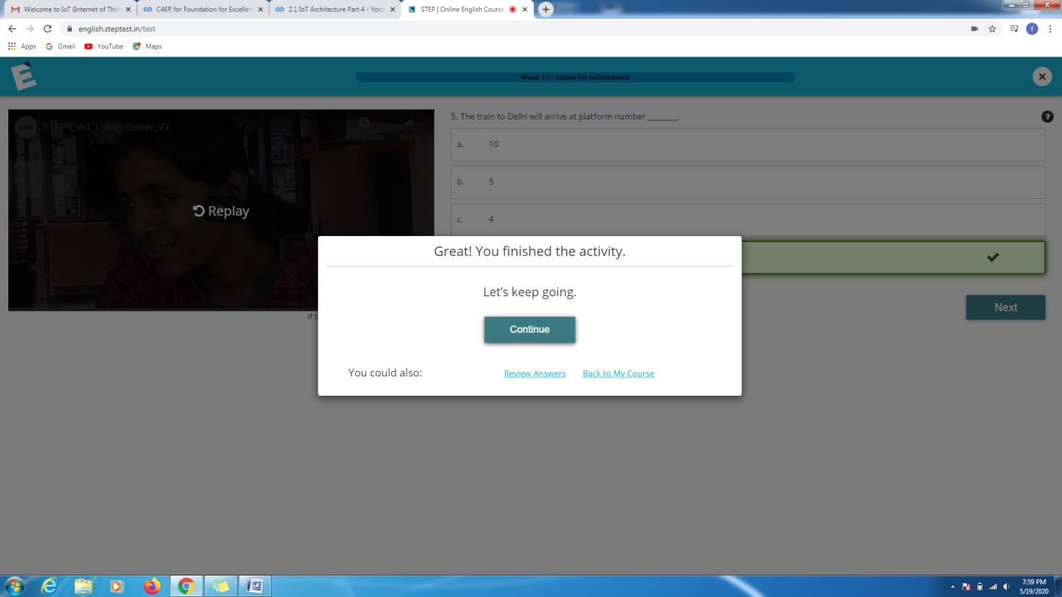

CODING CHALLENGES DETAILS:

Problem statement 1:

A user will input two strings, and we find if one of the strings is a sub sequence of the other. Program prints “yes” if either the first string is a sub sequence of the second string or the second string is a sub sequence of the first string.  
Assume that, the length of the first string is smaller than or equal to the length of the second string.

**An expected output of the program:**

Input the first string  
tree  
Input the second string  
Computer science is awesome  
YES

Solution : Uploaded it in github

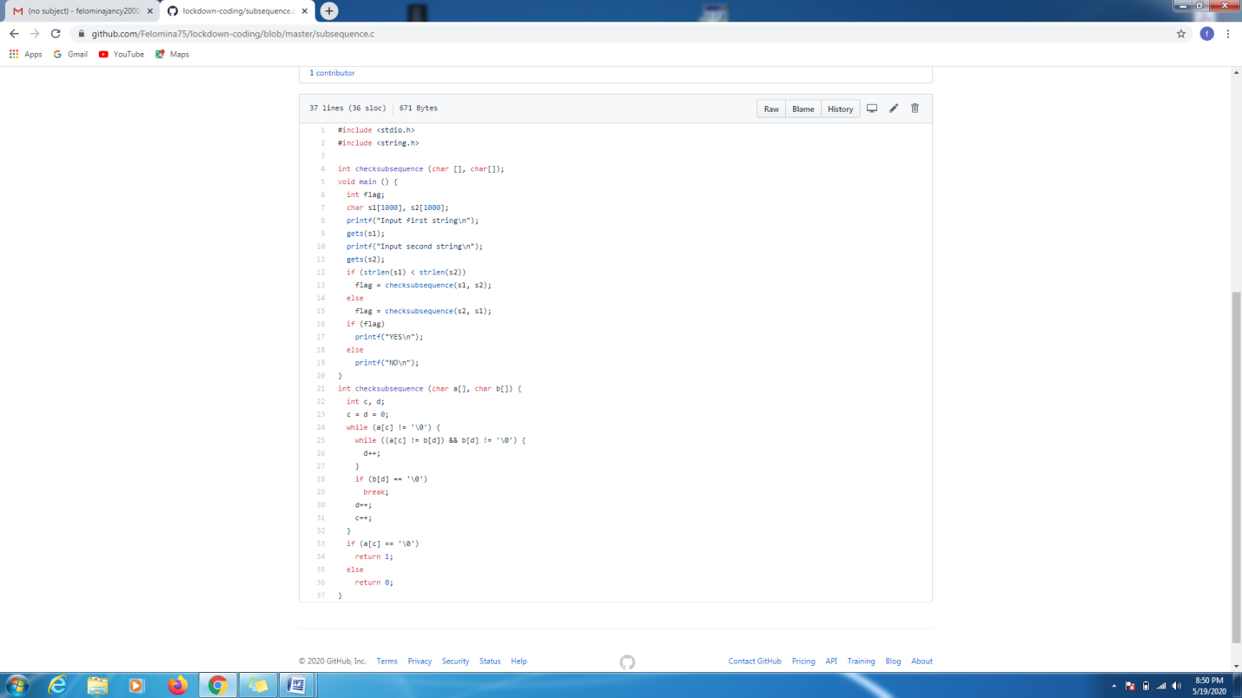

Problem statement 2:

We have a Letter or a word then we need add some letters to it and need to find out shortest palindrome  
For example we take "S": S will be the shortest palindrome string.  
If we take "xyz": zyxyz will be the shortest palindrome string  
So we need to add some characters to the given string or character and find out what will be the shortest palindrome string by using simple java program.

Solution: Uploaded in github.

