VUTTR-FRONT

#README

-Vuttr front foi desenvolvido para se comunicar com Vuttr Back utilizando serviços que interagem com a API REST (Back-End)  
#Tecnologias utilizadas:

[x]Angular 9   
-Javastcript  
-Html  
-Css  
-TypeScript

[x]NodJs  
[x]Npm

[x]Bootstrap

[X]Responsive

[x] ReactiveForms

IDE:  
[x]Visual Studio Code v 1.47.2

------------------------------------------------------------------

VUTTR-BACK

#README

-Vuttr - back foi desenvolvido utilizando o Spring Boot.

#Tecnologias Utilizadas

[x]Spring framework

[X]Spring Web

[x] Spring Security

IDE:  
**[X] Spring Tool Suite 4**

Version: 4.6.1.RELEASE

Build Id: 202004200639

Base de dados MySQL

Workbench 8.0 CE  
-Script de criação da Base  
-Carga nas tabelas

- Vuttr.mwb  
 – Diagrama

SWAGGER:  
<http://localhost:3000/v2/api-docs/>  
  
<http://localhost:3000/swagger-ui.html>

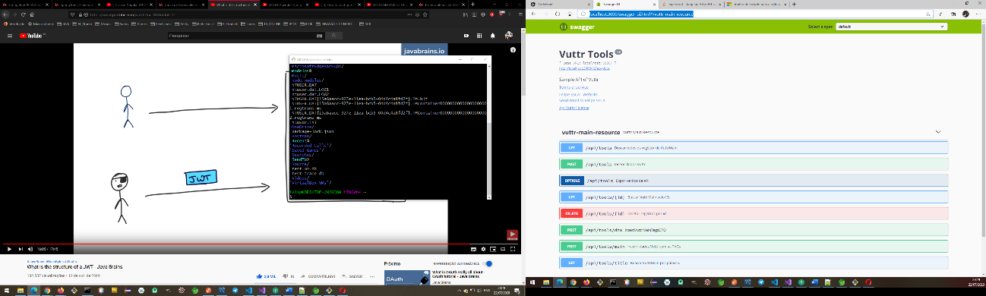

## Back-END WEB - API 0: A API deve responder na porta 3000 http://localhost:3000/api/tools/

**1: Deve haver uma rota para listar todas as ferramentas cadastrada**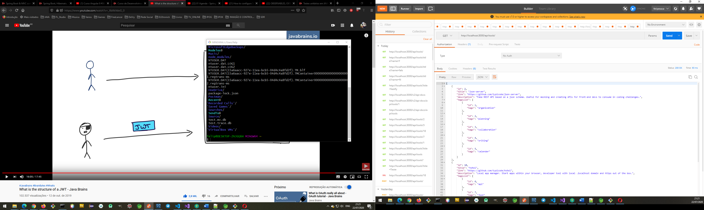

**[GET]**  
  
http://localhost:3000/api/tools/  
  
[

{

"id": 2,

"title": "json-server",

"link": "https://github.com/typicode/json-server",

"description": "Fake REST API based on a json schema. Useful for mocking and creating APIs for front-end devs to consume in coding challenges.",

"tagsList": [

{

"id": 1,

"tags": "organization"

},

{

"id": 2,

"tags": "planning"

},

{

"id": 3,

"tags": "collaboration"

},

{

"id": 4,

"tags": "writing"

},

{

"id": 5,

"tags": "calendar"

}

]

},

{

"id": 10,

"title": "hotel",

"link": "https://github.com/typicode/hotel",

"description": "Local app manager. Start apps within your browser, developer tool with local .localhost domain and https out of the box.",

"tagsList": [

{

"id": 6,

"tags": "api"

},

{

"id": 7,

"tags": "Json"

},

{

"id": 8,

"tags": "schema"

},

{

"id": 9,

"tags": "node"

},

{

"id": 10,

"tags": "github"

},

{

"id": 11,

"tags": "Rest"

}

]

},

{

"id": 17,

"title": "fastify",

"link": "https://www.fastify.io/",

"description": "Extremely fast and simple, low-overhead web framework for NodeJS. Supports HTTP2.",

"tagsList": [

{

"id": 12,

"tags": "web"

},

{

"id": 13,

"tags": "framework"

},

{

"id": 14,

"tags": "http2"

},

{

"id": 15,

"tags": "https"

},

{

"id": 9,

"tags": "node"

}

]

}

]

## 2: Deve ser possível filtrar ferramentas utilizando uma busca por tag

## [GET]

<http://localhost:3000/api/tools/title?name=f>  
  
[

{

"id": 17,

"title": "fastify",

"link": "https://www.fastify.io/",

"description": "Extremely fast and simple, low-overhead web framework for NodeJS. Supports HTTP2.",

"tagsList": [

{

"id": 12,

"tags": "web"

},

{

"id": 13,

"tags": "framework"

},

{

"id": 14,

"tags": "http2"

},

{

"id": 15,

"tags": "https"

},

{

"id": 9,

"tags": "node"

}

]

}

## ] 3: Deve haver uma rota para cadastrar uma nova ferramenta [POST] http://localhost:3000/api/tools/

Obs, se for utilizar Postman para teste alterar o localhost para *  
  
@CrossOrigin(origins = {

"http://localhost:4200" }, allowedHeaders = "*", allowCredentials = "false", maxAge = 15

* 60, methods = { RequestMethod.***GET***, RequestMethod.***POST***, RequestMethod.***DELETE***, })  
  
  
{

"title": "cadastro",

"link": "https://www.fastify.io/",

"description":"Extremely fast and simple, low-overhead web framework for NodeJS. Supports HTTP2.",

"tags":["node", "organizing", "webapps", "domain", "developer", "https", "proxy"]

}  
**access-control-allow-origin →**\*

**connection →**keep-alive

**content-length →**0

**date →**Thu, 23 Jul 2020 00:30:02 GMT

**keep-alive →**timeout=60

**location →**http://localhost:3000/api/tools/19

**vary →**Origin, Access-Control-Request-Method, Access-Control-Request-Headers  
  
Status: 201 Created

Content-Type: application/json

## 4: O usuário deve poder remover uma ferramenta por ID

## [DELETE]

**access-control-allow-origin →**\*

**connection →**keep-alive

**date →**Thu, 23 Jul 2020 00:35:20 GMT

**keep-alive →**timeout=60

**vary →**Origin, Access-Control-Request-Method, Access-Control-Request-Headers  
  
DELETE /tools/:id

Resposta:

Status: 204 No Content

id 19(  
{

"status": 404,

"mensage": "Resource not found using this id!",

"dateTime": "2020-07-22T21:35:52.1756408-03:00"

}

## Dev. Front-End 1: O(A) usuário(a) deve poder ver a lista de todas as ferramentas cadastradas

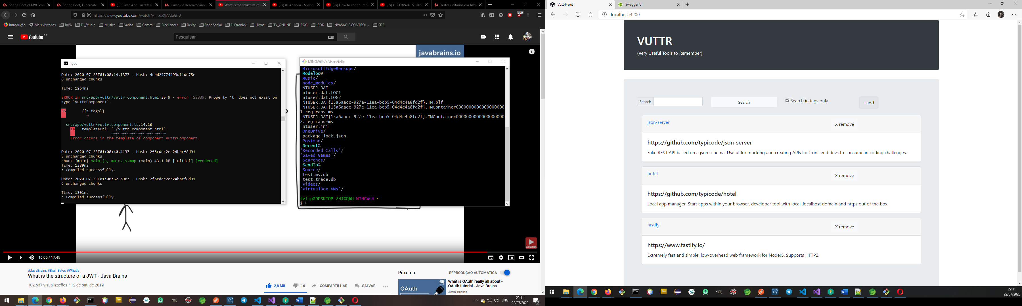

## 2: O usuário deve poder adicionar uma nova ferramenta

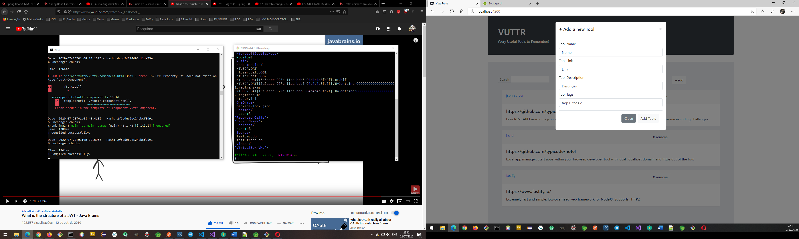

## 3: O usuário deve poder remover uma ferramenta

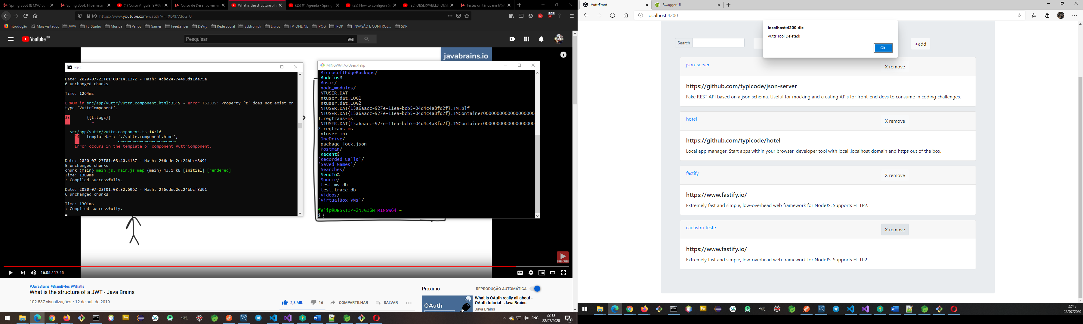

## 4: O usuário deve poder buscar ferramentas dinamicamente (global ou utilizando apenas tags)

Serviços que acessam o backend e recupera os dados para exibir na tela.