Job van der Poel

Phone: +31683014500 | E-mail: [Job_poel@hotmail.com](mailto:Job_poel@hotmail.com) | Website: Jobvdpoel.com

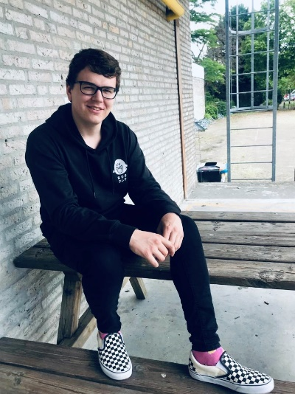**Summary**

I am a game designer, currently in my 4th year at BUAS (Breda University of Applied Sciences) following the Creative Media and Game Technologies programme. I am looking for an internship in order to gain industry experience and to develop my skills even further. Over the course of my studies I have worked as a level designer or gameplay designer on several game projects. I am enthusiastic about creating fun and interactive experiences for the players by putting my skills to the test.

**Work experience**

Gameplay designer – Kra-Ken  
September 2018 – July 2019

* Worked on applying hurt and hitboxes for the moves of the characters.
* Worked closely together with artists and programmers to ensure the quality of the systems and animations used.
* Gathered feedback from peers and team members and used it to iterate and improve my work.
* Released on Steam as of July 29th, 2019.

Puzzle/Level designer – Canine 49  
May 2018 – June 2018

* Designed several puzzles and scenarios for the players to solve.
* Worked closely together to ensure quality and clarity of the stages the player traverses.
* Play tested my designs with peers in order to ensure their clarity.
* Worked together with the Rainbow Connection in order to realise the concept of a terminally ill boy from America.
* Released on Itch.io as of June 27th, 2018.

**Education**

Bachelor of Creative Media and Game Technologies – September 2015 – Current  
Breda University of Applied Sciences, Breda

RSG ‘T Rijks High School – September 2010 – June 2015

**Skills**

* Experience with Unreal Engine 4 and Unity.
* Experience with source control software such as P4V and Tortoise SVN.
* Experience with Scrum and Agile development and appropriate software such as Trello and JIRA.
* Engaged listener able to absorb feedback and listen to the ideas of others and use it to improve the product.
* Able to work together and communicate with a team in order to reach a shared goal.
* Actively looks for opportunities to learn and is not afraid to ask questions whenever there is a problem.

**Hobbies and interests**

I have a passion for video games. I like to keep myself up to date on what is going on with gaming trends by playing and reading about new releases. I am a fan of games such as The Legend of Zelda series and World of Warcraft. I also have a big interest in anime and manga, and like to spend my free time watching or reading it.