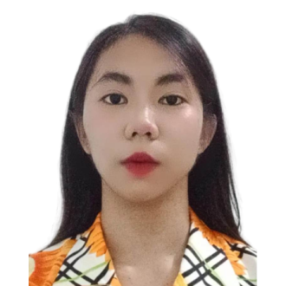

**ALESSANDRA PHOEBE C. BAUTISTA**  
BLK 7 LOT 60 CITTA ITALIA BUHAY NA TUBIG IMUS, CITY CAVITE  
+ (63) 945-413-4851  
alessandra.bautista20@gmail.com

**CAREER OBJECTIVE**

Seeking a position as a Software Engineer to contribute to the company's success while further enhancing my knowledge and demonstrating my skills in the field of Computer Science.

**PERSONAL DETAILS**

Age : 18

Sex : Female

Birth Place : Imus Health Center

Birth Date : July 3, 2006

Nationality : Filipino

Civil Status : Single

Religion : Roman Catholic

**EDUCATIONAL BACKGROUND**

2024 – PRESENT **Cavite State University – Imus Campus**

Cavite Civic Center, Palico IV, Imus City, Cavite

2022 – 2024 (Grade 11 – 12) **General Flaviano Yengko Senior High School**

Phase 11-A, Dama De Noche St. Pasong Buaya II, Imus City, Cavite

Science, Technology, Engineering, and Mathematics (STEM)

2018 – 2022 (Grade 7 – 10) **General Emilio Aguinaldo National High School**

LTO Compound, Palico IV, Imus City, Cavite

2012 – 2018 (Grade 1 – 6) **Buhay Na Tubig Elementary School**

Buhay na Tubig Rd., Brgy. Buhay na Tubig, Imus City, Cavite

**ACHIEVEMENTS**

2024 Academic Excellence Award (With Honors)

General Flaviano Yengko Senior High School

Grade 12

2023 Academic Excellence Award (With Honors)

General Flaviano Yengko Senior High School

Grade 11

2022 Academic Excellence Award (With High Honors)

General Emilio Aguinaldo National High School

Grade 10

2021 Academic Excellence Award (With Honors)

General Emilio Aguinaldo National High School

Grade 9

2019 Academic Excellence Award (With Honors)

General Emilio Aguinaldo National High School

Grade 7

**SKILLS**

* Good communication skills
* Possess strong leadership qualities
* Ability to quickly grasp new concepts and adapt to dynamic work environments
* Flexible in handling diverse tasks
* Able to work independently and work effectively with others

**REFERENCES**

**Mr. Christmar S. Marte**

High School Teacher

General Emilio Aguinaldo National High School

09098279005

christmar.marte@deped.gov.ph

**Mrs. Ditas V. Flores**

Master Teacher I

General Flaviano Yengko Senior High School

09177205063

Dits_mon@yahoo.com

**Mrs. Selene D. de los Reyes**

ALS Teacher

Buhay na Tubig Elementary School

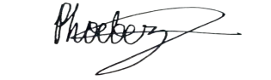09672468489

selene.delosreyes@deped.gov.ph

APPLICANT SIGNATURE