Pseudocode
START
Card Balance =10
Games Played = 0
Pick a Machine (0.25 OR 0.50)

WHILE (balance > 0) AND (games played) <
result = Win OR lose
IF result = Win
THEN
Card balance = balance + machine
ELSE
Card balance = balance – machine
THEN
NO of games = + 1
THEN
IF balance > 0 = TRUE OR FALSE
IF
TRUE
Cash out balance
END
IF
FALSE
END

Numbered Algorithm

- Starts with 10$ on the Prepaid Card
- Pick a slot machine (Either the (0.25₵) machine or a 0.50₵ machine)
- The Total number of games played for now is 0
- While there is still money on the prepaid card and the customer hasn’t run out of money or have played 17 games
- Play any of the machines
- If they win add the machine amount to the card
- If they lose deduct the machine amount from the card and add 1 to the number of games played
- If there is money left in the card cash it out
- Stop
- IF there isn’t
- Stop

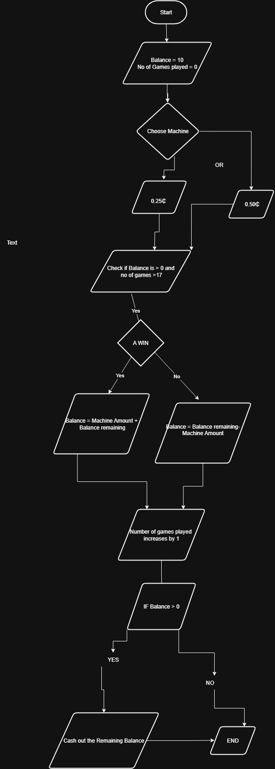FLOWCHART

