Assignment Sets and Venn Diagrams
Complete the problems assigned below. Show your work on this sheet.
Place your answers to each question in the table below:
Question | 1 | 2 | 3 | 4 | 5 | 6 | 7 | 8 | 9 | 10
/20 | 2 | 2 | 2 | 2 | 2 | 2 | 2 | 2 | 2 | 2
Answer: | 38 | 185 | 250 | 29 | 10 | 4 | 16 | 5 | 5 | 5

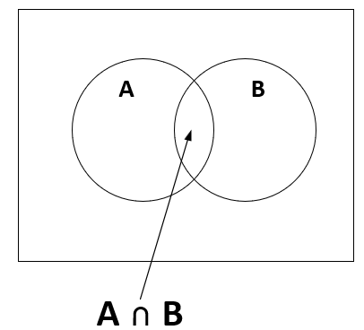
- A coffee shop recently surveyed people coming through the door as to what they were seeking in the shop. 24 stated they were looking for coffee (A), 22 stated they were looking for donuts (B), and 8 of them stated they wanted coffee and donuts (A ∩ B). Use the Venn Diagram and the formula below to calculate the total number of customers who were surveyed - n(A U B).
Formula: n(A U B) = n(A) + n(B) – n(A ∩ B)
Calculate the total number of customers
n(A U B)

n(A) =24
n(B) = 22
n (A ∩ B) = 8
n(A U B) = 24 +22 – 8
= 46-8
= 38

- According to a survey amongst 200 NBCC students, 150 students like cold drinks (A), 110 students like hot drinks (B), and 75 like both (A ∩ B). How many students like at least one of the drinks?
Formula: n(A U B) = n(A) + n(B) – n(A ∩ B)
n(A) =150
n(B) = 110
n (A ∩ B) = 75
n(A U B) = 150+110 – 75
= 260-75
= 185

- In a group of 500 people, 400 people can speak English (E), and 350 people can speak French (F ). How many people can speak both languages (E ∩ F)?
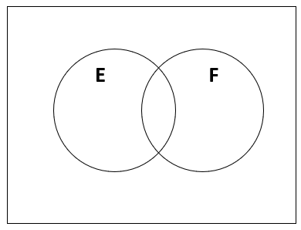
Formula: n(E ∪ F) = n(E) + n(F) – n(E ∩ F)

n(E ∪ F) =500

n(E) =400
n(F) = 350
n (E ∩ F) = 400 + 350 -500
= 750- 500
= 250

Given the following Venn Diagram, answer the questions below:
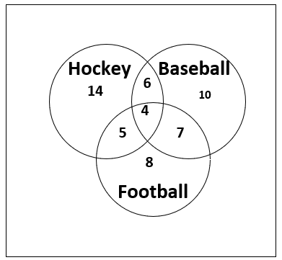

- How many students like hockey?
= 14+ 6 + 5 + 4 = 29

- How many students like Baseball
and Hockey?
= 6 + 4 = 10

- How many students like Hockey, Baseball,
and Football?

= 4

- How many students like Baseball but
not Football?
= 10 + 6 = 16

- Given a finite set of 10 numbers:
U = {0,1,2,3,4,5,6,7,8,9},

and the following set for A:
A = {0,1,2,3,4,6,7,8,9}

What is the value of A^{c}?

The only value missing is = 5

A^{c} = 5

- Given the following two sets of numbers:
A = {0,1,2,3,4,5}
B = {5,6,7,8,9}

What is the value of A ∩ B?

The only value intersecting is 5
A ∩ B = 5

- Given the following two sets of numbers:
A = {2,3,5,6,7,8}
B = {1,5,9}

List all the elements in A $∩$ B

The only value in both is 5

A $∩$ B = 5

