**Cisco Packet Tracer Project Report**

**1. Network Topology Setup**

*Description:*  
This step involved physically connecting three PCs and one router using one switch. The PCs were assigned to different VLANs to segment the network logically. The router interface connected to the switch was configured as a trunk to carry multiple VLANs.

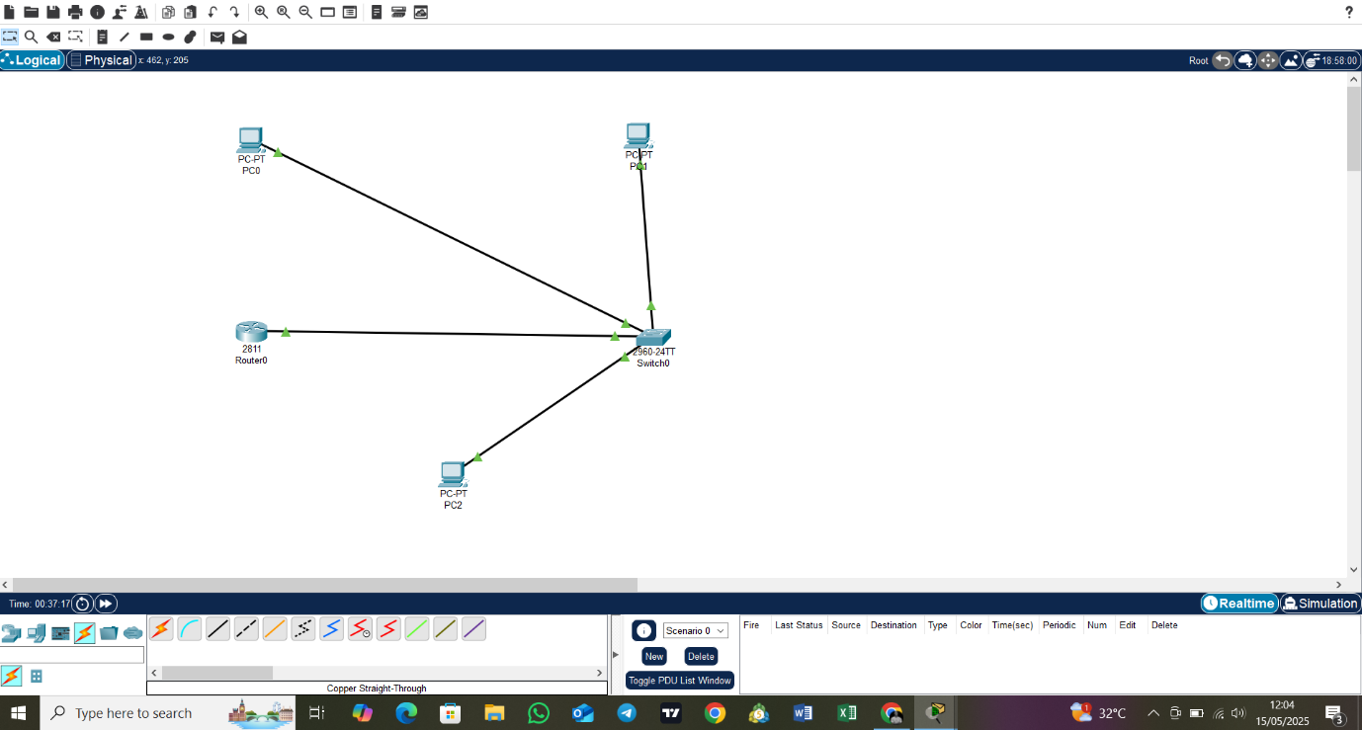

## 2. VLAN Configuration on Switch

Description:  
Created VLANs 10 (Sales), 20 (Marketing), and 30 (IT) on the switch. Assigned ports Fa0/1, Fa0/2, and Fa0/3 to the respective VLANs to isolate traffic within departments.

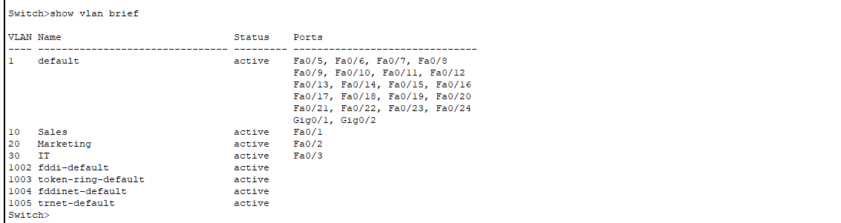

## 3. Router Subinterface Configuration

Description:  
Configured router subinterfaces on the router’s physical interface to handle inter-VLAN routing. Each subinterface was assigned an IP address within the respective VLAN subnet and encapsulation dot1Q for VLAN tagging.

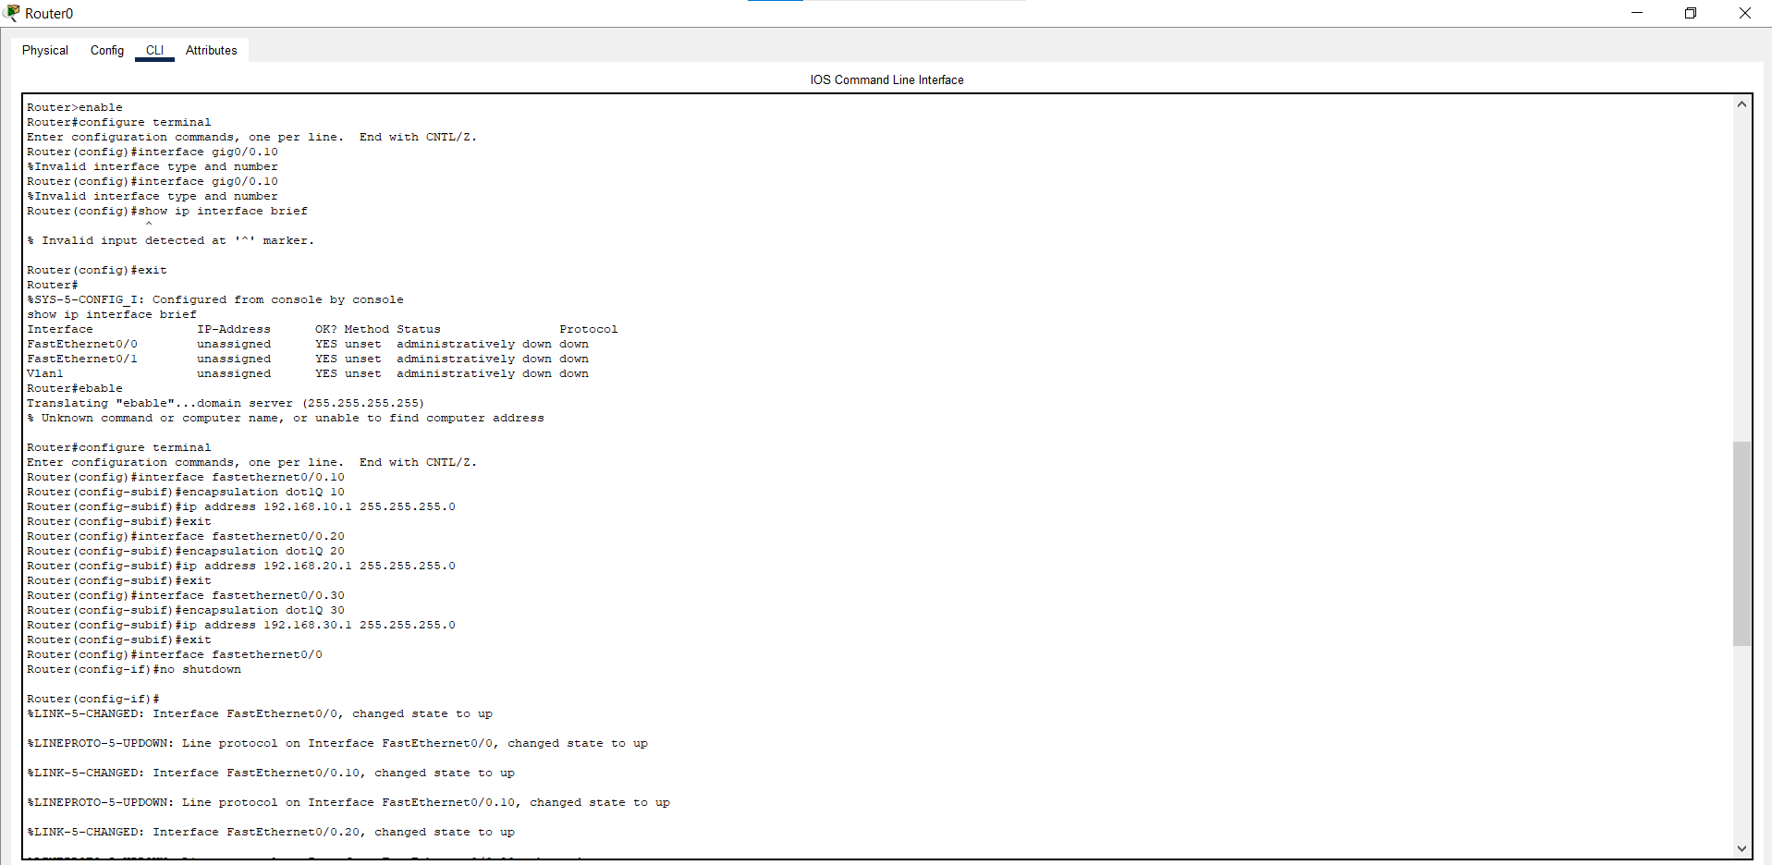

## 4. PC IP Configuration

Description:  
Configured each PC with a static IP address corresponding to its VLAN subnet and set the default gateway to the router subinterface IP for its VLAN. This enabled communication within and across VLANs.

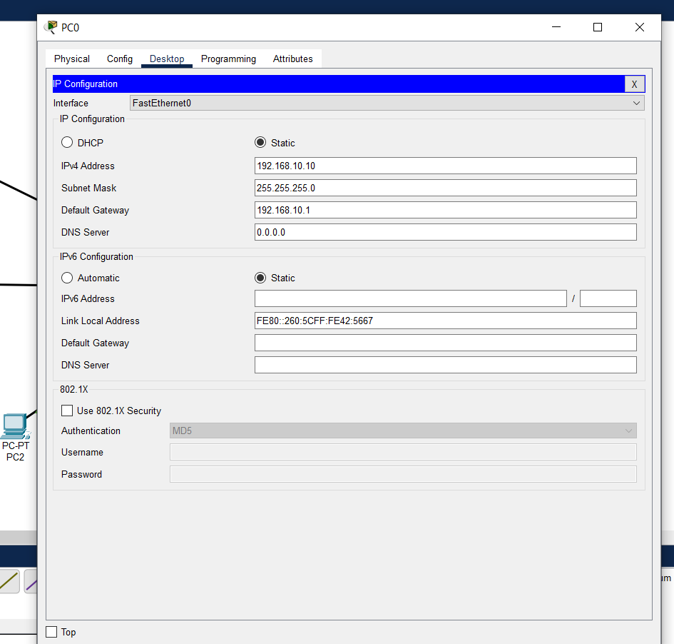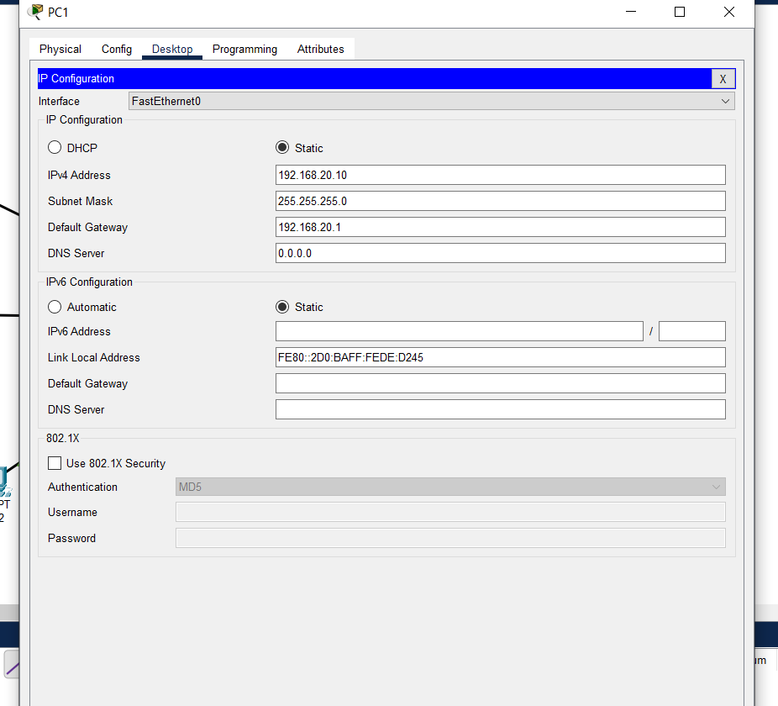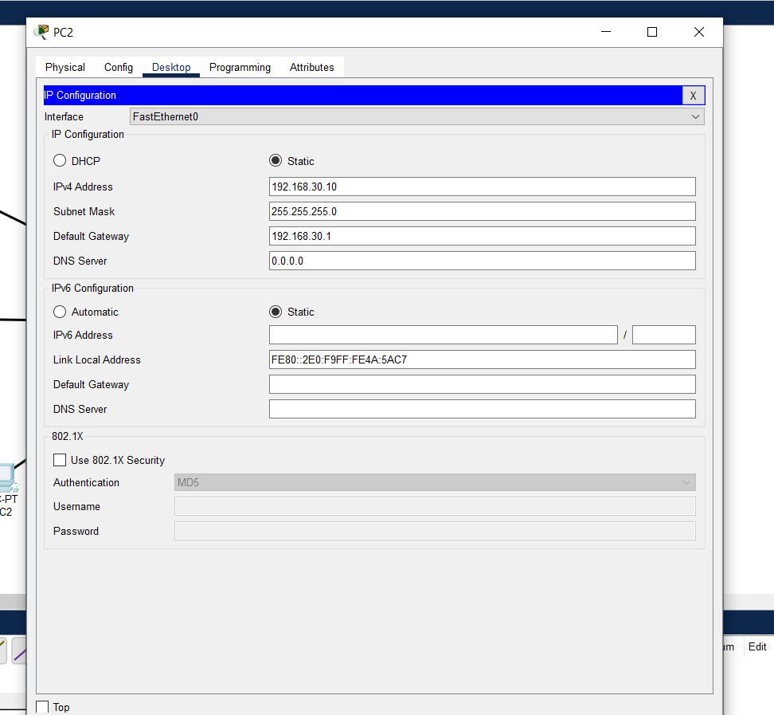

## 5. Ping Tests Between PCs

Description:  
Performed ping tests from each PC to PCs in the other VLANs. Successful pings confirm that inter-LAN routing is working correctly via the router subinterfaces.

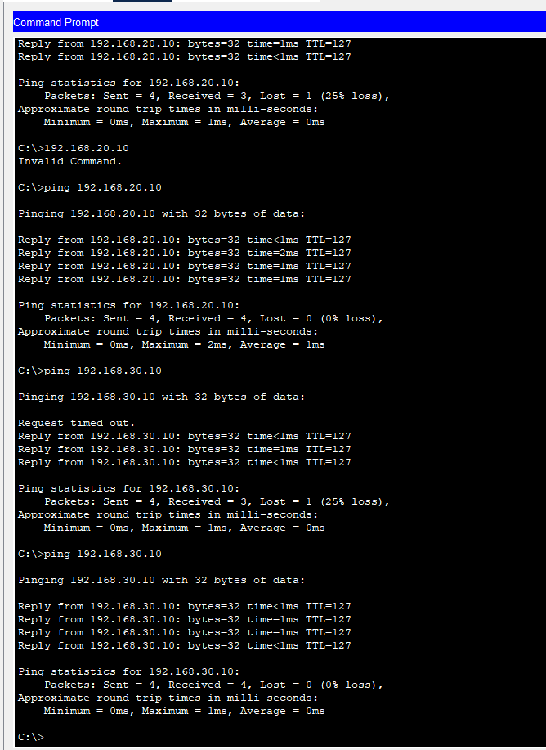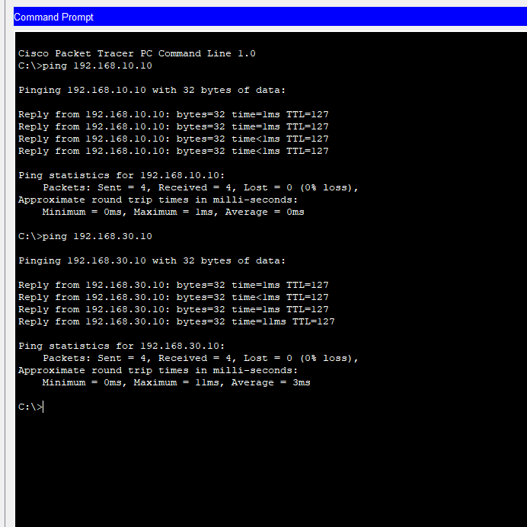

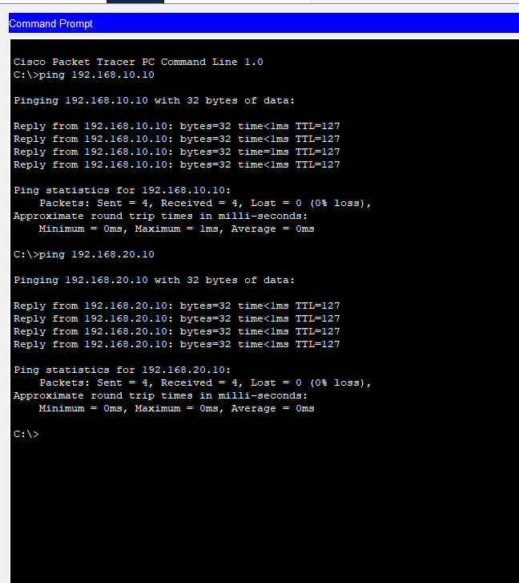

## 6. Router Interface Status Verification

Description:  
Displayed the status of the router’s physical interface and subinterfaces, confirming all are up and correctly configured for inter-VLAN routing.

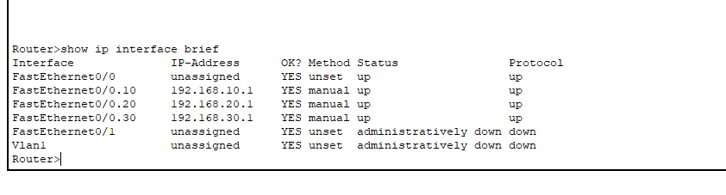

## 8. Switch VLAN and Port Status Verification

Description:  
Checked VLAN assignments and port status on the switch to confirm proper VLAN membership and trunk port operation.

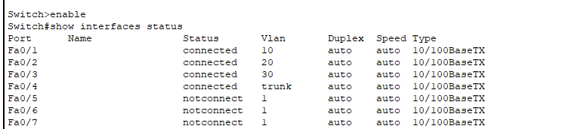

**End of Report**