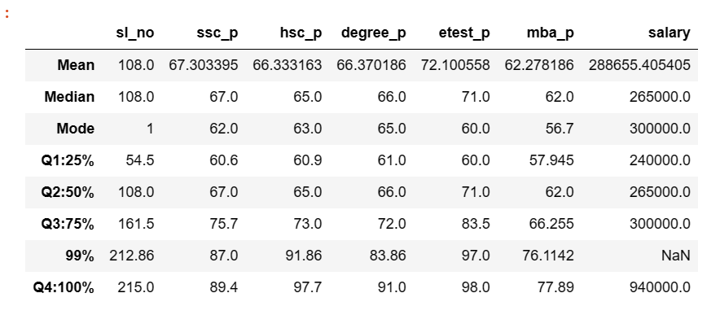

In SSC mark 1st 25 percentile of students got 61% marks

In SSC mark 1st 50 percentile of students got 67% marks

In SSC mark 1st 75 percentile of students got 75%marks

In SSC mark 1st 100 percentile of students got 89% marks

In 12th mark 1st 25 percentile of students got 61% marks

In 12th mark 1st 50 percentile of students got 65% marks

In 12th mark 1st 75 percentile of students got 73%marks

In 12th mark 1st 100 percentile of students got 98% marks

In Degree mark 1st 25 percentile of students got 61% marks

In Degree mark 1st 50 percentile of students got 66% marks

In Degree mark 1st 75 percentile of students got 72%marks

In Degree mark 1st 100 percentile of students got 91% marks

In entrance mark 1st 25 percentile of students got 60% marks

In entrance mark 1st 50 percentile of students got 71% marks

In entrance mark 1st 75 percentile of students got 84%marks

In entrance mark 1st 100 percentile of students got 98% marks

In MBA mark 1st 25 percentile of students got 58% marks

In MBA mark 1st 50 percentile of students got 62% marks

In MBA mark 1st 75 percentile of students got 66%marks

In MBA mark 1st 100 percentile of students got 77% marks