**Test1 Patel Femina**

**Machine Learning N03094115**

% converting wine.csv to wine.mat

Wine=csvread('wine.csv');

save('wine.mat','Wine')

**Question 1**

% Taking the first 1280 data rows and calling them the training set

trainingset=Wine(2:1281,:);

**Question 2**

% Taking the remaining rows and calling them the test set

testset=Wine(1282:1600,:);

**Question 3**

% Model M1 using training set

x=trainingset(:,[1 7]);

% columns 1 and 7 are for acidity and sulphite level of wine respectively

y=trainingset(:,9);

% column 9 is for quality of wine

[J_h,t_h]=testGradientDescend(x,y,1.0,0.5,0.5,0.01,2000)

% Given values for Ө0, Ө1, Ө2, α and max Iterations are 1.0, 0.5, 0.5, 0.01, 2000 respectively

% value of J_h goes from 0.62720 to 0.35760 and the corresponding Ө values are 1, 0.5, 0.5 to %2.96316, 0.19935, 1.40583. Lower the value of cost function, better the model.

% So **0=2.96316, 1=0.19935 and 3=1.40583**

% Graph of the cost function as the iterations proceed for Model M1

plot(J_h,'rx');

xlabel('Iterations #');

ylabel('Cost Function, J');

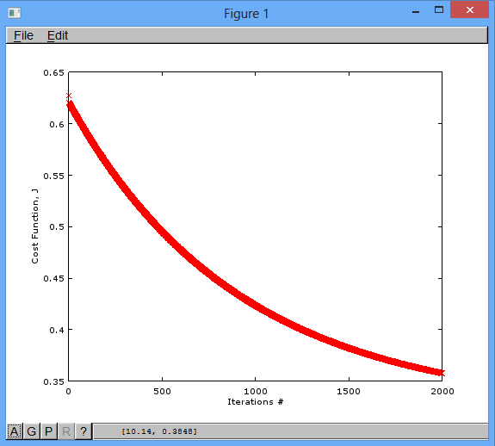

Hypothesis function for model M1, hӨ(x) = Ө0*x0 + Ө1*x1 + Ө2*x2

By default we take x0=1

So equation is Ө0 + Ө1*x1 + Ө2*x2

Placing the values of Ө0, Ө1 and Ө2 from above we get

**hӨ(x) = 2.96316 + 0.19935*x1 + 1.40583 *x2**

**Question 4**

% Model M2 using training set

x1=trainingset(:,[3 6]);

% columns 3 and 6 are for sugar and pH level of wine respectively

y1=trainingset(:,9);

% column 9 is for quality of wine

[J_h,t_h]=testGradientDescend(x1,y1,1.0,0.5,0.5,0.01,2000)

% Given values for Ө0, Ө1, Ө2, α and max Iterations are 1.0, 0.5, 0.5, 0.01, 2000 respectively

% value of J_h goes from 2.04119 to 0.35864 and the corresponding Ө values are 1, 0.5, 0.5 to %1.450857, 0.038766, 1.243855. Lower the value of cost function, better the model.

% So **0=1.450857, 1=0.038766 and 3=1.243855**

% Graph of the cost function as the iterations proceed for Model M2

plot(J_h,'rx');

xlabel('Iterations #');

ylabel('Cost Function, J');

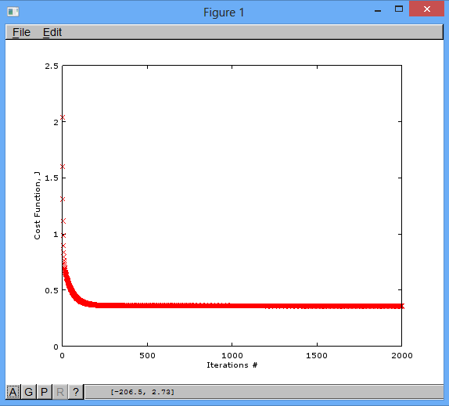

Hypothesis function for model M2, hӨ(x) = Ө0*x0 + Ө1*x1 + Ө2*x2

By default we take x0=1

So equation is Ө0 + Ө1*x1 + Ө2*x2

Placing the values of Ө0, Ө1 and Ө2 from above we get

**hӨ(x) = 1.450857 + 0.038766 *x1 + 1.243855*x2**

**Question 5**

% Evaluating cost function using Ө values of M1 to predict the quality of wine in the test data set

x3=testset(:,[1 7]);

y3=testset(:,9);

costFunForMultivariable(x3, y3, 2.96316,0.19935,1.40583)

ans = 0.32174

% Evaluating cost function using Ө values of M2 to predict the quality of wine in the test data set

x4=testset(:,[3 6]);

y4=testset(:,9);

costFunForMultivariable(x4, y4, 1.450857,0.038766,1.243855)

ans = 0.33412

As the value of cost function of Model M1 is lower than that of Model M2, **M1 is a better model**.