**TEST 3**

**Saumil Sabhaya ID: N02985643**

**Ans 1:**

function v = a_LinRegRegularized (xData, yData, x_vals,n,lambda)

m = length(xData);

m2= length(x_vals);

X = [ones(m,1) xData];

for i=2:n

X = [X xData.^i];

end

dg = eye(n+1);

dg(1,1) = 0;

x_tranpose = X';

theta = pinv(x_tranpose*X + lambda*dg)*x_tranpose*yData;

XINPUT = [ones(m2,1) x_vals];

for j=2:n

XINPUT = [XINPUT x_vals.^j];

end

v = theta'*XINPUT';

endfunction

**Ans 2(a):**

Regression Curve for degree 7 polynomial for different lambda values

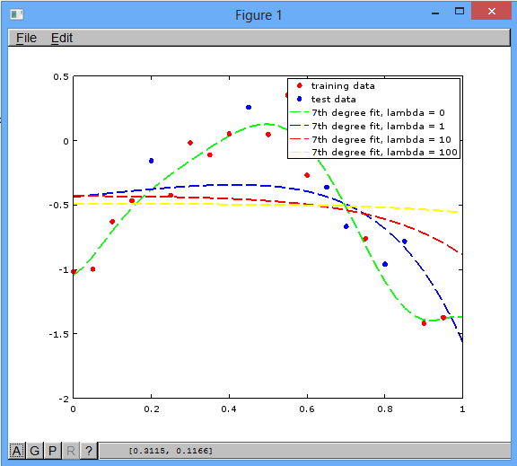

**Ans 2(b):**

Regression Curve for degree 10 polynomial for different lambda values

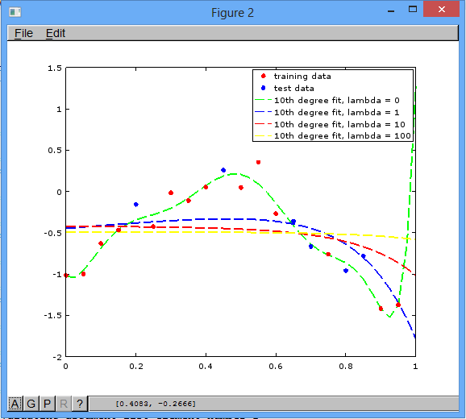

**Ans 2(c):**

Regression Curve for degree 12 polynomial for different lambda values

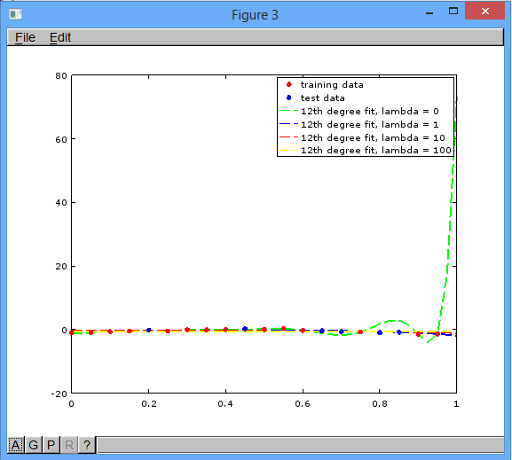

**Ans 2(d):**

Regression Curve for degree 14 polynomial for different lambda values

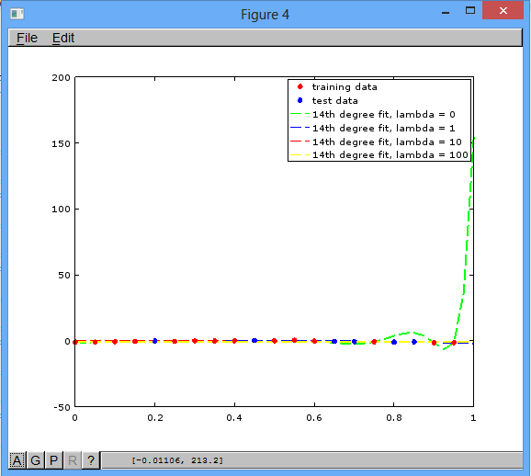

**Ans 2(e):**

Regression Curve for degree 16 polynomial for different lambda values

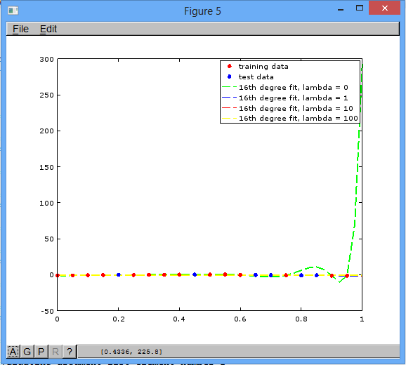

**Ans 3:**

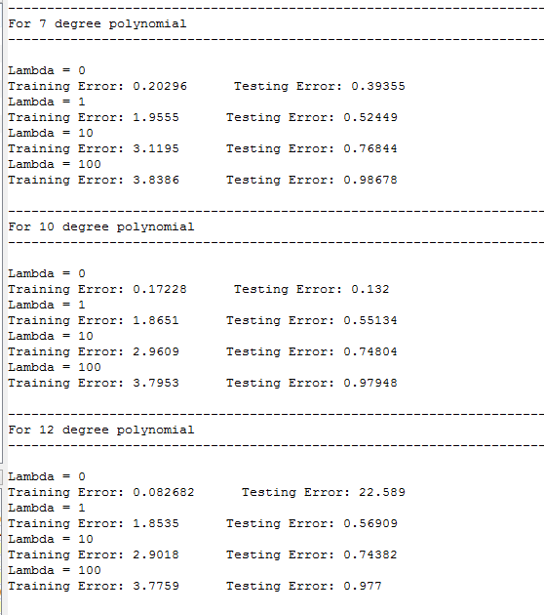

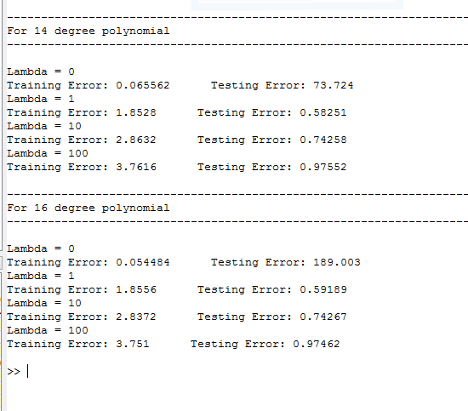

**Ans 4:**

Overfitting occurs when the algorithm fits the data too well. More the value of degree of polynomial, more is the overfitting because it can cover most of the training data points.

When we apply regularization, as we increase the value of lambda, there will be an increase in the error function of the training data. When the degree of polynomial is less, error function for test data will also increase with increase in lambda values. And when there is an increase in the degree of polynomial, with increase in lambda values, there will be decrease in the error function of the test data and after that with increase in lambda, the value of cost function for test data will increase again but at a very slow pace.