Website Development Project

Website Project Proposals
Two candidate organisations — Part 1
Student Name: Mafemani Mongwe
Student Number: 10516411

Proposal 1: Bean & Leaf Roastery

1. Organisation Overview
Name: Bean & Leaf Roastery (fictional small business)
Bean & Leaf Roastery is a fictional independent coffee roastery and café founded in 2019 by two friends passionate about specialty coffee. Starting as a small roasting operation supplying local cafés, it has grown into a flagship store with a loyal social media following, but has never had a dedicated website.
Mission: To source and roast ethical, high-quality coffee while supporting local farmers and building a genuine community around specialty coffee.
Vision: To become the leading destination for specialty coffee in Johannesburg, known for quality, sustainability, and community.
Target Audience: Coffee enthusiasts and young professionals aged 25-40, students and remote workers seeking a café to work from, and local cafés/retailers interested in wholesale supply.

2. Website Goals and Objectives
Goals:
- Establish an online presence that reflects the brand and product range.
- Generate wholesale and supply enquiries from local cafés and retailers.
- Provide customers with up-to-date information on products, locations and opening hours.
- Grow an email subscriber base for promotions and new product launches.
Key Performance Indicators (KPIs):
- Increase overall website traffic by 30% within the first 6 months of launch.
- Generate at least 50 wholesale/supply enquiries per quarter via the enquiry form.
- Reach 500 newsletter sign-ups within the first 3 months.
- Achieve an average session duration of 2+ minutes, indicating engaged browsing.

3. Current Website Analysis
Bean & Leaf Roastery currently has no dedicated website and relies solely on Instagram and Facebook to communicate with customers.
Strengths:
- An engaged Instagram following of over 5,000 people.
- Strong, recognisable visual brand identity already established on social media.
Weaknesses / Areas for Improvement:
- No centralised, searchable information on products, pricing or store hours.
- No formal channel for wholesale or supply enquiries.
- Information about store locations is scattered and sometimes out of date.

4. Proposed Website Features and Functionality
- Homepage (index.html): Hero image of the roastery/café, brief introduction, call to action ("Shop Beans" / "Enquire Wholesale"), navigation menu.
- About Us (about.html): Company history, mission and vision, team/roaster profiles.
- Products (products.html): Coffee bean varieties, brewing equipment, and subscription options with descriptions.
- Enquiry (enquiry.html): Form for wholesale/supply enquiries from cafés and retailers.
- Contact (contact.html): Contact details, map showing both store locations (CBD flagship and Sandton kiosk), and a contact form.

5. Design and User Experience
Colour Scheme: Warm, earthy palette: coffee brown (#4B3621), cream (#F5E9DA) and burnt-orange accent (#D2691E), evoking warmth and craft.
Typography: A warm serif (e.g. Playfair Display) for headings paired with a clean sans-serif (e.g. Open Sans) for body text, for a balance of character and readability.
Layout and Design Approach: A clean, image-forward grid layout that highlights product photography, with a single-column layout on mobile for easy browsing.

6. Website Wireframes
Low-fidelity wireframes for each of the five planned pages, showing the intended placement of the header, navigation, hero/banner area, main content blocks and footer.

6.1 Homepage (index.html)
HEADER: Logo + Site Title
NAVIGATION: Home | About | Products | Enquiry | Contact
HERO: Roastery image, tagline, "Shop Beans" / "Enquire Wholesale" CTA buttons
Featured Products | About Teaser | Newsletter Sign-up
FOOTER: Contact info | Social links | Copyright
Figure 1: Homepage wireframe

6.2 About Us (about.html)
HEADER: Logo + Site Title
NAVIGATION: Home | About | Products | Enquiry | Contact
HERO: "Our Story" banner image
Company History | Team / Roaster Profiles | Mission & Vision
FOOTER: Contact info | Social links | Copyright
Figure 2: About Us wireframe

6.3 Products (products.html)
HEADER: Logo + Site Title
NAVIGATION: Home | About | Products | Enquiry | Contact
HERO: "Shop Our Range" banner
Coffee Beans | Brewing Equipment | Subscriptions
FOOTER: Contact info | Social links | Copyright
Figure 3: Products wireframe

6.4 Enquiry (enquiry.html)
HEADER: Logo + Site Title
NAVIGATION: Home | About | Products | Enquiry | Contact
HERO: "Partner With Us" wholesale banner
Wholesale Enquiry Form | Why Partner With Us | Contact Details
FOOTER: Contact info | Social links | Copyright
Figure 4: Enquiry wireframe

6.5 Contact (contact.html)
HEADER: Logo + Site Title
NAVIGATION: Home | About | Products | Enquiry | Contact
HERO: "Visit Us" banner
Store Locations Map | Contact Form | Opening Hours
FOOTER: Contact info | Social links | Copyright
Figure 5: Contact wireframe (both store locations shown on map)

7. Estimated Budget
Development will be completed in-house as part of this project, so costs below reflect ongoing running costs (hosting, domain, maintenance).
Item | Estimated Cost (ZAR) | Frequency
Domain registration | R250 | Annual
Web hosting | R150 | Monthly
SSL certificate | R0 (included with hosting) | Annual
Ongoing maintenance / content updates | R500 | Monthly
Stock images/icons (Unsplash, Creative Commons) | R0 | Once-off

8. Project Timeline (Part 1)
Week | Milestone
Week 1 | Finalise and submit project proposal for approval.
Week 2 | Conduct research and gather content, images and assets.
Week 3 | Design sitemap and set up file/folder structure and GitHub repository.
Week 4 | Build basic HTML structure for all 5 pages (header, nav, main, footer).
Week 5 | Integrate researched content into HTML files with appropriate tags.
Week 6 | Test across browsers, fix issues, comment code, and push final commits.

Proposal 2: Paws & Hope Animal Shelter

1. Organisation Overview
Name: Paws & Hope Animal Shelter (fictional NPO)
Paws & Hope is a fictional non-profit animal shelter established in 2015. Run largely by volunteers, it rescues, rehabilitates and rehomes abandoned and at-risk animals, and relies on donations and community support to operate.
Mission: To rescue, rehabilitate and rehome abandoned and at-risk animals, while educating the community on responsible pet ownership.
Vision: A community in which every animal has a safe, loving home.
Target Audience: Prospective pet adopters (individuals and families aged 20-55), donors and corporate sponsors, volunteers, and community members concerned about animal welfare.

2. Website Goals and Objectives
Goals:
- Increase visibility of animals available for adoption.
- Grow the volunteer base and simplify the sign-up process.
- Increase recurring donations and sponsorships.
- Raise awareness of responsible pet ownership and the shelter's work.
Key Performance Indicators (KPIs):
- Increase online adoption enquiries by 40% within 6 months of launch.
- Recruit at least 15 new volunteers per quarter via the website.
- Grow the number of monthly recurring donors by 25 per quarter.
- Grow the newsletter subscriber base to 1,000 within the first year.

3. Current Website Analysis
Paws & Hope currently has no dedicated website and relies on a Facebook page to post updates, adoption listings and appeals for donations.
Strengths:
- An active and engaged Facebook community of over 3,000 followers.
- Regular, well-received posts about individual animals looking for homes.
Weaknesses / Areas for Improvement:
- No centralised or searchable list of animals currently available for adoption.
- No simple online mechanism for donors to give, or for volunteers to sign up.
- Information about the organisation and its programmes is scattered across posts rather than presented clearly.

4. Proposed Website Features and Functionality
- Homepage (index.html): Hero image of rescued animals, brief introduction, call to action ("Adopt Now" / "Donate"), navigation menu.
- About Us (about.html): Organisation history, mission and vision, and profiles of key staff/volunteers.
- Get Involved (services.html): Animals available for adoption, volunteering opportunities, and sponsorship programmes.
- Enquiry (enquiry.html): Form allowing visitors to enquire about volunteering or becoming a sponsor.
- Contact (contact.html): Contact details, map showing both the main shelter and a satellite adoption centre, and a contact form.

5. Design and User Experience
Colour Scheme: A warm, trustworthy palette: teal-green (#2E8B79), warm yellow (#F4B942) and a soft cream/white background, chosen to feel caring and approachable.
Typography: A rounded, friendly sans-serif (e.g. Poppins) for headings paired with a highly readable sans-serif (e.g. Lato) for body copy.
Layout and Design Approach: A warm, photography-led design using a card-based grid to showcase animals available for adoption, built mobile-first given the largely mobile social-media audience.

6. Website Wireframes
Low-fidelity wireframes for each of the five planned pages, showing the intended placement of the header, navigation, hero/banner area, main content blocks and footer.

6.1 Homepage (index.html)
HEADER: Logo + Site Title
NAVIGATION: Home | About | Get Involved | Enquiry | Contact
HERO: Rescued animal image, tagline, "Adopt Now" / "Donate" CTA buttons
Featured Animals | Our Mission | Donate / Volunteer CTA
FOOTER: Contact info | Social links | Copyright
Figure 1: Homepage wireframe
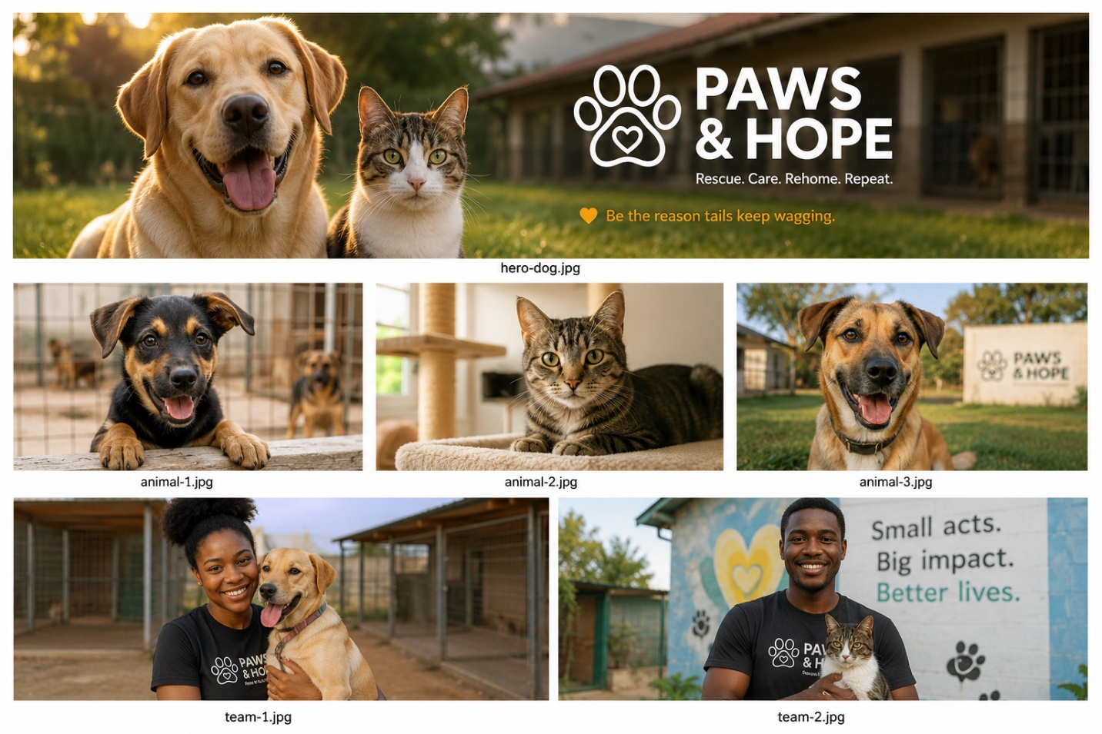

6.2 About Us (about.html)
HEADER: Logo + Site Title
NAVIGATION: Home | About | Get Involved | Enquiry | Contact
HERO: "Our Story" banner image
Organisation History | Mission & Vision | Team / Volunteer Profiles
FOOTER: Contact info | Social links | Copyright
Figure 2: About Us wireframe

6.3 Get Involved (services.html)
HEADER: Logo + Site Title
NAVIGATION: Home | About | Get Involved | Enquiry | Contact
HERO: "Get Involved" banner
Adoptable Animals | Volunteer Opportunities | Sponsorship Programmes
FOOTER: Contact info | Social links | Copyright
Figure 3: Get Involved wireframe

6.4 Enquiry (enquiry.html)
HEADER: Logo + Site Title
NAVIGATION: Home | About | Get Involved | Enquiry | Contact
HERO: "Volunteer or Sponsor" banner
Volunteer / Sponsor Enquiry Form | Why Get Involved | Contact Details
FOOTER: Contact info | Social links | Copyright
Figure 4: Enquiry wireframe (supports volunteer AND sponsor enquiries)

6.5 Contact (contact.html)
HEADER: Logo + Site Title
NAVIGATION: Home | About | Get Involved | Enquiry | Contact
HERO: "Visit Us" banner
Shelter Locations Map | Contact Form | Opening Hours
FOOTER: Contact info | Social links | Copyright
Figure 5: Contact wireframe (main shelter + satellite adoption centre shown on map)

7. Estimated Budget
Development will be completed in-house as part of this project. Costs below cover ongoing running costs, including online donation processing.
Item | Estimated Cost (ZAR) | Frequency
Domain registration | R250 | Annual
Web hosting | R150 | Monthly
Online donation gateway fees (e.g. PayFast, ~2.9% + R2/txn) | Variable | Per transaction
Ongoing maintenance / content updates | R500 | Monthly
Stock images/icons (Unsplash, Creative Commons) | R0 | Once-off

8. Project Timeline (Part 1)
Week | Milestone
Week 1 | Finalise and submit project proposal for approval.
Week 2 | Conduct research and gather content, images and assets.
Week 3 | Design sitemap and set up file/folder structure and GitHub repository.
Week 4 | Build basic HTML structure for all 5 pages (header, nav, main, footer).
Week 5 | Integrate researched content into HTML files with appropriate tags.
Week 6 | Test across browsers, fix issues, comment code, and push final commits.

