Ornstein-Uhlerbeck process:

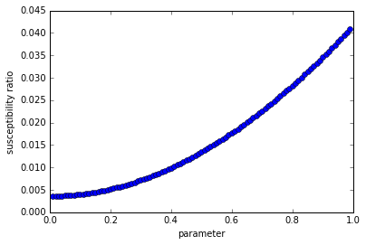

Energybalance

1. Normal results
2. Emergent constraints

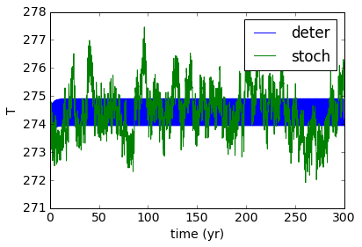

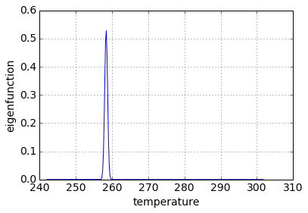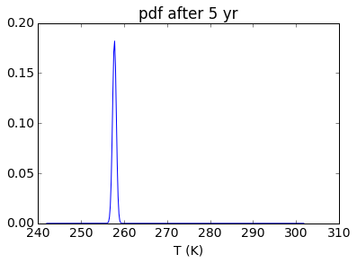

Left: Using Chang-Cooper to calculate matrix, then matrix exponential.  
Right: calculating first eigenvector of discretized operator.

