Design and Implementation Overview

**Class Structure Diagram**

The following diagram demonstrates the relationships and dependencies among the classes in the project:

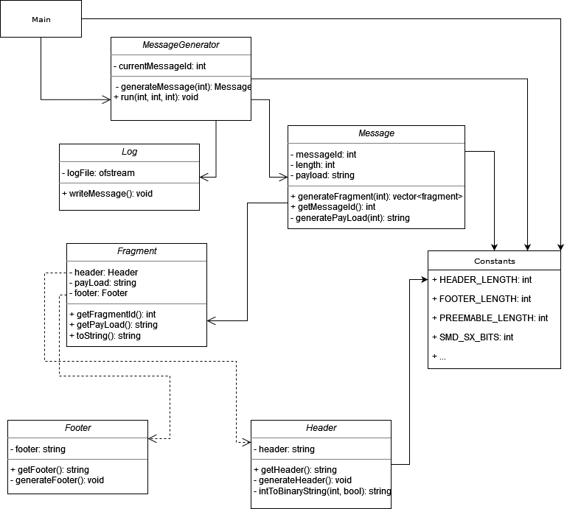

**Code Components**

**1. main.cpp**

The main.cpp file contains the main() function, which serves as the entry point of the application. It parses command-line arguments to get the number of messages, message length, and channel width. It then creates an instance of MessageGenerator and calls its run() method to start the message generation process.

**2. MessageGenerator**

The MessageGenerator class is responsible for creating and managing messages and their fragments. Its primary function is run(), which performs the following tasks:

* **Loop Through Messages**: Iterates over the number of messages to be generated.
* **Create Message Objects**: For each message, it creates an instance of the Message class.
* **Generate Fragments**: Calls the generateFragments() method of the Message object.

**3. Message**

The Message class handles the creation of message fragments. Its generateFragments() method does the following:

* **Calculate Payload Size**: Determines the size of each fragment based on the channel width and message length.
* **Create Fragment Objects**: Loops over the message payload and creates fragments. Each fragment is sized to fit within the channel width, considering headers and footers.
* **Handle Padding**: If a fragment is shorter than the channel width, it is padded with zeros.

**4. Fragment**

The Fragment class represents a single fragment of a message. It has the following member variables:

* **Header**: An instance of the Header class, which is created based on whether the fragment is the first or last in the message.
* **Payload**: The actual data of the fragment.
* **Footer**: An instance of the Footer class, which is determined based on whether the fragment is the last one in the message, padded with 0s if the fragment length is less than the channel width.

**5. Header**

The Header class handles the header for each fragment. It takes a boolean isFirstFragment to determine the appropriate header format. The header contains:

* **Preamble**: Fixed 6 bytes of 0x07.
* **SMD-Sx**: Message ID in a 2-bit field.
* **SFD**: Fixed value 0xD5 for the first fragment, otherwise, the fragment count 0xXX.

**6. Footer**

The Footer class represents the footer for each fragment. It takes a boolean isLastFragment to determine whether the footer should be:

* **Last Fragment**: Fixed 0xAABBCCDD.
* **Other Fragments**: Fixed 0x11223344.

**7. Logger**

The Logger class is responsible for writing the generated fragments to a file. It logs each fragment along with its message ID and fragment ID to message_log.txt in the docs/ directory.

**How the Code Works**

1. **Initialization**: The main() function initializes the MessageGenerator with the command-line arguments.
2. **Message Generation**: The MessageGenerator creates Message objects and calls generateFragments() for each message.
3. **Fragment Creation**: Each Message object generates fragments based on the payload and channel width.
4. **Header and Footer Handling**: Each fragment has a header and footer created according to its position (first, last, or intermediate).
5. **Padding**: Fragments shorter than the channel width are padded with zeros.
6. **Logging**: The Logger writes the details of each fragment to message_log.txt.

**Makefile and Running the Program**

Ensure that you have a Makefile in the project root to build and run the program. The Makefile should handle compiling, linking, and cleaning tasks. Use the make command to build the project and make run ARGS="arg1 arg2 arg3" to execute it with command-line arguments, where:

arg1: number of messages.

arg2: length of the message payload (in bytes).

arg3: channel width (in bytes).

**Sample Output**

Here are examples of how the output is logged:

make run ARGS="2 6 20"

1. **Non-fragmented Messages**:

2 messages with length 6 and channel width of 20:

1, 1, 07 07 07 07 07 07 00 D5 FF FF FF FF FF FF AA BB CC DD 00 00

2, 1, 07 07 07 07 07 07 01 D5 FF FF FF FF FF FF AA BB CC DD 00 00

make run ARGS="2 5 15"

1. **Fragmented Messages**:

2 messages with length 5 and channel width of 15:

1, 1, 07 07 07 07 07 07 00 D5 FF FF FF 11 22 33 44

1, 2, 07 07 07 07 07 07 00 00 FF FF AA BB CC DD 00

2, 1, 07 07 07 07 07 07 01 D5 FF FF FF 11 22 33 44

2, 2, 07 07 07 07 07 07 01 00 FF FF AA BB CC DD 00