Design and Implementation Overview

**Project Overview**

This project is designed to simulate the generation of **Ethernet packets** and **eCPRI IQ Message Type 0 packets**. The program allows for the configuration of various parameters, such as packet size, burst periodicity, and the number of IQ samples, while ensuring proper 4-byte alignment of the generated packets. The project also generates packets in bursts, adhering to time and alignment constraints, and allows output of the generated packets in JSON format.

**Class structure diagram**

**Key Components**

**1. main.py**

This is the **entry point** of the program. It:

* Loads the configuration from config.txt.
* Instantiates the PacketGenerator class.
* Starts the packet generation process.

**2. config.py**

The Config class handles reading and parsing the configuration file (config.txt). It is responsible for:

* Loading parameters such as STREAM_DURATION_MS, BURST_SIZE, BURST_PERIODICITY_US, IFGs_NUMBER, SOURCE_ADDRESS, and others.
* Providing the configuration values to the PacketGenerator.

**3. packet.py**

This is the core of the packet generation logic. It contains the PacketGenerator class, which:

* **Generates Ethernet and eCPRI packets** based on the configuration.
* **Handles burst generation**, ensuring each burst sends a specified number of packets (BURST_SIZE) and respects the burst periodicity (BURST_PERIODICITY_US).
* **Manages 4-byte alignment** of packets by adding appropriate padding with IFGs (inter-frame gaps).
* **Writes generated packets** to a JSON file (packets.json), including their structure and contents.
* **Simulates time** during packet generation to match the streaming duration (STREAM_DURATION_MS).

**Key Methods:**

* + **generate_packets()**: Generates packets in bursts and logs them in the packets.json file, simulating the time for each burst and handles time limit for currently generating packets.
  + **create_packet()**: Generates a single Ethernet packet containing payload either random bytes or an eCPRI frame.
  + **send_ifgs()**: Sends IFGs after each burst to ensure proper spacing and alignment.

**4. ethernet_frame.py**

This module defines the EthernetFrame class, which:

* Constructs Ethernet frames with fields like **source MAC address**, **destination MAC address**, **EtherType**, **payload**, and **CRC**.
* **Preamble and SOF** are also added as part of the Ethernet frame structure.

**Key Methods:**

* + **build_frame()**: Builds the complete Ethernet frame, including the header data and payload with padding if needed for minimum packet length.

**5. ecpri_frame.py**

This module defines the eCPRIFrame class for constructing **eCPRI IQ Message Type 0 packets**. It:

* **Encapsulates the eCPRI frame** within an Ethernet frame.
* **Builds the eCPRI header** and appends the **IQ payload** (which can be random or fixed, as per the configuration).

**Key Methods:**

* + **build_frame()**: Constructs the complete eCPRI frame with header and payload.
  + **build_ecpri_header()**: Builds the 4-byte eCPRI header, including message type and payload length as per the eCPRI configuration.

**6. utils.py**

This module contains utility functions such as:

* **CRC calculation**: Used to calculate the CRC value for Ethernet frames.
* **IFG padding calculation**: Used to calculate how many bytes of padding is needed to align each the packets to a multiple of 4.

**7. config/config.txt**

The configuration file is used to set parameters for packet generation. It includes:

* **STREAM_DURATION_MS**: Total streaming duration in milliseconds.
* **PACKET_TYPE**: regular ethernet packet or eCPRI packet.
* **BURST_SIZE**: Number of packets sent per burst.
* **BURST_PERIODICITY_US**: Periodicity between bursts in microseconds.
* **IFGs_NUMBER**: Number of IFG bytes inserted after CRC.
* **SOURCE_ADDRESS**, **DESTINATION_ADDRESS**, **ETHER_TYPE**: Addresses and EtherType for Ethernet frames.
* **PAYLOAD_TYPE**: Specifies if the payload is random or fixed.
* **MAX_PACKET_SIZE**: Maximum size of each packet.
* **IQ_SAMPLE_NUM**: Specifies the number of IQ samples in one eCPRI packet.

**How It Works**

**1. Initialization**

* The program starts by reading the configuration from config/config.txt.
* A PacketGenerator object is created using the loaded configuration.

**2. Packet Generation**

* The generate_packets() method is invoked, which begins a time simulation and generates packets according to the configuration.
* The program generates packets in **bursts**. Each burst contains a specified number of packets (BURST_SIZE), and bursts are sent at intervals defined by BURST_PERIODICITY_US.

**3. Packet Structure**

* Each Ethernet packet consists of:
  + **Preamble and SOF**: Standard Ethernet preamble (7 bytes) and start-of-frame delimiter (1 byte).
  + **Destination MAC Address**: 6 bytes.
  + **Source MAC Address**: 6 bytes.
  + **EtherType**: 2 bytes.
  + **Payload**: Random or fixed payload based on configuration with minimum length of 46 bytes (padding is added as necessary).
  + **CRC**: 4 bytes for error detection.
* For eCPRI packets, the Ethernet frame contains an **eCPRI header** and **IQ payload**.
* eCPRI IQ Message Type 0 Structure:
  + **Common Header (4 bytes)**:
    - **Protocol Revision and concatenation indicator** (1 byte): Indicates the version of the eCPRI protocol, and the C indicator which indicates if there is another eCPRI frame following this frame or not.
    - **Message Type** (1 byte): Indicates the message type. For **IQ Message Type 0**, this is **0**.
    - **Message Length** (2 bytes): Specifies the length of the payload in bytes, **excluding the header**.
  + **IQ Payload** (Variable length):
    - This is the actual IQ data. It contains a sequence of **I/Q samples**.
    - The payload size is specified by the **Message Length** field in the header.

**4. Alignment and IFGs**

* After generating each burst, the program ensures that packets are **4-byte aligned** by adding IFGs as necessary.
* The IFGs (30 bytes by default) are inserted between bursts to maintain proper spacing and alignment.

**5. Simulation of Time**

* The program simulates time progression, ensuring that the total generation duration matches the STREAM_DURATION_MS specified in the configuration.

**6. Output**

* The generated packets are written to a **JSON file (packets.json)**, which contains the full structure and content of each packet.

**Sample output**

* **Regular Ethernet packet**

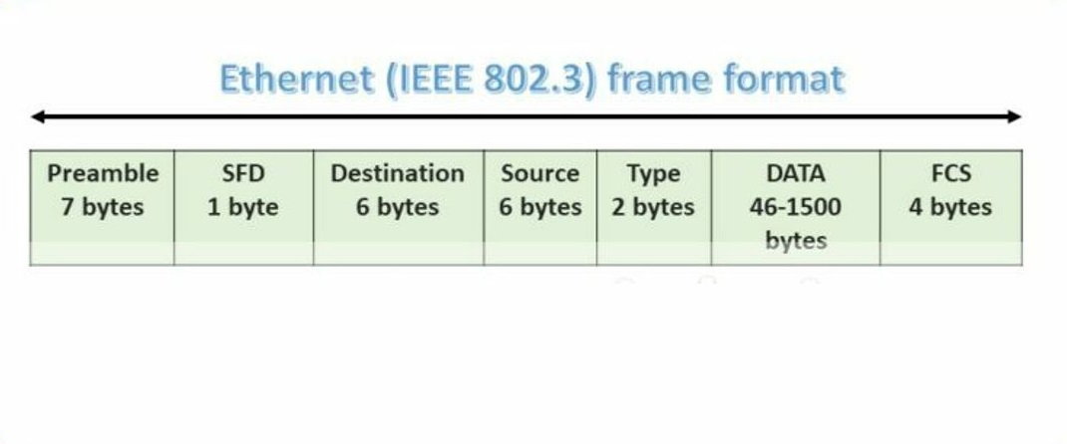

* {
* "preamble": "55555555555555",
* "SOF": "fd",
* "destination_adrs": "10:20:30:30:20:10",
* "source_adrs": "10:20:30:40:50:60",
* "ethertype/length": "0800",
* "data": "81e6106ccf20a9e511178470957586abeb0a5f45075d30b8bd92f4d507dbe0910000000000000000000000000000",
* "crc32": "064b54fa"
* }
* **eCPRI packet**

eCPRI data encapsulated inside the Ethernet packet

* {
* "preamble": "55555555555555",
* "SOF": "fd",
* "destination_adrs": "10:20:30:30:20:10",
* "source_adrs": "10:20:30:40:50:60",
* "ethertype/length": "aefe",
* "eCPRI data": {
* "version": 0,
* "message_type": 0,
* "message_length": 16,
* "data_payload": "d3077fec901c76d38a725fb9f0e56d7f",
* "padding": "0000000000000000000000000000000000000000000000000000"
* },
* "crc32": "3c804c00"
* }