Exercise 01

Task 1
RTL Analysis - Schematic
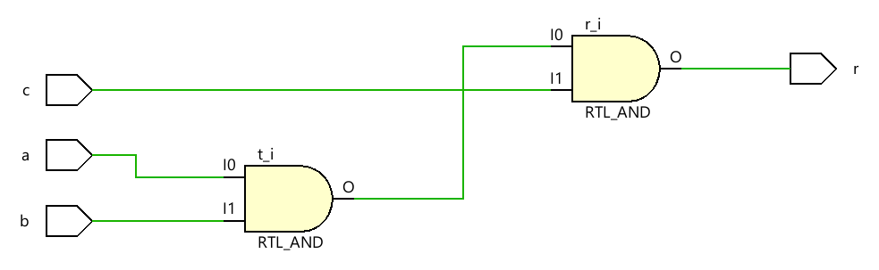

Synthesis - Schematic
