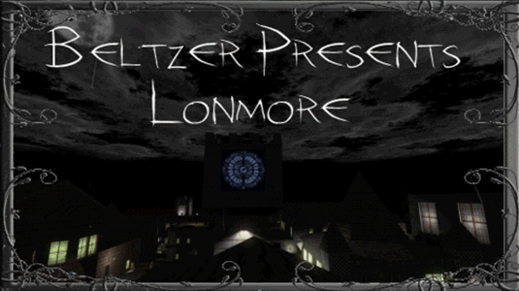

Title : Lonmore
Author : Beltzer
Contact info : beltzer2@hotmail.com
Date of release : 12 November 2021
Version : 1.2
Description : I left the City because the cops were getting too close to me.
I've been in this city, Lonmore, for a month now.
I have a nice apartment, rather expensive, so my savings are getting thin.
I love this city. Lots of rich people with fat purses.
But I need something bigger. Something that brings me a lot of loot.
I guess I could visit some other houses tonight, while I'm out. Time to begin.

==============================================================================
Play Information

Game : Thief 2: The Metal Age ND v1.27
File names : miss20.mis, miss21.mis, miss22
Equipment store : No
Difficulty Settings : Yes
Map/Automap : Yes/No
New graphics : Yes
New sounds : Yes
Language : English, German, Spanish
Briefing : Yes

==============================================================================
Known Bugs:

- Nothing crucial.

==============================================================================

My previous missions
Reunification Campaign
The Abandoned Castle
The Favour
Mortuos Liber Campaign
The Sister

Loading Information
Tested with AngelLoader and FMSelector

Thanks To:

Voice Actors
Cardia (Male behind window)
McTaffer (Prison Guard)
Redleaf (Mech Lady)
Samantha1 (Woman behind window)
SlyFoxx (Garrett)

Beta testers
Dardo
Draconigen
Fortuni
Mat99
Myles
Pete

All the texts - proofreading.
Dardo
McTaffer

German translation:
Baeuchlein

Spanish translation:
Dardo

Custom objects
Blackthief
Christine
Dale
Darkmax
DarkShadow
Elvis
Eshakataar
Firemage
Gamophyte
GORT
Greenhorn
LarryG
Lord Alan
Nameless Voice
Nicked
OttoJ55
R Soul
Sensut
Sliptip
Sluggs
Soul Tear
T2X
Targa
TDBonko
Team Calendra
Team Cosas
Team Rose Cottage
Vladimiroquai
Von.Eins
Yametha

Meshes and skins
Corsair
Darkmax
Purgator
TDBonko
Team Calendra
Team T2x

Textures
Enhancement pack
NecroAge
textures.com
sketchuptextureclub.com
Esse

Custom Scripts
KDScript
Nameless Voice
TnhScript

Sounds
Dario D
Tabias “Spadey” Scot

And, obviously, thanks to my fiancee Sandra for her moral support whilst putting up with me working on it 24/7.

==============================================================================
Copyright Information

This level is © by Beltzer. Distribution of this level is allowed in any way, shape, or manner you wish. However,
you must leave the mission intact and give me credit for it :-)

This level was not made and is not supported by Looking Glass Studios or Eidos Interactive.

==============================================================================

