Castle Michele
A Thief 2 FM by Ricebug & Xorak
Uses Dark Engine V1.22
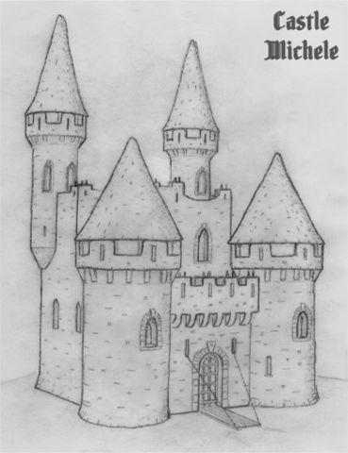

TURN ON WEATHER AND FOG TO PLAY THIS MISSION.

Rather thin plot line:

Garrett is approaching his retirement years. The last thing he needs is to take on another difficult challenge.
Unfortunately, an unexpected letter from Basso drops like a flash bomb from his front door mail slot. It seems that
some shady business may be behind a woman’s demise, a lady he vaguely remembers as ‘Michele.’ She got him
out of a jam in Murkbell. What goes around comes around. He decides to take the long trip into the country to
unravel this mystery.

Objects

Christine: Furniture, dishes, drapes, home decor

Daraan: Tree, cabinets
DEDX: Ice beast, Annie, stalactites

Digital Nightfall (COSAS): door, key, jewelry, loot

Elvis: Statue in castle hallway

Eshkataar: Light beams
Jason Otto: Furniture, grates, chain
LarryG: Paintings, castle doors, rat model

Pinkdot: Books, bookcases, iron hoop candle holder, candle

Ricebug: Animal skin rugs, stair banister

Textures

C-BEAM
Genetica
Nameless Voice
Jason Otto (AI skins)

Translators

Apiai (French)
Soldi (Russian)
Smallman_647 (Italian)
Zappen (German)

Quality Control

fortuni
itllrun10s
Peter Smith
Yandros
Apiai
Soldi
Smallman_647
Zappen

Intro Movie

Location: A Meeting With Basso (Calendra’s Legacy, by Purah)

Dulcimer Music: Bradley Fish
Fat Garrett: FireMage
Train Sequences: Train Simulator 2015
Software: Sony Movie Studio Platinum

Special thanks to Yandros for his technical assistance.

This level was not made and is not supported by Looking Glass Studios or Eidos Interactive.

