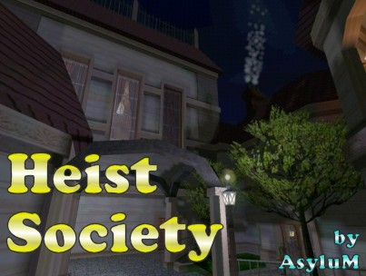

Author: AsyluM (Mark Smith)
Version: 1.0
Date of release: 11/05/04

Description: Sources have led you to believe that Lord Gellard, a noble renowned
for his vicious competitiveness, has gathered an exquisite collection of valuable
artifacts and rare gems in the enormous mansion on his sprawling estate in Hightowne.
You're in need of a big job right now to meet certain expenses, so the Gellard
Estate should fit the bill.

You've heard that Lord Gellard somehow manages to control portions of the city
leadership and aristocracy... getting proof of how he's doing this would give you
something you could use against him, or sell to one of his enemies. Supposedly,
Gellard even has a secret passage from his estate that comes out somewhere in
or near City Hall... finding it could prove very useful.

He is also reputed to have the best guards and security devices around... since he
has close ties to the Mechanists, he has a number of their security devices on the
grounds. Cleaning out the estate won't be easy, but then paying the rent never is...

* Play Information *

Mission Title: Heist Society
File name: miss25.mis
Difficulty Settings: yes
Equipment store: yes
Map / Automap: yes / yes
New graphics: yes
Multi language support: no
Briefing : no

This is my second FM. If you haven’t played my first, Hidden Agenda, give
it a try too. However, this is NOT a sequel, so doing so isn’t necessary.

Difficulty level info:
There are numerous differences between the difficulty levels:
- Numbers of AIs and their patrol routes
- Locations of keys and other important items
- Bonus objectives
Also, your starting location varies:
Normal - Just inside the servant’s back entrance
Hard - On the grounds, by the front entrance
Expert - On the grounds, in the graveyard

* Construction *

Base: Built from scratch
Build Time: About a year, off more than on
Completion Time (Gold phase): About eight months

BIG Thanks to:
Alpha / Beta Tester - RiCh
Beta Testers - Nightwalker, Peter Smith

Gold Development Team:
Story completion/refinement: Moghedian, SlyFoxx
Dromed work: Yandros, VladMidnight, Moghedian
Additional Testers:
Nightwalker, Morrgan, Peter Smith, Dafydd, FreddyFox

Custom Textures and Objects:
Balatro, GOB, AsyluM - Textures
Targa - Various custom objects
Eshaktaar – New flames
Yandros – New bookcase
Rob Hicks and the DedX team - DromEd Deluxe

New sounds:
Voice work – SlyFoxx, Cainam and Moghedian, prepared by Yandros
Music - Vivaldi, The Four Seasons, Spring III
Thunder ambient 1 – from Gaetane’s FM The Korrigans
Thunder ambients 2 & 3 – Prepared by FreddyFox, taken from
http://www.partnersinrhyme.com/soundfx/Weather.shtml

If you spot your work in this mission and don't see your name in this list,
please contact Yandros and this file will be updated.

Additional Thanks To:
Epithumia - File hosting
Avalon - For creating the very useful TOW
Posters on TTLG TEG forum - For making DromEding somewhat easier :)

Yandros REALLY wants to thank:
Mark (AsyluM) for creating such a great mission and nearly finishing it for us.
Matt (VladMidnight) for so doggedly pursuing the completion of it.
Melissa (Moghedian) for her tremendous effort on reworking the story and texts.
The whole Gold team for all the hard work that went into getting this thing released.

* Loading information *

This level is Darkloader ready.

* Copyright *

This level is (c) by Mark Smith, 5th November 2004

Distribution of this level is allowed as long as it is free and the package is
kept intact. You may not include this level to any map pack without my permission.
No one may edit and re-distribute this mission without my express permission.

This level was not made and is not supported by Looking Glass Studios or Eidos Interactive.

