Morbid Curiosity
NewDark 1.24
Author: PukeyBrunster
Release date: October 2016
Version: 1.1 (see below for updates)

Important Note: You may need to run the game on Newdark 1.24 for it to work properly, as well as disabling any mods. Some players have had inexplicable crashes, which I am hoping either of the above can fix.

STORY:

The Hammers are after an item called The Builder’s Rattle. It’s an ancient icon that was stolen by one of their own priests.

Thieving from a thief is always irresistible. No doubt this priest is on the run, and I’ve learned that the item is on its way to Bledwater. It’s a town about two days from here, where my contact Peyton has been fencing some of my more high profile items over the years.

I’ll need Peyton to stash some equipment for me, as I’ll be swimming in under Southgate. On my last visit, I spent most of the time in a prison cell, and I’d rather not announce my arrival this time just in case they remember me.

This part of town is known for its tourists, and with any luck I can blend in with the rogues and merchants who flock here. After I finish the job, maybe I’ll take in some sights, sample the wines, or visit the shops like the rest of them. At any rate, I’m looking forward to a change of scenery.

This priest won’t even know what hit him by the time I’ve sold his hammer to the highest bidder, and taken my leave.

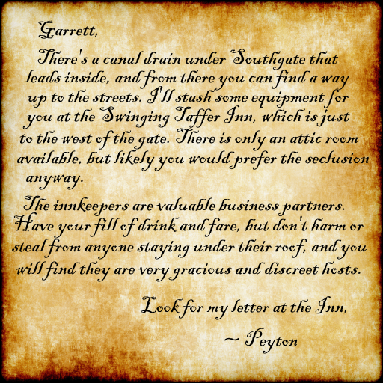
VERSION 1.1 UPDATES:
Some spoilers ahead. Added notes page to map section. Removed two placed ropes due to these possibly causing errors, as neither are really necessary in the mission. Leveled volume on some ambients, fixed the curator’s window (this should not be the way into the Gallery), canal torch supports now not-frobbable, no more banner appearing upon destruction of canal beastie, Builder’s Rattle should no longer disappear if accidentally frobbed on incorrect object, got rid of some superfluous lockpicks, made elevator buttons on Gallery lift more visible, made exit to Gallery Tour remain open in case player wants to return, removed block pathfind on town gates.. although this does add a small annoyance, as AI trying to run through gates cause that lock sound to play over and over. Other minor fixes.

New loot list included with the zip – it’s incomplete (even I can’t find it all) and the mission is too large to run a dump to track it down. The list is fairly comprehensive though, and will at least help you to reach minimum loot goal. Please feel free to PM me here if you can add to this list!

DIFFICULTY:
Normal: Fewer AI, easier/optional objectives
Hard: Some fewer AI, somewhat easier/optional objectives
Expert: Challenging, with additional optional objective not available in other levels

KNOWN ISSUES:
There are some readables that are triggers to complete objectives, or set off a sequence of events. Although you don’t have to read them, you will need to frob some of them, and it is suggested you should try to read them to make completing the mission easier. Most contain clues or information relative to the mission, and I aimed for brevity where possible so as to avoid long readables.

Beta Testers did not run into this, but on occasional playthroughs, the player’s arm has disappeared on me. Weapons work fine, but the visible arm of Garrett can't be seen. This seems to happen when too many AI are alerted at one time, but so far I am the only person who has experienced this. In case this happens to you, I have been able to remedy by starting the mission over.

Do not use up all of your arrows (water, earth, fire, gas) or you won’t be able to complete a certain objective later on. Near the certain area these arrows can be found – you just have to look around for them, and don’t use them all up from there.

Some players have had trouble with sound. I downgraded certain sound files to 16 bit (thank you Fen!) which I am told works with Hardware Acceleration and EAX turned on. Otherwise, the only fix has been to disable HA and EAX.

PLAY INFORMATION:

Game: Thief 2: The Metal Age
File name: miss20.mis
Difficulty Settings: Yes
Equipment store: No
Map/Automap: Yes/No
New graphics: No
New sounds: Yes
New models: Yes
EAX Support: No
Multi language support: English only
Briefing: No

CONSTRUCTION:
Base: From scratch
Map Size: Large-ish. Not huge. File size large due to heavy custom content.
Build Time: About 16 months (not counting scratched attempts)

SYSTEM REQUIREMENTS:
NV & TNH custom scripts need to be installed for game to work properly (included with zip).
Created on HD Pavilion integrated graphics card.
Windows 7 / 64 bit quad core /2.60 GHZ / 8 GB RAM

CREDITS

TESTERS:

Cardia, Ittlrun10s, Gloria Creep, and Ravenhook – thank you for your hard work and encouraging feedback. I owe you a lot of deer legs ;-)

TEXTURES & OBJECTS:

Textures.com, Thief Object Repository, and some of your fan missions. Please let me know if I forgot to credit you, so that I can add you to this list, ask subsequent permission, and give my many thanks if granted.

Purgator’s AI, Christine, Team COSAS, CRC, Daemonite, Dale, Daraan, Digital Nightfall, Elvis, Eshaktaar, Firemage, G’len, GORT, LarryG, Nameless Voice, Nicked, OttoJ55, Paweuek, Pinkdot, Pkaa, R Soul, Redleaf, Saturnine, Schwaa, Sluggs, Soul Tear, Targa, TDBonko, Team T2X, The Watcher, Willie, Yametha, Yandros, Zombeh. Please also see below in Music and Sound for some credits I may have missed.
MUSIC AND SOUND (and/or perhaps some missed objects & textures credit):

Sephy

Clips from SoundBible.com

Clips from FreeSound.org
From FMs: Seven Shades of Mercury, Keeper of Infinity, HOC2/The Dragon’s Claw, Cell Six, Breaking The Stone, Eclipsed, Ghosthouse, Bathory, Keeper of the Prophecies, Deceptive Perception 2, The Black Frog, Drymian Codex, Rocksbourg, Kingsbridge, Ashen Age, Being Thief, Anna to the Rescue (Assassins Creed1, Gothic2)

ARTWORK:
Giuseppe Arcimboldo (Gallery art), Bronzino portrait of Maria de Medici, de’Rossi Portrait of a Young Man, John Waterhouse, Salvador Dali (self portrait borrowed & tweaked from Being Thief by Sensut). The Kiss by Munch, The Lovers by Magritte, Love by Klimt. Others tweaked from various pics of antique ads, medieval book art, and tapestries.

SPECIAL THANKS TO:
TTLG, Shalebridgecradle, object makers, fan mission makers & players alike who keep this game surprising and fresh.

Copyright Information:
This level was made by PukeyBrunster. Distribution of this level is allowed as long as it is free and the package is kept intact.

This level was not made and is not supported by Looking Glass Studios or Eidos Interactive.

