Name Class Date

3.3 Energy Flow in Ecosystems
Lesson Objectives
Trace the flow of energy through living systems.
Identify the three types of ecological pyramids.
Lesson Summary
Food Chains and Food Webs Energy flows through an ecosystem in one direction from primary producers to various consumers.
A food chain is a series of steps in which organisms transfer energy by eating and being eaten. Producers, such as floating algae called phytoplankton, are at the base of every food chain.
A food web is a network of all the food chains in an ecosystem. Food webs are very complex. Small disturbances to one population can affect all populations in a food web. Changes in populations of zooplankton, small marine animals that feed on algae, can affect all of the animals in the marine food web.

Trophic Levels and Ecological Pyramids Each step in a food chain or food web is called a trophic level. Producers make up the first trophic level. Consumers make up higher trophic levels. Each consumer depends on the trophic level below it for energy.
An ecological pyramid is a diagram that shows the relative amounts of energy or matter contained within each trophic level in a food chain or food web. Types of ecological pyramids are pyramids of energy, pyramids of biomass, and pyramids of numbers:
Pyramids of energy show relative amounts of energy available at different trophic levels.
Pyramids of biomass show the total amount of living tissue at each trophic level.
A pyramid of numbers shows the relative numbers of organisms at different trophic levels.

Food Chains and Food Webs
1. Complete the table about feeding relationships.

Feeding Relationships
Relationship | Description
Food Chain
Food Web

Name Class Date

Use the food chain to answer Questions 2–4.
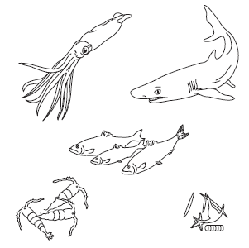
- Draw arrows between the organisms to show how energy moves through this food chain. Write producer, herbivore, or carnivore under each organism.

- Explain how energy flows through this food chain.

- What would happen to this food chain if a disturbance caused a serious decline in the shark population?

- What role does energy play in the diagram, and how is it represented?
VISUAL ANALOGY

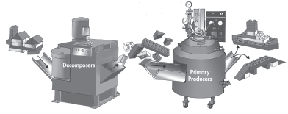

Name Class Date

Trophic Levels and Ecological Pyramids
Write True or False on the line provided.
6. Primary consumers always make up the first trophic level in a food web.
7. Ecological pyramids show the relative amount of energy or matter contained within each trophic level in a given food web.
8. On average, about 50 percent of the energy available within one trophic level is transferred to the next trophic level.
9. The more levels that exist between a producer and a given consumer, the larger the percentage of the original energy from producers is available to that consumer.

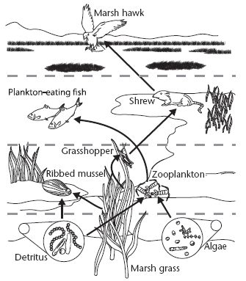
Use the diagram to answer Questions 10–17.
Match the organism with its trophic level. A trophic level may be used more than once.

Organism
10. algae
11. grasshopper
12. marsh grass
13. marsh hawk
14. plankton-eating fish
15. ribbed mussel
16. shrew
17. zooplankton
Trophic Level
A. primary producer
B. first-level consumer
C. second-level consumer
D. third-level consumer

3

Name Class Date

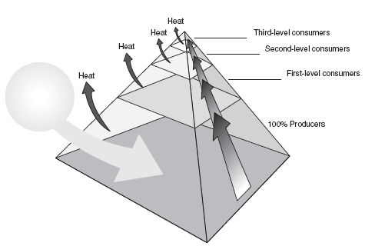
- Complete the energy pyramid by writing the source of the energy for the food web and how much energy is available to first-, second-, and third-level consumers.

For Questions 19–21, complete each statement by writing the correct word or words.
- A pyramid of _______________ illustrates the relative amount of living organic matter available at each trophic level in an ecosystem.
- A pyramid of _______________ shows the relative numbers of individual organisms at the trophic levels in an ecosystem.
- A pyramid of _______________ shows the relative amounts of energy available at the trophic levels of a food chain or food web
Apply the Big idea

- Identify which type of ecological pyramid best traces the flow of matter through an ecosystem. Explain your answer.

