Technical Report
UK Transport Reliability API:
Agent-Ready Reliability Analytics via MCP Tools
COMP3011 - Web Services and Web Data
Coursework 1: Individual Web Services API Development Project

This report summarises the design, implementation, testing, and reflection for a public transport reliability API built around open UK transport data, user-reported incidents, analytics endpoints, and MCP-compatible tool access.

GitHub repository: [insert link]
API documentation PDF: [insert link]
Presentation slides / visuals: [insert link]

1. Project Overview
Project summary. The project implements a developer-facing web API for analysing public transport reliability in the UK. It combines a conventional REST interface for user-reported incidents with analytical endpoints for route reliability, delay patterns, anomaly detection, and recommendation logic. The system is designed to satisfy the coursework requirement for a data-driven API with SQL-backed CRUD, while also extending beyond the minimum specification through MCP-compatible tool access and analytics-oriented endpoints.
Why this topic. Transport reliability is a suitable coursework domain because it naturally mixes operational data, temporal analysis, and real user interaction. A transport API also provides a credible justification for combining database-backed records with computed insights. This aligns closely with the assignment brief, which explicitly lists public transport reliability and delay analytics as an example project direction and highlights MCP compatibility

2. Requirements Alignment
The implementation was shaped around the coursework pass/fail and quality criteria:
- At least one SQL-backed data model with full Create, Read, Update and Delete functionality.
- At least four HTTP endpoints returning appropriate machine-readable responses.
- Use of correct status codes and practical error handling.
- Runnable code with documentation, technical report, and supporting presentation materials.
- A brief Generative AI declaration included for coursework compliance.
In practice, the core data model is Incident, which stores user-reported service disruption information. This model provides the complete CRUD requirement, while the analytics endpoints operate on imported transport data and aggregated delay patterns. The report therefore focuses on design choices, database decisions, testing, limitations, and submission requirements.

3. Architecture and Technology Choices
The system follows a layered architecture so that HTTP delivery, business logic, persistence, and agent tooling remain loosely coupled. This separation improves maintainability and makes oral examination discussion easier because each responsibility can be explained independently.
Layer | Role | Design justification
API router | Receives HTTP requests, validates inputs, returns JSON responses | Keeps endpoint behaviour explicit and aligned with REST conventions.
Service / analytics layer | Calculates reliability scores, delay heatmaps, anomalies, and recommendations | Prevents analytical logic from leaking into controllers.
Persistence layer | Stores incident CRUD records in SQL tables | Satisfies coursework database requirement and supports consistent transactional updates.
MCP tool wrapper | Exposes selected capabilities to agent workflows | Extends the project beyond standard coursework minimums and supports the advanced feature narrative.
Programming language and framework. A Python-based implementation is appropriate for this project because it offers strong support for data ingestion, analytics, and API development in a single ecosystem. Python also pairs naturally with SQL access libraries and rapid prototyping workflows, which is useful for a coursework project with both engineering and exploratory elements.
Database choice. A SQL database was chosen because the coursework specifically expects CRUD linked to a database and recommends SQL In this project, SQL is a good fit because incident records are structured, relational, and benefit from indexed filtering by line, timestamp, or status. It also simplifies auditability in the oral examination, where examiners may ask how updates, deletions, and filtered retrieval are stored and verified.

4. Data Model and API Design
Core entity. The Incident model represents a user-submitted transport disruption report, such as a delay, suspension, signalling issue, overcrowding event, or service alert. A typical record contains identifiers, route/line metadata, timestamps, short descriptive text, severity, and status.
Endpoint group | Purpose
POST /incidents | Create a new user-reported incident in the SQL database.
GET /incidents | List incidents, optionally filtered by route, status, or period.
PUT /incidents/{id} | Update an existing incident and maintain a consistent record lifecycle.
DELETE /incidents/{id} | Remove a report that is invalid, duplicated, or withdrawn.
GET /analytics/reliability | Return route-level reliability metrics over a selected time range.
GET /analytics/heatmap | Show delay concentration by route, time band, or other temporal grouping.
GET /analytics/anomalies | Identify unusually poor performance periods or outlier behaviour.
GET /analytics/recommend-journey | Recommend the more reliable journey pattern using available analytics.
Design rationale. This structure intentionally combines operational CRUD with read-heavy analytics. That balance is important because a transport system is not only a database of incidents; it is also an information product that should help a user or downstream agent reason about service quality. The endpoint set therefore satisfies the minimum coursework requirement while making the API more distinctive and defensible during the oral examination.

5. Data Sources and Processing
Data sourcing strategy. The project is built around open UK transport data, combined with user-generated incident reports. This is consistent with the brief's recommendation to use publicly available datasets and to cite their academic suitability in the report.
- Imported transport data supports analytical queries such as reliability scoring and time-based delay summaries.
- User-reported incident records provide the writable CRUD entity needed for the database-backed API.
- Pre-processing scripts transform raw fields into line, date, and metric structures better suited to relational storage and aggregation.
Data preparation. Transport datasets are often distributed as CSV, JSON, or mixed tabular formats. For analysis, these were normalised into schema-consistent tables and aggregated views so that route-level metrics could be calculated efficiently. This reduced repeated computation at request time and created a cleaner separation between ingestion and runtime analytics.

6. Reliability Analytics and MCP Integration
Analytics design. The analytical side of the system focuses on decision-support rather than raw data exposure. Reliability scoring estimates overall service quality over a selected interval; heatmaps identify time windows with concentrated delay; anomaly detection highlights unexpected performance drops; and journey recommendation uses those metrics to guide route choice. Packaging these as independent capabilities makes the API more useful for both human and agent users.
MCP compatibility. A notable extension is the use of MCP-compatible wrappers so that an agent can call the API as a structured tool. The brief explicitly names MCP compatibility as an example of an advanced feature. In this project, MCP serves two purposes: it improves the demonstration narrative by showing modern interoperability, and it reframes the API as agent-ready infrastructure rather than a traditional CRUD service alone.

7. Testing Strategy and Error Handling
Testing focused on correctness, robustness, and explainability in the oral examination. The goal was not only to check whether endpoints respond, but whether they behave consistently under realistic and invalid inputs.
Area | What was tested | Expected outcome
CRUD operations | Create, list, update, and delete incident records | Records persist correctly and status codes match request results.
Validation | Missing fields, malformed query parameters, invalid identifiers | Client receives clear 4xx errors with structured messages.
Analytics endpoints | Time range filters, route parameters, empty result windows | Metrics compute correctly and edge cases return safe responses.
MCP tools | Tool call forwarding and parameter mapping | Agent-facing tools resolve to the correct API endpoint behaviour.
Error handling. The API uses appropriate HTTP status codes and consistent JSON error responses, reflecting the brief's minimum requirement for industry-conventional status handling. This includes signalling invalid user input, missing resources, and server-side failures in a predictable format that is easy to document and test.

8. Challenges and Lessons Learned
Balancing CRUD with analytics. A simple CRUD-only service would satisfy the minimum pass requirement, but it would not demonstrate enough originality. The main design challenge was therefore to combine a conventional writable model with analytics that feel genuinely useful rather than artificially added.
Making outputs demonstrable. Transport metrics can be technically correct yet difficult to explain live. This led to a focus on outputs that are interpretable in presentation, such as route summaries, anomaly flags, and heatmap-style groupings.
Designing for explanation, not only implementation. In an oral assessment, the strongest architecture is one that can be justified clearly. Separating routing, analytics, persistence, and MCP tooling made the codebase easier to reason about and easier to defend in questions about trade-offs.

9. Limitations and Future Work
- Authentication in the prototype is limited and could be extended with token-based access control, per-user ownership of incidents, and role separation.
- The recommendation logic is heuristic rather than predictive; a stronger future version could incorporate forecasting or probabilistic delay modelling.
- Dataset coverage and freshness depend on the selected import pipeline. A production-ready deployment would benefit from scheduled refresh jobs and stronger provenance tracking.
- Testing can be expanded into a more comprehensive automated suite covering performance, load, and regression scenarios.

10. Generative AI Declaration
Generative AI tools were used in a limited supporting role during planning, debugging, and documentation refinement. Final technical decisions, implementation, validation, and submission were completed and checked by the author.
Tool | How it was used | Contribution level
ChatGPT / comparable LLM assistant | Project ideation, architecture discussion, report drafting, API documentation drafting, and presentation preparation. | High-level and iterative
AI-assisted coding support | Debugging, endpoint design suggestions, and data-import script scaffolding. | Methodological / productivity

11. Conclusion
Overall, the UK Transport Reliability API was designed to meet the coursework baseline while also demonstrating a more ambitious direction through analytics and MCP-compatible tooling. The project shows how a SQL-backed CRUD API can be expanded into a decision-support system that is practical for users, defendable in an oral examination, and extensible toward more advanced agent-ready workflows.

References
- School of Computer Science, University of Leeds. COMP3011 Coursework 1 Brief (2025/26).
- Relevant dataset source(s): Transport for London (TfL) Open Data — primarily the TfL Unified API, which provides live and current data including line status, disruptions, arrival/departure predictions, timetables, routes, and journey-planning-related transport information.
- Libraries/frameworks used in implementation: FastAPI, Pydantic, SQLAlchemy, SQLite, HTTPX, Docker, Docker Compose, pytest, Uvicorn, and a custom MCP-compatible server layer.
- A planning conversation showing how alternative project ideas were compared.
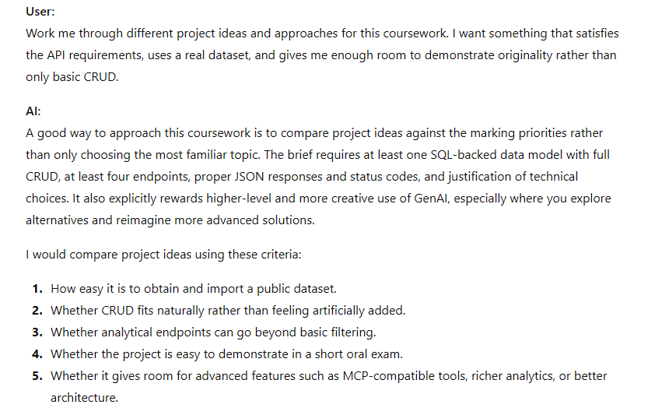
- A debugging conversation related to data import, endpoint structure, or testing.
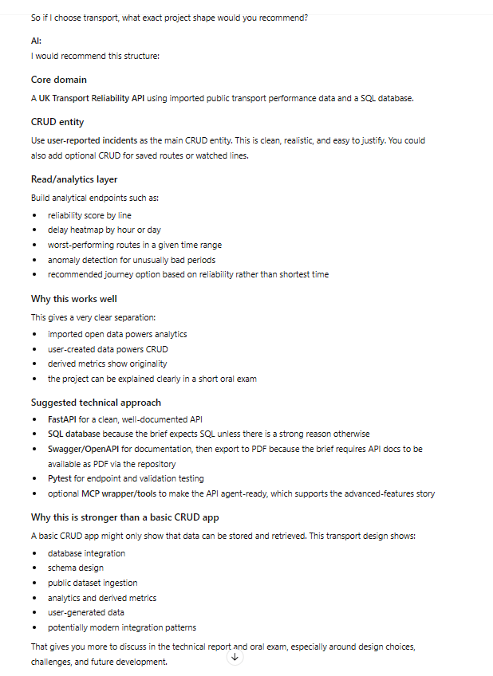
- A documentation conversation demonstrating how the API or report structure was refined.
