1. Create a script that will take User Input – from Keyboard while running - with if, else if, and else conditionals to calculate the Total Resistance (R_T)

                1) r1 , r2, and r3 are connected in series manner. (R_T= r1+r2+r3)

                2) r1, r2, and r3 are connected in parallel manner.(R_T = 1/((1/r1)+(1/r2)+(1/r3)) )

                3) r1 is connected to the parallelly connected r2 and r3 in series manner.

                                (R_T = r1 + r2xr3/(r2+r3) )

 The output should be

                Dear Ms or Mr. [Your Name],

The Total Resistance is [your result] ohms since r1, r2, r3 are connected in [series, parallel, combination] manner.

“The script should prompt the user to type in values for the following variables while the program is running - Your Name, r1 , r2 , and r3 .”

1. Repeat problem 1. This time use “switch”.

Create a script with user input to check whether the 3 vertices form a right triangle or not. Also, add several lines to check whether those vertices form a isoceles triangle. Also, this script should calculate the area of the triangle by using Heron’ Formula. 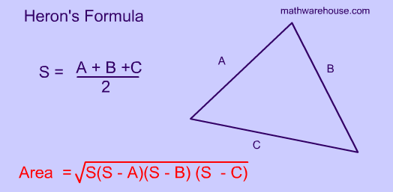

Your output should have the format of

-With the given vertices (Display Vertices) will (or not ) form a right triangle, will (or not) form an isoceles triangle. The area of the triangle is (The result.)

1. Create a script that will solve a set of simultaneous equations.

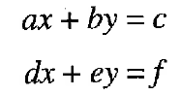

a, b, c, d, e, and f are user input.

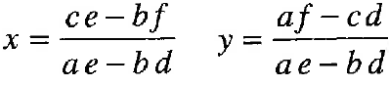

Your script should be able to calculate x and y.

Also the script should ask the user whether he /she would like to continue on finding answers for other equations and then continue on with the answer “Y”.

Your output should have the format of

-With given values of “a”, “b”, “c”, “d”, “e”, and “f”, the answer for x is “Answer” and y is “Answer”