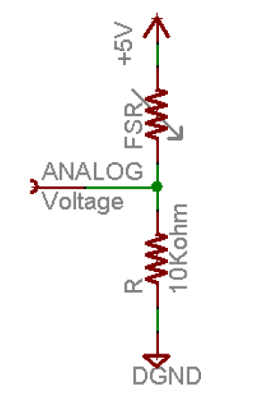**Assignment TP1: Rapid Prototyping**

This assignment is realized by David Feng (10250) and Kenza Kettani (10279).

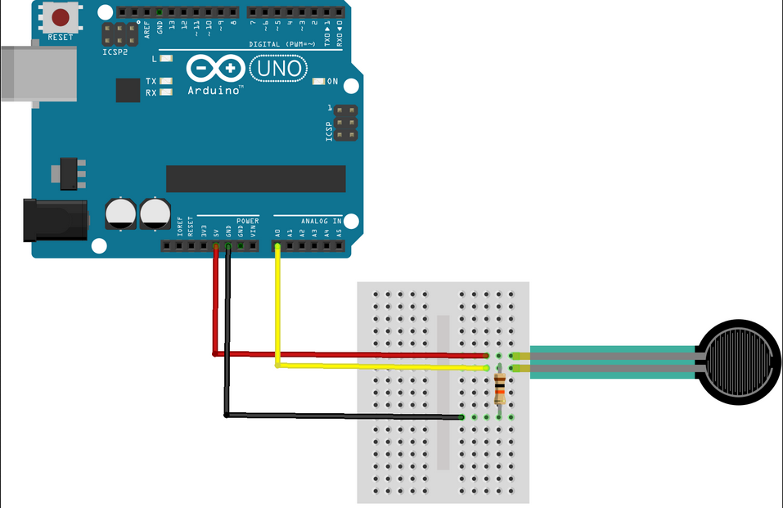

We have chosen a force sensitive resistor (FSR) as sensor in this circuit and we used a 10 KOhm resistance.

1. Measurement setup:  
   After the construction of the circuit, it is necessary to stack several elements to have a sufficient weight. We have chosen a EWA2 loud speaker, Xiao MI Note 3 smartphone, an ashtray and a cup. The measures are taken once all these elements are in place.   
   To have a stable measurement, we added a counter (3s) before taking measurements in the Arduino program and a delay of 200ms between each measurement.
2. We use the program that we created before in the exercise 6. And we use the processing software to save the data.  
   100 measurements are stored in a data file. The measurements correspond to the analog read from the port COM3.   
     
   Its mean value is 0.039 N. And its random error is 0.038 N.  
     
   To calculate the force, we must calculate first the fsrVoltage, the fsrResistance and the fsrConductance.  
     
    The Vinput is equal to 5000 mV. We multiply by 10 000 because we used a 10 KOhm as resistance.  
    we measure in micromhos.  
     
   Then we have to estimate the force by estimation. If the fsrConductance value is less than 1000 micromhos, then the force will be equal to fsrConductance/80. Else, the force will be equal to (fsrConductance – 1000)/30.
3. We repeat the same measurement setup by using a second sensor exchanged with another group.  
   Its mean value is 0.046 N. And its random error is 0.045 N.  
     
   To calculate the random error (sigma), the below formula is used:
4. The systematic error as difference of the 2 mean values is abs (0.039 – 0.046)=0.007N.

The Force1 and the frequency1 correspond to our FSR. And the Force2 and the frequency2 correspond to the second FSR.

