**IoT TP2: Pong Game**

This assignment is realized by David Feng (10250) and Kenza Kettani (10279).

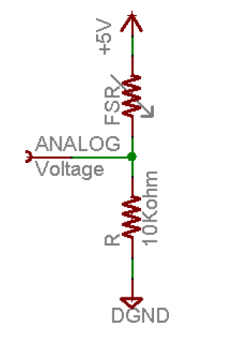

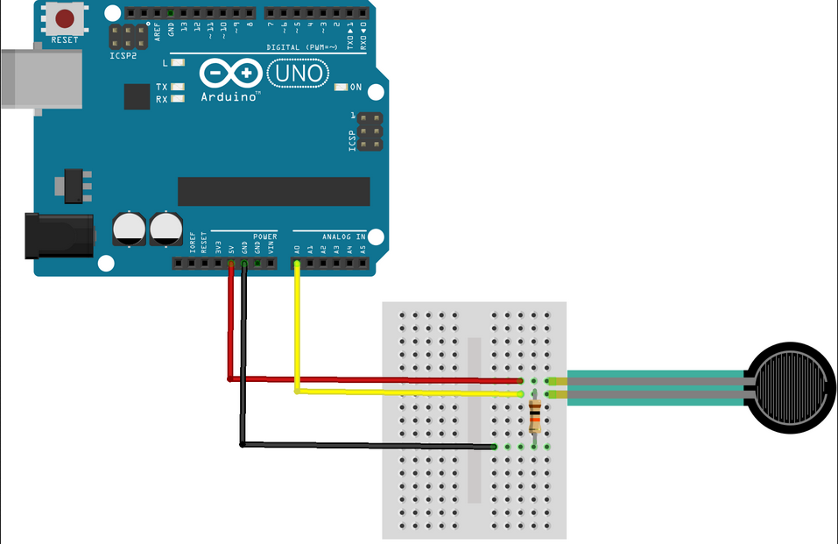

Let’s take back the force sensitive resistor sensor in the TP1 assignment. We will use it to control the paddle of our pong game.

For the internet connection to our pong game, we have chosen the functionality to send email, to check inbox and its content.

So, we must install some java libraries: smtp.jar, pop3.jar, mailapi.jar, imap.jar, activation.jar. To install it, just drag and drop it in the current sketchbook, and it will create a code folder containing all libraries we need. It is the version 1.4.5 that we have used.

Then, oompile and upload to the Arduino the standard firmata example to allow the communication between Arduino and Processing.

To control the paddle with the sensor, we replace the (xrect = mouseX) value by the mapped sensor value.

Now, we can send an email to notify the score once the game is finished (an email from [fyhdavid@gmail.com](mailto:fyhdavid@gmail.com) to [feng_yu_hui_david@hotmail.fr](mailto:feng_yu_hui_david@hotmail.fr) ).

To check the inbox mail, the code should work but we met an invalid certification path to requested target problem. To resolve that, we need to install the java certification and to add our hostname and https port to the trusted KeyStore. But, we do not really trust the java certification method and we do not want either to expose more our mail box to risks of hacks.



