**Exercise 14:**

We need to install Adafruit TSL 2561 library and Adafruit Unified Sensor.

We have a lux sensor.

By using the example sensorapi provided by Adafruit, we can get the lux value of our sensor.

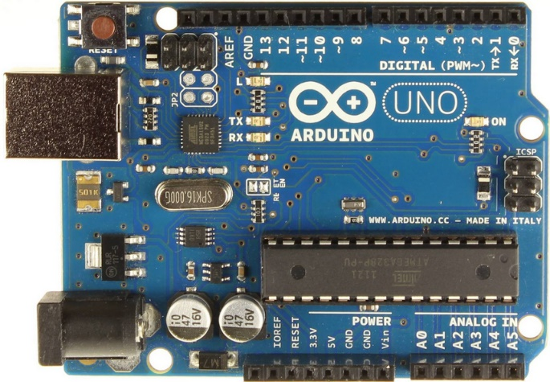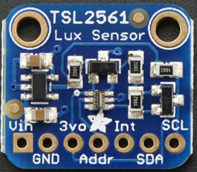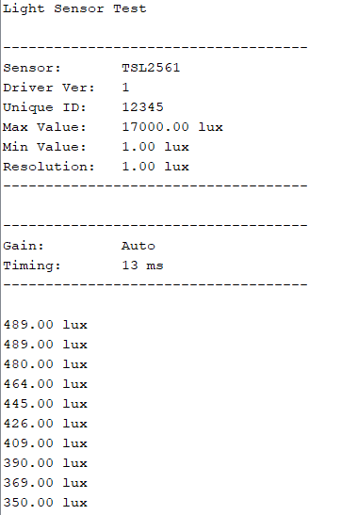We re-use the pong game achieved previously. By replacing the xrect value by the value thought the port COM3, we can control the paddle with the lux sensor.

**CODE FROM PROCESSING**  
import processing.serial.*; //import serial communication classes

import cc.arduino.*; //import Arduino classes

Arduino arduino; //declare an Arduino object

int sensorPin = 0;

int sensor;

float sensorValue;

float xball;

float yball;

float xrect;

float yrect;

float xdelta;

float ydelta;

int score=0;

Serial myPort; // Create object from Serial class

String val; // Data received from the serial port

float finalvalue;

void setup() // runs once at start

{

size(400,700);

background(0);

xball=200;

yball=200;

xrect=200;

yrect=600;

xdelta=6;

ydelta=-3;

//println(Arduino.list()); // use this to get port#

//arduino = new Arduino(this, Arduino.list()[0], 57600); //instanciate own Arduino object

// COM port number and baudrate

//arduino.pinMode(sensorPin, Arduino.INPUT);

String portName = Serial.list()[0]; //change the 0 to a 1 or 2 etc. to match your port

myPort = new Serial(this, portName, 115200);

}

void draw() //loops forever

{

background(0);

if ( myPort.available() > 0)

{ // If data is available,

val = myPort.readString(); // read it and store it in val

}

if(val != null){

finalvalue = float(val);

println(finalvalue);

sensorValue = map(finalvalue, 0, 2000, 0, width);

}

move(sensorValue);

rebond();

ballraquette();

}

void ballraquette(){

rect(xrect, yrect, 100, 10);

ellipse(xball,yball,10,10);

}

void move(float localSensorValue){

xball += xdelta;

yball += ydelta;

//sensor = arduino.analogRead(sensorPin);

//sensorValue = map(sensor, 0, 5000, 0, width);

xrect = (localSensorValue);

}

void rebond(){

if( xball > width-10 && xdelta > 0){ // droite

xdelta = -xdelta;

}

if( xball < 10 && xdelta < 0){ // gauche

xdelta = abs(xdelta);

}

if( yball < 10 && ydelta < 0){ // haut

ydelta = abs(ydelta);

}

if( yball > yrect-10 && xball > xrect-100 && xball < xrect+100){ // bas

ydelta = -ydelta;

score += 1; // get a point when the ball rebonds on the paddle

}

if(yball > yrect){

noLoop();

println("GAME OVER");

println("score: " + score);

}

}

**CODE FROM ARDUINO**

#include <Wire.h>

#include <Adafruit_Sensor.h>

#include <Adafruit_TSL2561_U.h>

Adafruit_TSL2561_Unified tsl = Adafruit_TSL2561_Unified(TSL2561_ADDR_FLOAT, 12345);

void configureSensor(void)

{

/* You can also manually set the gain or enable auto-gain support */

// tsl.setGain(TSL2561_GAIN_1X); /* No gain ... use in bright light to avoid sensor saturation */

// tsl.setGain(TSL2561_GAIN_16X); /* 16x gain ... use in low light to boost sensitivity */

tsl.enableAutoRange(true); /* Auto-gain ... switches automatically between 1x and 16x */

/* Changing the integration time gives you better sensor resolution (402ms = 16-bit data) */

tsl.setIntegrationTime(TSL2561_INTEGRATIONTIME_13MS); /* fast but low resolution */

// tsl.setIntegrationTime(TSL2561_INTEGRATIONTIME_101MS); /* medium resolution and speed */

// tsl.setIntegrationTime(TSL2561_INTEGRATIONTIME_402MS); /* 16-bit data but slowest conversions */

/* Update these values depending on what you've set above! */

// Serial.println("------------------------------------");

// Serial.print ("Gain: "); Serial.println("Auto");

// Serial.print ("Timing: "); Serial.println("13 ms");

// Serial.println("------------------------------------");

}

void setup(void)

{

Serial.begin(115200);

// Serial.println("Light Sensor Test"); Serial.println("");

/* Initialise the sensor */

//use tsl.begin() to default to Wire,

//tsl.begin(&Wire2) directs api to use Wire2, etc.

if(!tsl.begin())

{

/* There was a problem detecting the TSL2561 ... check your connections */

Serial.print("Ooops, no TSL2561 detected ... Check your wiring or I2C ADDR!");

while(1);

}

/* Display some basic information on this sensor */

// displaySensorDetails();

/* Setup the sensor gain and integration time */

configureSensor();

/* We're ready to go! */

Serial.println("");

}

void loop(void)

{

/* Get a new sensor event */

sensors_event_t event;

tsl.getEvent(&event);

/* Display the results (light is measured in lux) */

if (event.light)

{

Serial.print(event.light);

// Serial.println(" lux");

}

else

{

/* If event.light = 0 lux the sensor is probably saturated

and no reliable data could be generated! */

Serial.println("Sensor overload");

}

delay(250);

}